**List of Figure**

Figure 1 shows the primary research plan. 17

Figure 2 Modified waterfall methodology to fit the project requirement 18

Figure 3 Iterative product design 20

Figure 4 Matching psychological needs (SDT) to game design elements. 27

Figure 5 summary of game mechanics most commonly used in the studies of gamification 35

Figure 6 shows the acknowledgment notice for the data being processed by the survey. 44

Figure 7 shows the question ask in the survey to target the target audience demographics. 45

Figure 8 shows first 4 question of the section B. 46

Figure 9 shows the subsequent 6 question in section B. 47

Figure 10 shows the last two question in section B. 47

Figure 11 shows the Acknowledgement of Notice pie chart from the response of the respondent. 48

Figure 12 shows the percentage of male and female respondents. 49

Figure 13 shows the age group for our respondent. 49

Figure 14 shows the survey respondents' highest educational level. 50

Figure 15 shows the survey respondents' employment. 50

Figure 16 shows the result of the survey whether respondent in playing games. 51

Figure 17 shows the average time respondents spent weekly playing games. 51

Figure 18 shows whether respondents prefer a game that has a problem riddle or challenge. 52

Figure 19 shows whether the respondent pursue in-game achievement. 53

Figure 20 shows whether the respondent prefers grinding a game. 54

Figure 21 shows the preference of survey respondents in taking a risk in a game. 54

Figure 22 shows that our respondents would love playing games socially with friends. 55

Figure 23 shows the preference of survey respondents against the single-player game. 55

Figure 24 shows whether our survey respondents prefer in-game leaderboards. 56

Figure 25 shows whether the respondent likes interactive storylines. 57

Figure 26 shows the preference of the respondent towards the rewards schedule. 57

Figure 27 shows that the respondent's preference toward progress indicator. 58

Figure 28 shows the Mash-up mapping in Mural. 60

Figure 29 shows the selected insight from the mapping on a side and the final sketch/concept resulting from them. 61

Figure 30 shows two portions, top and bottom, where a paper prototype is devised from the ideation concept. 63

Figure 31 shows four portions, top left, right and bottom left, right where a paper prototype is devised from the ideation concept. 65

Figure 32 shows the flowchart of the implementation phase. 66

Figure 33 shows Gantt Chart for the individual project. 68

Figure 34 shows the screen capture of the asset categorizing in Unity. 70

Figure 35 shows detailed information about the current selected GameObject. 71

Figure 36 shows all the Scenes in the project. 72

Figure 37 shows all the GameObject in the AestonTown Scene. 72

Figure 38 shows the Project Structure. 73

Figure 39 shows the navigation structure. 75

Figure 40 shows the sample Tilemap being created with the Grid component laid out. 76

Figure 41 shows the creation of a New Palette to store a specific group of Tiles. 77

Figure 42 shows the Sorting layer and Order in Layer of the Tilemap Renderer component in the Tilemap. 77

Figure 43 shows the name structure of Tilemaps. 78

Figure 44 shows the component attached to the Solid Objects Tilemap. 78

Figure 45 shows the completed Tilemap of Countryside Scene. 79

Figure 46 shows the C# script creation process. 80

Figure 47 shows the newly created script. 80

Figure 48 shows the detail of the PNG file when opened in Unity. 82

Figure 49 shows the Sprite Editor. 83

Figure 50 shows the complete code snippet of the PlayerController script. 84

Figure 51 shows the PlayerController script attached to the Player GameObject. 85

Figure 52 shows the code snippet that allows for movement. 85

Figure 53 shows the Dopesheet in the Animation panel. 86

Figure 54 shows creating a new Blend Tree. 87

Figure 55 shows the creation of the parameters. 87

Figure 56 shows the Blend Tree properties. 87

Figure 57 shows the motion checking window. 88

Figure 58 shows the code snippet. 88

Figure 59 shows the code snippet. 89

Figure 60 shows the code snippet for the CameraController script. 90

Figure 61 shows how the camera positioned the player avatar. 91

Figure 62 shows the component details of the Essential Loader GameObject. 92

Figure 63 shows the code snippet of the EssentialLoader script. 93

Figure 64 shows the UI Canvas Hierarchy. 95

Figure 65 shows the UIFade Script component in UI Canvas. 96

Figure 66 shows the DialogManager Script component in UI Canvas. 96

Figure 67 shows the Game Menu Script component in UI Canvas. 97

Figure 68 shows the Battle Reward Script component in UI Canvas. 98

Figure 69 shows the detailed properties of FadeImage GameObject. 99

Figure 70 shows the code snippet for the UIFade script. 100

Figure 71 shows the dialogue box shows in a scene. 101

Figure 72 shows the detailed properties for Dialog Box GameObject. 102

Figure 73 shows the detailed properties for Text Gameobject in the Dialog Box. 103

Figure 74 shows the code snippet for the DialogManager script (Part 1). 104

Figure 75 shows the code snippet for the DialogManager script (part 2). 105

Figure 76 shows the in-game menu when the player right-clicks on their mouse. 106

Figure 77 shows the in-game menu Item tab. 106

Figure 78 shows the item used for which character. 107

Figure 79 shows the in-game menu Stats tab. 107

Figure 80 shows the code snippet for the GameMenu script (part 1). 108

Figure 81 shows the code snippet for the GameMenu script (part 2). 109

Figure 82 shows the code snippet for the GameMenu script (part 3). 110

Figure 83 shows the code snippet for the GameMenu script (part 4). 110

Figure 84 shows the code snippet for the GameMenu script (part 5). 111

Figure 85 shows the code snippet for the GameMenu script (part 6). 111

Figure 86 shows the code snippet for the GameMenu script (part 7). 112

Figure 87 shows the code snippet for the GameMenu script (part 8). 112

Figure 88 shows the code snippet for the GameMenu script (part 9). 112

Figure 89 shows the code snippet for the GameMenu script (part 10). 113

Figure 90 shows the code snippet for the GameMenu script (part 11). 113

Figure 91 shows the OnClick() function in the button in Unity Editor. 114

Figure 92 shows the Buy tab in the Shop user interface in the scene panel. 115

Figure 93 shows the item list from a Shopkeeper NPC in Scene. 116

Figure 94 shows the Shop user interface in the game. 116

Figure 95 shows the Sell tab in the Shop user interface in the scene panel. 117

Figure 96 shows the Sell tabs in the game. 117

Figure 97 shows the code snippet for the Shop script (Part 1). 118

Figure 98 shows the code snippets for the Shop script (Part 2). 119

Figure 99 shows the Reward GameObject in the scene panel. 120

Figure 100 shows the code snippets for the BattleReward script 121

Figure 101 shows the component of RewardScreen GameObject. 122

Figure 102 shows the component details of the GameManager GameObject. 123

Figure 103 shows the code snippet for GameManager script (Part 1). 124

Figure 104 shows the code snippet for the GameManager script (Part 2). 125

Figure 105 shows the code snippet for the GameManager script (Part 3). 125

Figure 106 shows the code snippet for the GameManager script (Part 4). 126

Figure 107 shows the code snippet for the GameManager script (Part 5). 127

Figure 108 shows the code snippet for the GameManager script (Part 6). 128

Figure 109 shows the code snippet for the GameManager script (Part 7). 129

Figure 110 shows the code snippet for the QuestManager script (Part 1). 130

Figure 111 shows the code snippet for the QuestManager script (Part 2). 130

Figure 112 shows the QuestManager script component in GameManager GameObject. 131

Figure 113 shows the code snippet for the QuestManager script (Part 3). 131

Figure 114 shows the code snippet for the QuestManager script (Part 4). 132

Figure 115 shows the code snippet for the QuestManager script (Part 5). 132

Figure 116 shows the code snippets of QuestObjectActivator Script. 133

Figure 117 shows the QuestObjectActivator as a component of a GameObject. 133

Figure 118 shows the code snippet for the QuestManager script (Part 6). 134

Figure 119 shows the code snippet for the QuestManager script (Part 7). 134

Figure 120 shows the code snippets Audio Manager script. 135

Figure 121 shows the component details of AudioManager GameObject. 136

Figure 122 shows the RoadToAestonTown scene in the Scene panel. 137

Figure 123 shows the battle scene when the battle is started. 138

Figure 124 shows the BattleStarter script as a component in Battle Zone GameObject. 138

Figure 125 shows the BattleManager script in BattleManager GameObject. 139

Figure 126 shows the Butterfly enemy prefabs component details. 140

Figure 127 shows the players perspective when they left the tutorial scene. 141

Figure 128 shows the dialogue box prompt when the player interacts with an interactable element in the game. 142

Figure 129 shows the dialogue box that prompts up when interacting with the Old Lady NPC. 142

Figure 130 shows the door that opened after the player was done talking to the Old Lady NPC. 143

Figure 131 shows the player perspective upon entering the quest area. 143

Figure 132 shows the interaction between the player and the Actor NPC. 144

Figure 133 shows the dialogue prompt on the crate. 145

Figure 134 shows the switch turns green if the answer is correct. 145

Figure 135 shows the switch turned red if the answer is wrong. 145

Figure 136 shows the reward screen that prompt after all the switch is in the correct position. 146

Figure 137 shows the exclamation mark on top of the overseer NPC. 147

Figure 138 shows the removal of the exclamation mark once the player talks to the NPC. 147

Figure 139 shows the door behind is closed upon player leaving with quest completed. 148

Figure 140 shows the obstacle being removed upon the player completes the quest. 148

Figure 141 shows the component detail of the Switch GameObject. 149

Figure 142 shows the code snippets of the PressureDetection script (Part 1). 150

Figure 143 shows the code snippets of the PressureDetection script (Part 2). 151

Figure 144 shows the component of a patching system in the plan for the future. 152

**List of Table**

Table 1 other definitions of gamification by various authors 24

Table 2 learning theoretical background and framework applied in the gamification studies. 27

Table 3 Game mechanics adapted from (Xu, 2012) 30

Table 4 game elements & terminology (Seaborn & Fels, 2015) 31

Table 5 Adapted gamification platforms 34

Table 6 psychological needs with matching game design elements. 39

Table 7 shows the Game Design elements that are in the project. 154

Table 8 The SafeAssign plagiarism checking percentage 157

Table 9 shows all the literature studies done for the game element usage for Figure 5 157

Table of Contents

1 Defining Research Project 13

1.0 Introduction 13

1.1 Technology and Learning 13

1.2 The Theory of Gamified Learning 14

1.3 Problem Statement 15

1.4 Detailed research question 16

1.5 Research objective 16

1.6 Keywords 17

1.7 Project Title 17

1.8 Client, Audience, and Motivation 17

1.9 Primary Research Plan 18

1.10 Conclusion 22

2 Abstract and Literature Review 23

2.0 Abstract 23

2.1 Introduction 23

2.2 Definition of gamification 23

2.3 Theoretical background and framework 25

2.4 Game design 29

2.4.1 Game mechanics 29

2.4.2 Game element 33

2.5 Educational Gamification Platforms and Apps 34

2.5.1 Game element used 35

2.6 Game Development tools and programming language for mobile game development 36

2.7 Game Design Document 37

2.7.1 Matching psychological needs to game design elements 38

2.8 Conclusion 40

3 Research Methodology 42

3.0 Introduction 42

3.1 Project Preparation 42

3.2 User and Context Analysis 43

3.2.1 Context Analysis 43

3.2.2 User Analysis 44

3.2.3 Success Metrics 59

3.3 Ideation 60

3.4 Design 63

3.5 Implementation 66

3.6 Evaluation & Monitoring 67

3.7 Gantt Chart 68

3.8 Conclusion 69

4 Project Development 70

4.0 Introduction 70

4.1 Assets 70

4.2 Prefabs 71

4.3 Scene 72

4.4 Project Structure 74

4.5 Navigation Structure 75

4.6 Creating Tile map for the environment 76

4.7 C# Script 80

4.8 Player 82

4.8.1 Sprite sheet 82

4.8.2 Creating Script 84

4.8.3 Animating the Player 86

4.9 Camera 90

4.10 Essential Loader 93

4.10.1 UI Canvas 94

4.10.2 GameManager 123

4.10.3 AudioManager 135

4.10.4 BattleManager 137

4.11 Use Case System 142

4.11.1 Scenario 142

4.11.2 The switch 149

4.11.3 NPC Dialogue 152

4.12 Future Work 153

4.12.1 Patch System 153

4.12.2 Use Case Scenario 154

4.12.3 Game Design Element 154

4.13 Conclusion 155

5 Evaluation and Results 156

6 Appendix 157

7 References 178

# Defining Research Project

## Introduction

Research lamented that "the challenge of teaching has increased when faced with increasingly apathetic students" (Wood & Reiners, 2012). Generation Y, born between 1980 and 1994, and generation Z, born between 1994 and 2012, is considered challenging to motivate by applying traditional teaching methods. Despite straining efforts from educational professionals to apply innovative teaching practices, many students still perceive traditional schooling as boring and ineffective (Lee & Hammer, 2011). Grabinger & Dunlap, the most prominent example, found that traditional teaching does not encourage students to problem-solve or adapt their learning content to new situations (Grabinger & Dunlap, 1995). Hence, there is a need to identify the method for teaching refinement to tackle all the problems stated. In addition, the student prefers engaging and interactive online learning (Martin & Bolliger, 2018).

## Technology and Learning

In the 21st century, the term "technology" is an essential issue in many fields, including education. Technology has become the knowledge transfer highway in most countries. The term "just Google it" has become a ritualisation to the epistemic trust in the actors, be they lecturers, search engines or news websites for the students (Bhatt & Mackenzie, 2019). As a part of this, schools and other educational institutions need to consider ICT integration in their curriculum to prepare them to live in "a knowledge society" (Ghavifekr, et al., 2012).

Integration of Information, Communication, and Technology (ICT) in education often refers to using new computer-based communication incorporated in the daily classroom instructional process (Green & Hannon, 2007). The teacher is the crucial player in integrating ICT in daily classrooms better due to the capability of ICT in providing a dynamic and proactive teaching environment (Abirini, 2006). The adoption of ICT is a continuous and arduous step that requires collaboration between multiple parties, be they policymakers, teachers, parents and students (Ghavifekr, et al., 2014).

However, the worldwide pandemic of COVID-19 widened the gap between teachers and students. In order to reduce gatherings of large crowds and ensure physical distancing, face-to-face education was cancelled. Consequently, most universities carry out their activity with students only online (Sobaih, et al., 2020). With the E-Learning platform, students can work collaboratively on online projects, discuss lectures using online forums and watch videos embedded into instructor's lecture notes (Narciss, et al., 2007). On the other hand, an E-Learning platform brings some considered obstacles in students' learning process. Specifically, decreased motivation in students, delayed feedback or help because teachers are not always available when students may need help while learning, or feeling of isolation due to classmates' lack of physical presence (Yusuf & Al-Banawi, 2013). In recent years, gamification has gained considerable interest in education circles to motivate and engage students in their learning process. A recent study has shown gamification to positively affect students' knowledge retention (Putz, et al., 2020).

## The Theory of Gamified Learning

The term "gamification" is a neologism derived from the digital media field. It was coined in 2002 and documented in 2008 (Marczewski, 2013). According to the Oxford English Dictionary, the word *gamification* refers to 'the application of typical elements of game playing (e.g. point scoring, competition with others, rule of play) to other areas of activity, typically as an online marketing technique to encourage engagement with a product or service' (Kawachi, 2017). A similar concept, such as 'game-based learning' and 'gamification of learning' has come to life. These approaches are under the umbrella term of active learning from a mere theoretical view emerging education engage learners and favour knowledge application over knowledge acquisition (Sandrone, et al., 2020) (Sandrone & Schneider, 2020). It specifies the shift from a traditional teacher-centric approach to a learner-centred approach (Sandrone & Schneider, 2020).

Gamification and its motivational potential are the trends for increasing and promoting user engagement in various contexts (Mekler, et al., 2017). It is favourable for enhancing user engagement. As a result, mobile app developers implement gamification into their apps to enhance user experience (Hofacker, et al., 2016). Specifically, the critical thing in gamification contexts has defined as "the various elements and mechanics that structure games and aid in inducing gameful experiences within the system" (Huotari & Hamari, 2017). Therefore, through the users' voluntary interaction with the system, gamification promotes a series of psychological outcomes such as enhanced motivation and engagement, aiming to shape the users' behaviours (Koivista & Hamari, 2019).

## Problem Statement

Unified Modelling Language (UML) has become the standard language for designing and analysing object-oriented software concepts. Several tools support design with UML, but they only provide the facility to draw UML diagrams and generate code from the UML model (GURU99, 2021). So far, no tool provides the environment to learn different concepts of UML. The introduction of exploration games guides the software developers to choose the best design for the requirements (Tenzer & Stevens, 2007). However, it does not provide the step-by-step learning of different UML diagrams.

From "Identifying difficulties in learning UML" by (Siau & Loo, 2006), five meta-regions merged from 15 clusters that reflect major categories of difficulties ranging perceived when learning UML from insufficient course material to memorising the notations and constructs in UML.

This projects aim to develop the concepts of the use case diagram by providing a new learning environment. An educational application that will make the developer learn the basics and cores of the use case diagram. This gamified experience will have a perpetual impact on the user/developer (Bai, et al., 2020). In this way, the modelling deficiencies will improve and reducing the reworking.

## Detailed research question

1. Does any of the existing game-based learning applications aid in improving the engagement and motivation of the users?
2. How to structure the game progress based on the in-game elements to improve engagement and motivate users?

## Research objective

The objectives of this project are:

1. To represent the teaching of Use Case Diagram by allowing continuous learning even offline via gamification.
2. To develop one bite-size use case diagram lesson by applying the concept of gamification.

## Keywords

Gamification; motivation; Educational games; problem-solving; instructional design; Language learning platform.

## Project Title

Bullfinch - Gamification of Use Case Diagrams

## Client, Audience, and Motivation

The client for this project is the one who is struggling with the current method of learning UML diagrams. The application will provide a new learning environment for those who are eager to improve themselves. This project focuses more on students, software developers, and secondary audiences are lecturers or project managers. This project will integrate a continuous learning process into daily life as a mobile application.

With this project successfully being implemented, it will benefit both the primary and secondary audiences. It is crucial and beneficial for the students and developers where they lack materials to practice. Furthermore, a lecturer who would like to spice up their lesson requires an engaging method to utilise the mobile application. Similarly, a bite-sized and interactive class with the mobile application will stress less and allow them to learn better. Besides, with the resources accessible directly in a location, it can save time and requiring less effort.

The primary motivation of this project is to improve the current modelling deficiencies of students in their assignments. Therefore, this application can help in raising modelling deficiencies with the new learning process.

## Primary Research Plan

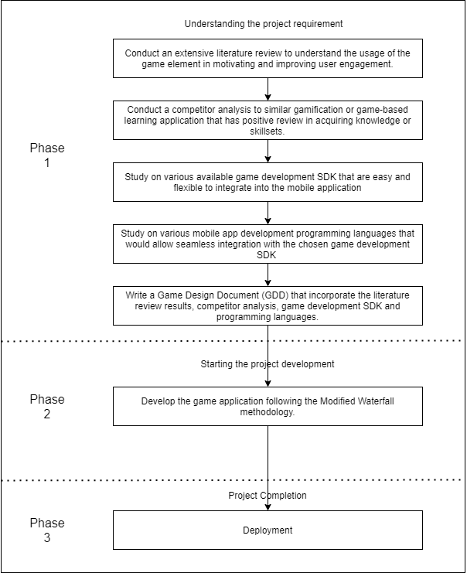

Figure shows the primary research plan.



Figure Modified waterfall methodology to fit the project requirement

The primary research plan involves designing and implementing a new learning environment for the use case diagram. The key idea of this project is to create an engaging learning environment that will help raise the modelling deficiency in the university. Therefore, understanding gaming personas and context characteristics are crucial to measuring this project's success metrics for a balanced strike between motivating and attraction grabbing against too dry, dull and technical.

First, the project plan and list of objectives are written in the Initial Allocation Forms. Then, the initial allocation forms will go through an initial proposal filtering that is the Go decision from the project panelist. After receiving the green light, the project conditions such as time constraints, budget, legal & ethical issues, desired actions and success criterion are listed and further discussed with the project supervisors.

The second is the user and context analysis. It will be focusing on defining the target audiences, identifying the target user needs, motivations and create their personas. In this project, to better understand the target users' motivations and preferences, a user persona survey containing the persona information such as gender, age, highest educational level, employment, and gaming preferences is distributed. Furthermore, to understand the context of gamification, an extensive literature review that covers areas such as psychology behind gamification, existing edutainment systems and game design mechanics are explored. In addition to the extensive literature review, there is also a justification of the game development SDK used to develop the application (Ng, et al., 2018).

The third is the ideation phase. The ideation phase is where brainstorming ideas and consolidating ideas happen. This phase takes all the user and context analysis to develop an idea for the upcoming design phase.

The fourth is the designing phase. After collecting ideas, concrete gamification designs are developed. This step is crucial and is related to the ideation phase (Jain, 2017). It will focus on elaborating "playable" prototypes to evaluate the effectiveness of a particular idea. Furthermore, the rapid development of a prototype using wireframes encourage an iterative design process.

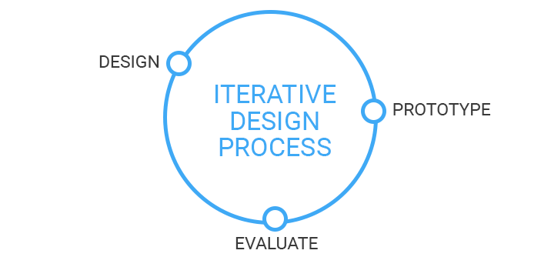

Figure Iterative product design

The fifth is the implementation phase. This phase will follow iterative procedure development cycles to ensure quick identification and assessment of technical issues when developing individual gamification solutions. With iterative model, it allows for small, simplified implementation and progressively gain more complex and broad feature set until the final system is complete (airbrake, 2016).

Lastly, the evaluation phase investigates whether the developed gamified applications met the predefined objectives from the first phase. Furthermore, a set of success metrics will be evaluated by the project panelist.

## Conclusion

The improvement in technology propels every field forwards. The educational field also receives many benefits. For example, students could browse the Internet for study materials. The class can be conducted online and offer an engaging learning environment for students via game-based learning. Therefore, the research question investigates existing game-based learning application and the structuring and element of the game application to apply the findings into the Bullfinch–Gamification of Use Case Diagram. As well as promoting continuous learning for the user even user is offline while developing a bite-size lesson for use case diagram. As a result of the successful implementation of Bullfinch, both primary and secondary targeted audience will benefit from extra learning materials available for learning use case diagram. Also included is the primary research plan that shows an overview of the project methodology.

The following section will include an extensive literature review and analysis on the existing game-based learning application to develop a Game Design Document and justification for choosing the game development framework.

# Abstract and Literature Review

## Abstract

The adoption of gamification in learning and instruction has mass appeal among the learners in stimulating motivation, engagements and social influence. This report applies the psychology behinds the game design elements to fulfil the basic psychological needs. These findings are interpreted as the direct support that gamification is effective as the specific game design elements have specific psychological effects. Therefore, the importance of applying the game design elements into an application is performed.

## Introduction

This section included an extensive literature review on gamification's user engagement and motivation to answer the research question proposed in the project. As well as look into the existing gamification/game-based learning platforms and apps to identify the game design elements used. It is essential to condense the information collected into a Game Design Document (GDD).

## Definition of gamification

Various definitions of game and elements, such as rules, structure, levels of participation, and certainty of the result, can change the essence of a game (Seaborn & Fels, 2015). Gamification is much easier to conceptualise if compared to the definition of a game. Game elements and game mechanics used in non-game contexts is interpreted as gamification (D., et al., 2015). In fact, (Landers & Callan, 2011) has developed an online social media network for the student to discuss and share learning experiences. It is crucial for the current study, and they introduced gamified online quizzes that offer social rewards as virtual badges upon quizzes completion. Their study found that most of the student reported the quiz as fun, enjoyable and rewarding after going through the gamified quizzes. However, the study by Landers and Callan failed to clarify that gamification led to higher student engagement or actual learning benefits if comparing to the non-gamified version.

Three years later, (Landers, 2014) reintroduce gamified learning as the critical mileage that aided subsequent studies to approach research on gamification in a structured manner. The core idea behind this theory is that gamification can improve existing instructional design either through moderation or mediation process. As (Bilgin & Gul, 2020) point out, it is essential to note that gamification is a combination of entertainment and serious games. The entertaining component of games applies to solve real-world problems within a gaming environment.

Table other definitions of gamification by various authors

|  |  |  |
| --- | --- | --- |
| **Author** | **Definition** | **Focus of definition** |
| (Zichermann, 2011) | Game thinking and game mechanics are used to engage users and solve problems. | Game design |
| (Zichermann & Linder, 2010) | Gamification is a tool for supplementing branding initiatives through the application of game elements and mechanics. | Game marketing |
| (Deterding, et al., 2011) | The use of video game elements in non-gaming systems to improve user experience and user engagement. | System perspective |
| (Gartner, 2013) | The use of game mechanics and experience design to digitally engage and motivate people to achieve their goals. | General process |
| (Werbach & Hunter, 2012) | The use of game elements and game-design techniques in non-game contexts. | Business approach |
| (Huotari & Hamari, 2017) | Enhancing a service with gameful experiences to support users overall value creation. | Service marketing |
| (Werbach, 2014) | Making activities more game-like. | General process |

Furthermore, as shown in Table 1, gamification shares these contexts: 'by applying game elements', 'in non-game areas', and 'providing the users with the benefits.' Therefore, as shown by (Sigala, 2015), "Although the definitions vary in prominence, they all include both a systemic component defining how the game is constructed (e.g., the use of game mechanism) and an experiential component describing the human involvement and outcomes within the game". Along that line, this project aims to use gamification to promote behaviours (e.g. student motivation, participation and collaboration, and more) that make learning delightful and allow the students to gain and apply knowledge better. With the correct implementation, the effectiveness of the learner characteristics and the context will be as practical as the game design (Bilgin & Gul, 2020), (Buckly & Doyle, 2017), (Hamari, et al., 2014).

## Theoretical background and framework

Gamification has developed itself in various non-game related fields (Deterding, et al., 2011). Nonetheless, there is a limited theoretical framework for defining and analysing gamification (Seaborn & Fels, 2015). Namely, (Aparicio, et al., 2012) adopted the concept of autonomy, competition, and relatedness basing on self-determination theory (Ryan & Deci, 2000). Their framework consists of four steps. First, identify the main objective. Second, identify the traversal objective. Third, determine the game mechanics. Fourth, evaluation of the framework for the applied system.

Additionally, (I. Blohm, 2013) and (Nicholson, 2013) proposed a meaningful gamification strategy and framework for game design elements based on the Intrinsic and Extrinsic Motivation theory (Ryan & Deci, 2000). Specifically, Nicholson proposed a continuum of motivation mediated by internal and external control based on organisational integration theory, a sub-theory of self-determination theory in gamification (Ryan, et al., 1997). According to (Nicholson, 2013), the game elements that is meaningful to users can induce intrinsic motivation regardless of external rewards, and the users can decide what is meaningful for them. Furthermore, the report also highlights the importance of the gamified context while matching the user's background and the gamified settings through the concept of situated motivational affirmance (Deterding, 2011).

Admittedly, this analysis was conducted to identify the successful game design that can align well with the established learning theories. Procedurally, this theoretical model helps to frame the research questions. On the other hand, this analysis attempted to answer research question two regarding the underlying structure of theoretical models for game elements to improve engagement and motivate users. Table 2 listed the learning theories applicable to the gamification model. It has 19 articles that made implicit mention of their theoretical foundations, whilst the remaining articles had no theoretical content. For example, (Albuquerque, et al., 2017) conducted an experimental study in an online gamified educational environment that tapped the foundations of educational theory for online learning. In comparison, (Chang & Wei, 2016) does not provide a conceptual framework based on a theoretical foundation. While, the use of, the concept of reputation points, commonly adopted by eBay and Amazon.com, was used to increase system reliability and learner engagement in a massive online course (MOOC).

Table learning theoretical background and framework applied in the gamification studies.

|  |  |  |
| --- | --- | --- |
| **No.** | **Learning Theories/Models** | **Studies** |
| 1. | Self-determination theory | (Aldemir, et al., 2018), (Baydas & Cicek, 2019), (Ding, et al., 2017), (Huang & Hew, 2018), (Huang, et al., 2019), (Jurgelaitis, et al., 2019), (Kuo & Chuang, 2016), (Lo & Hew, 2018), (Lopez & Tucker, 2019), (Mekler, et al., 2017), (Tsay, et al., 2018), (Roy & Zaman, 2018), (Zainuddin, 2018) |
| 2. | Flow theory | (Huang & Hew, 2018), (Jagušt, et al., 2018), (Jurgelaitis, et al., 2019), (Rachels & Rockinson-Szapkiw, 2018) |
| 3. | Goal-setting theory | (Groening & Binnewies, 2019), (Huang & Hew, 2018), (Huang, et al., 2019) |

In Table 2, SDT was found to be the salient theoretical framework of these 13 gamification studies. Furthermore, SDT offers students the three innate psychological needs that support by the internal factors of motivation, such as a sense of autonomy, competence and relatedness (Buil, et al., 2020), (T. Nishihara, 2020). It emphasises that satisfying students' three innate psychological needs reinforce students' intrinsic motivation. The more these needs are satisfied, the greater the intrinsic motivation that arises in gamified activities. Also, (Buil, et al., 2020) provides empirical evidence based on SDT that uses various game design elements to motivate students' and satisfy their need for competence, autonomy and relatedness, shown in Figure 3.

Figure Matching psychological needs (SDT) to game design elements.

The second most common theory in gamification research is flow theory, which is proposed by (Csikszentmihalyi, 1990) which is describe the people who are deeply immersed in a challenging activity can experience the 'flow'. The 'flow' can be explained as the heightened focus and immersion that can be achieved by developing higher skills. Furthermore, to enter flow from a control state, an increase in the challenge is required (Csikszentmihalyi, 2008).

The goal-setting theory has also been adopted in some studies. For example, (Groening & Binnewies, 2019) found that digital achievements provide a goal-setting function in line with the goal-setting theory and hypothesis that a more formidable goal can direct users to a high level of motivation and better performance.

To summarise, although different in forms, three things are commonly found in the theoretical background. First, design elements to engage the users; second, the use of Self-Determination Theory (SDT) for internal and external motivation process; third, framework proposal for gamification development and design.

## Game design

Gamification covers a broad spectrum of fields, and it includes designing the game mechanics in the application. Instead of blindly designing the game mechanics, this section investigates the definition of the commonly used game mechanics and game design elements.



### Game mechanics

Game mechanics are the basic building blocks of gamification applications (Deterding, et al., 2011), (Werbach & Hunter, 2012). Game mechanics means procedures and rules applied in a game. It explains the goals of the game and the methods and constraints to achieve them. They are mainly equivalent with game design patterns (Björk & Holopainen, 2004), (Kelle, et al., 2013). Furthermore, in the context of games and gamification, many authors have proposed the compilations of recurring game design elements (Kapp, 2012), (Robinson & Bellotti, 2013), (Werbach & Hunter, 2012), (Werbach & Hunter, 2015), (Zichermann & Cunningham, 2011), (Zichermann & Linder, 2010). Accordingly, there have been several discussions about the definition of game mechanics.

For instance, (Werbach & Hunter, 2012) identify 15 essential game mechanic elements: *avatars, badges, leaderboards, points, and teams.* Primarily, they highlight the so-called "PBL Triad"-the interplay of *points, badges* and *leaderboards*, which they consider characteristics of gamified applications (Werbach & Hunter, 2012). (Zichermann & Cunningham, 2011) proposed the game mechanic elements that include *points, badges, levels, challenges, leaderboards, on-boarding, social engagement loops, and feedback*. While (Bunchball, 2016) organised game mechanics into six elements: *points, levels, challenges, virtual goods, leaderboards, gifts,* and *charity*. (Kim, 2015) has prepared a list of helpful game mechanics in three categories: behavioural, feedback, and progression, and presented sub-items in Table 3 and Table 4.

Table 3 Game mechanics adapted from (Xu, 2012)

|  |  |  |
| --- | --- | --- |
| **Types** | **Mechanics** | **Examples/Description** |
| Progression | Achievements | Badge when completed something |
| Levels | Cumulation of points |
| Points | A numerical value for actions |
| Progression | A progress bar |
| Feedback | Appointment Dynamics | User's return for a positive effect |
| Bonus | A reward for challenges/tasks |
| Cascading Information | Information released for understanding |
| Combo | Reward skill through doing a combination of things |
| Countdown | A certain amount of time to do something |
| Quests/Challenges | A time limit or competition/a journey of obstacles |
| Reward Schedules | Timeframe for the rewards, contingency, response, etc. |
| Behavioral | Discovery/Exploration | Players love to discover and to be surprised |
| Epic Meaning | Motivated when achieve something great |
| Free Lunch | Something for free |
| Infinite Gameplay | Do not have an explicit end |
| Loss Aversion | An action to avoid losing something they currently have |
| Lottery | The winner is determined by chance |
| Ownership | Creates loyalty by owning things |
| Community Collaboration | Work together to solve a riddle, a problem or a challenge |
| Behavioural Momentum | A tendency to keep doing what they have been doing |
| Blissful Productivity | Playing hard rather than relaxing makes you happier |
| Status | The rank or level of a player |
| Urgent Optimism | Tackle an obstacle with a reasonable hope of success |
| Virality | Successful when you invite friends/the social check-in |

Table 4 game elements & terminology (Seaborn & Fels, 2015)

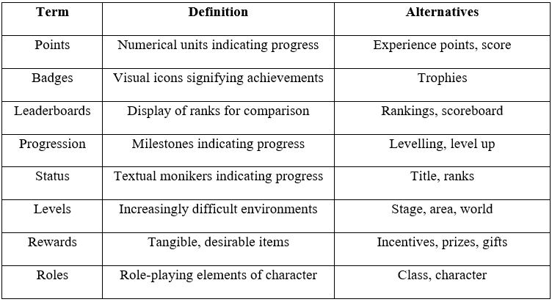

(Frasca, 2004) set definitions for two dimensions game designers must consider. Firstly, Ludus, meaning more "game-like," incorporates strict rules defining a winning and a loser. Secondly, Paidia is a more "play-like" element, but not strict ones that "define a winner and a loser." (Brathwaite & Schreiber, 2009) presented eight essential components: *players, game bits, game mechanics, game dynamics, goals, themes, game space,* and *game state.* (Schell, 2008) included four concepts: *mechanics, story, aesthetics (graphic & sound),* and *technology*. (Rollings & Morris, 2004) proposed five game-planning essentials: *interface, level design, game elements, rules,* and *gameplay*.

The elements the prior studies share is "the rules." Rules are the formal structure of a game, and rules define the overall formation (Salen, et al., 2004). In other words, the game mechanism means the basic operating principles of the game. Furthermore, rules are the original elements of a game that distinguish it from other activities or media. Understanding the rules that urge the users to take specific actions can explain the game's motivational mechanisms.

### Game element



Game elements differ from game mechanics. The game element delivers information to the players and usually appears in a user interface (Xu, 2012). Game elements are related to each other and may have similar names, even if they are not identical. The focus on these selections of elements such as *points*, *badges*, *leaderboards*, *performance graphs*, *meaningful stories*, *avatars*, and *teammates* is based on matching the game design elements to the psychological needs (Sailer, et al., 2017). The most representative game elements can be summed up as follows.

A point is a numeric unit that indicates the game progression. Similar terms include Experience points or Scores. It is the information provided to the player in line with game progression. Scores usually appear through Leaderboards. A badge is a form of virtual goods earned according to the player's performance during the game. Receiving, presenting, and donating virtual goods through the game can be viewed as a reward. (Zichermann, 2011) argues that money, the extrinsic motivator, can improve performance in the short term, but it can also reduce intrinsic motivation. Therefore, gamification designers must consider intrinsic and extrinsic motives. And besides the monetary and non-monetary incentives.

It is essential to present the players with clear goals and status changes so that overall progression does not feel dull. Progress level or Level up is one way to do it, and Challenges are dyadic to them. Title or Rank is another name for Status. Rewards, Roles, and Characters are also essential game elements.

## Educational Gamification Platforms and Apps

There are many education platforms and apps that incorporated game-based elements in order to boost engagement and get successful results. The educational gamification platforms and application in this section refer to interactive online services that create virtual spaces for information sharing—for example, a learning management system (LMS) or game-based learning platform.

In line with one of the research questions, the following table summarises analysis performed to identify the platforms and apps used in gamification research. The following has summarised 33 analysed papers that described studies that used existing platforms from various sources.

Table Adapted gamification platforms

|  |  |
| --- | --- |
| **Name of platform** | **Studies** |
| ClassDojo and ClassBadges | (Seixas, et al., 2016) |
| Ribbonhero of Microsoft | (de-Marcos, et al., 2016) |
| Rain classroom | (Ge, 2018) |
| Quizbot | (Garcia-Sanjuan, et al., 2018) |
| Duolingo | (Rachels & Rockinson-Szapkiw, 2018) |
| Kahoot and Quizizz | (Göksün & Gürsoy, 2019), (Baydas & Cicek, 2017) |
| Math Widgets | (Jagušt, et al., 2018) |
| Google + Communities | (Roy & Zaman, 2018) |
| iSpring Learn LMS | (Zainuddin, 2018) |

Furthermore, some studies have highlighted integrating game-based elements into the learning management system (LMS) as a positive fortification strategy to motivate and engage students in gamified learning. Such as, with integrating gamification using Web 2.0 tools, these technological solutions offered a new feature for Massive Open Online Courses (MOOCs) (Coursera, Udacity, and edX) (Aparicio, et al., 2019), wiki platforms (Özdener, 2018), moodle platforms or institutional LMS (Huang & Hew, 2018), (Huang, et al., 2019), (M. Jurgelaitis, 2019), (Lo & Hew, 2018).

Likewise, some studies developed their gamification platforms to prioritise user-centric needs and provide an impactful online experience for their users. Thus, these platforms promote students' learning performance and engagement (M.S. Kuo, 2016), participation in online discussion using the gamified tool 'gEchoLu' (Ding, et al., 2017), (Ding, et al., 2018), (Ding, 2019) and their involvement in online post-lecture questions (Bouchrika, et al., 2019).



### Game element used

The terms' game elements' and 'mechanics' have been used regularly in gamification research. This project believes that reviewing the main game components used in gamified learning and instruction is essential. Hence, this section briefly concludes the most common game principles in the 33 studies analysed. (Refer to the appendix for the list of game elements identified in the analysed articled) This analysis can serve as a reference point for both reader and researchers regarding which game elements can and should be implemented in their studies and guide informed debate. As a result, all the most used game mechanics were points, leaderboards and badges in Figure 4.

Figure summary of game mechanics most commonly used in the studies of gamification

## Game Development tools and programming language for mobile game development

Unity is a cross-platform game engine developed by Unity Technologies (Unity Technologies, 2021). It is used for creating games, app, interactive stories and art, visualisations, films, architecture and much more. Furthermore, Unity has a significant market share of 71% out of the top 1000 mobile games globally, with over 2.7 billion active users per month, run over 20 different platforms in the year 2020 (Unity Technologies, 2021).

Instead of creating code that runs the application, Unity allows developers to focus the gameplay in the scripts. The scripts must be attached to a GameObject, in order to tell the GameObjects how to behave. In addition, the script is written with a programming language called C# (pronounced C-sharp) (Unity Technologies, 2021).

Unity has four types of licensing plan, such as Personal, Plus, Pro, Enterprise. Each of them offers extra/lesser features depending on the plan. However, this project will use a personal plan. For a personal plan, it is eligible if the revenue or funding is less than $100K (~411,880 MYR) in the last 12 months. It retains the core functionality required to develop an application, such as Bolt visual scripting and core Unity real-time development platform (Unity Technologies, 2021). The bolt visual scripting enables the user to create logic for games or application without writing code (Unity Technologies, 2021). To summarise, the user would have to design a logic based on visual or unit-based graphical elements to create a prototype quickly. The core unity real-time development platform is the Unity Platform application.

In conclusion, Unity is a good engine for beginners with its significant market share in mobile games. A large market share indirectly means large communities, so the information is readily available in the forum, knowledge base and third-party website. Furthermore, Unity became much more beginner-friendly with the support of Bolt's visual scripting tools, as both programmer and non-programmer can design final logic or quickly create prototypes.

## Game Design Document

This section condensed a game design document that contains the required game mechanics and game design elements identified from previous sections. Furthermore, this section discusses designing game elements that follow the underlying psychological dynamics that make games and gamification engaging to users.



### Matching psychological needs to game design elements

With the facts that the perspective of self-determination has been successfully applied in the context of games (Przybylski, et al., 2010), (Rigby & Przybylski, 2009), it also emphasises the importance of the environment in fostering motivation (Deci & Vansteenkiste, 2004).

Self-determination theory stated that there are three basic psychological and intrinsic needs. First is the need for competence, autonomy, and social relatedness (Deci & Ryan, 1985), (Ryan & Deci, 2002). It can be explained:

1. *The need for competence* refers to efficiency and success while interacting with the environment (Vansteenkiste & Richard M. Ryan, 2013), (Rigby & Ryan, 2011). In order to feel competent, human influences the environment they are in deliberately. Therefore, this project assumes *the need for competence* can be addressed by points, performance graphs, badges or leaderboards (Sailer, et al., 2013). In order to provide granular feedback, *points* can affix with the player's action directly. *Performance graphs* visually indicate the player's progress over time, thereby providing sustained feedback. *Leaderboards* and *badges* are used to provide cumulative feedback by evaluating a series of player's action (Rigby & Ryan, 2011).
2. *The need for autonomy* refers to psychological freedom and volition to fulfil a specific task (Vansteenkiste, et al., 2012). Although psychological freedom refers to making decisions based on one's values and interest (Deci & Ryan, 2012), volition refers to the feeling of acting without external pressure or enforcement (Vansteenkiste, et al., 2010). Hence, autonomy touch on both to experienced *(i) decision freedom,* which implies being able to select between several routes of action. So *avatars* are relevant because they offer players freedom of choice (Peng, et al., 2012). *(ii) Task meaningfulness,* which implies that the course of manoeuvre at hand conforms with one's own goals and attitudes. Thus, *stories* play an important role, as a story can help players experience their actions as meaningful and volitionally engaging, regardless of whether choices are available (Rigby & Ryan, 2011).
3. *The need for social relatedness* refers to one's feeling of belonging, attachment, and care concerning a group of significant others. It is the basic craving of a human to integrate appropriately with the social environment (Deci & Vansteenkiste, 2004), (Ryan & Deci, 2000), (Deci & Ryan, 1985). As a result, *stories* can affect players' feeling of belongings as it offers a narrative frame in which the player is given a meaningful role. Bundled with *teammates*, who can be real co-players or non-playable characters, a sense of relevance can be evoked by emphasising the importance of the players' actions for the group's performance (Rigby & Ryan, 2011), (Groh, 2012). A shared goal, which can be conveyed within a meaningful story, can also foster experiences of social relatedness (Sailer, et al., 2013).

Specific game design elements can address a summary of the above arguments concerning the different psychological needs is shown in Table 6.

Table psychological needs with matching game design elements.

|  |  |  |
| --- | --- | --- |
| **Psychological need** | **Mechanism** | **Game design element** |
| Need for competence | Granular feedback | Points |
| Sustained feedback | Performance graph |
| Cumulative feedback | Badges |
| Cumulative feedback | Leaderboards |
| Need for autonomy (decision freedom) | Choices | Avatars |
| Need for autonomy (task meaningfulness) | Volitional engagement | Meaningful Stories |
| Need for social relatedness | Sense of relevance | Teammates |
| Shared goal | Meaningful Stories |

To summarise, according to Table 6, in this project, the game design elements that are going to implement in the application are *points, performance graph, badges, leaderboards, avatars, meaningful stories* and *teammates*. Furthermore, game design elements such as *levels* and *trophies* can be integrated into the application. It was the 4th and fifth-most game design elements used, according to Figure 4.

## Conclusion

This literature review section covers the context analysis that aims to answer the research questions in the previous sections. Furthermore, it helps to form the initial ideas of what is gamification. For example, in a different field, applying gamification elements into non-game contexts can improve existing instructional design and retain user interest.

Additionally, the underlying psychology elements are embedded within the game design elements to keep the user engaged and motivated. For example, offering innate psychological that provide a sense of autonomy, competence, and relatedness can boost the user's motivation.

Furthermore, the usage for each game mechanics and game elements are explored in a more profound understanding to implement it in the project correctly. It is also found that many educational platforms such as Coursera, eduX, Udacity offers gamification as a part of their MOOCs solutions.

Since the tools are essential for development, it is essential to choose a high reputation and covers significant market share to have easier access to community supports. There are multiple game development SDK in the market. However, Unity Game Development offers an easy jump start for a new game developer with their comprehensive knowledge base and community forum.

Lastly, combining all the factors above is crucial in writing a GDD for the initial design idea. Matching the psychological dynamics to the game design elements will keep the games and gamification engaging to users, thus reducing the software's risk of failure.

The upcoming section will discuss in-depth project management. Mainly on the research methodology and the implementation methods.

# Research Methodology

## Introduction

As mentioned in Section 1.9 Primary Research Plan, the methodology being implemented is the modified waterfall model. The original waterfall model has been changed to add a feedback system (Prashant, 2021). However, due to the time constraint nature of this project, the feedback system was only added at the Design, Implementation, and Evaluation & Monitoring. Furthermore, for an easier time understanding the feedback system, an iterative model was used to visualize that part.

## Project Preparation

During this stage, the initial requirement will be composed of a proposal. The proposal includes a rough expected delivery of the project, available features, and rough planning of where to start. Then the proposal is submitted to the panelist and approved.

During this stage, a project plan is prepared. The main purpose of this phase is to identify and clarify the objectives of the project. Therefore, prior to submitting the Initial Allocation Form, objectives are being discussed with the project supervisor to rank the importance. Furthermore, the objectives are being tweaked to fit SMART (Specific, Measurable, Achievable. Relevant, and Time-Bound) goals (Boogaard, 2021). For example, during the initial stage of listing out the objective, one of the objectives was "To allow user/developer to visually represent their concept by using available UML diagram.". However, it does not fulfill the "Specific," "Measurable," and "Time-Bound" goals, as the UML diagram is a large topic to cover, hard to measure, and not time-bound due to being a large topic to cover. After tweaking, the new objective was "To develop one bite-size use case diagram lesson by applying the concept of gamification.", which improved the initial inefficiency of the objective to fulfill the "Specific," "Measurable," and "Time-Bound" goals.

## User and Context Analysis

During this stage, a profound understanding of the target audience of the gamified project, as well as the context characteristics of the software.

During this stage, a profound understanding of the target audience and the contextual characteristics of the gamified project was collected. For the context-specific analysis, a significant effort was put into understanding the behavioral change and improving the player engagement. Additionally, a portion of the effort was put into understanding the target audience, separated into user group segmentation, and determining the general user characteristics, user and motivational needs, such as competence satisfaction (Huotari & Hamari, 2017).

### Context Analysis

A literature review is conducted to aid in achieving the project's objective. The literature review is arranged from the definition of gamification to understand better the underlying concept of gamification. Then the theoretical background and framework were reviewed to find the propeller for reinforcing the user's intrinsic motivation to be applied in the project. Next, the game design's mechanics and elements from different reports were identified and extracted to form Table 3 and Table 4. This helps to identify which game design mechanics and elements to include in the project. Also, 33 studies were analyzed to determine the top few most game elements used by the existing educational gamification platform. Lastly, game design elements were matched with the psychological factors behind self-determination theory to foster motivation and engagement to the user.

As a result, a survey containing the scale of 1 (Strongly disagree) – 5 (Strongly agree) was launched with questions crafted to determine the game persona of users around the same age.

### User Analysis

User analysis focused on the definition and the characterization of the target audience. In this project, the survey methods are used to collect and analyze information about the target audience. The survey was done online via Google Forms, and all the result was kept on personal Google Drive. Therefore, the data obtained from participants will not be retained by any third-party personnel and can be easily disposed of.

#### Survey Form

The survey launched via Google Forms garnered 63 responses in total. However, only 61 were usable because two people chose not to share their info. There is 3 section in the survey, and the first part was the acknowledgment notice for the usage of personal data. The first section is required because of the Malaysia Personal Data Protection Act (2010) (Department of Personal Data Protection, 2010). The following section is the personal information that includes gender, age, highest educational level, and employment. This second section is required for the Player Persona Template (Kumar, et al., 2020), which will provide the project with an understanding of the target audience. The last section is to determine the game personas based on the preference of game design elements in-game. It is essential to visualize the player persona to communicate the player needs in gamification projects. A variant of the user persona provides a valuable starting point and can be customized to meet the need of the gamification project.

The first part of the survey form is shown in Figure 6, which consists of the survey's objective, the personnel involved in the survey, and notice of acknowledgment for the data processing. Participants would be required to acknowledge that their data will be used for the project, only proceeding with the next section.

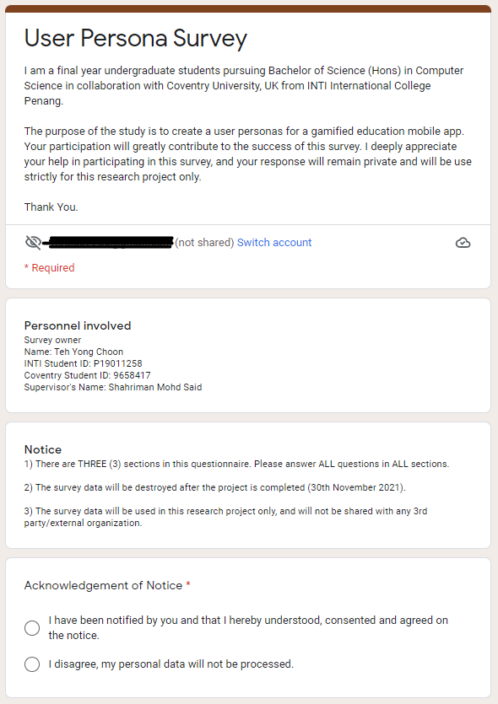

Figure shows the acknowledgment notice for the data being processed by the survey.

The next part of the survey in Figure 7 collects data to characterize the target user group. The data collected are gender because gender can massively affect gaming preferences. Age is vital as each generation has different needs in their game. Since the target audience was initially set to be college students, the educational level was taken into account. For employment, there are many differentiations because the pain points can represent the troubles that the player encounters (Kumar, et al., 2020).

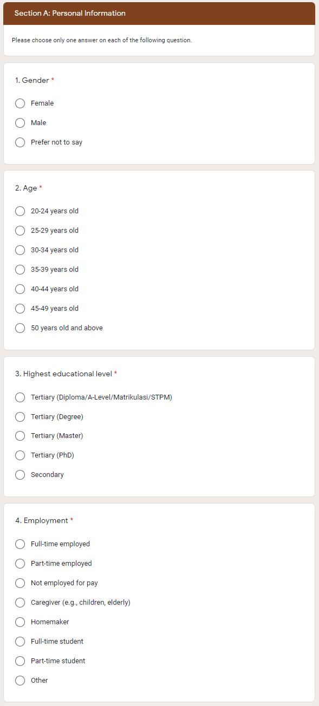

Figure shows the question ask in the survey to target the target audience demographics.

Section B of the surveys, shown in Figures 8, 9 and 10, asks general user needs and motivations in a game (Deterding, 2015; Huotari & Hamari, 2017). For example, with the result, it will be easier to implement the competence satisfactions for users based on the game element they like.

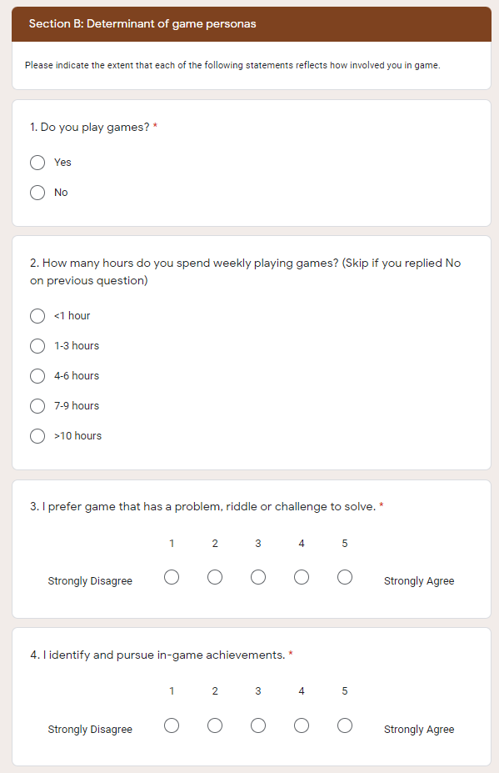

Figure shows first 4 question of the section B.

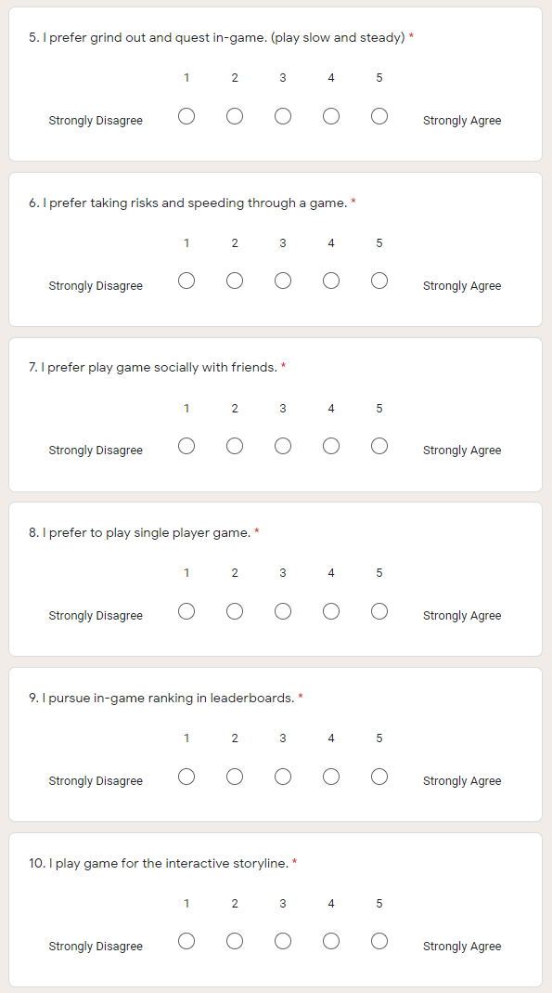

Figure shows the subsequent 6 question in section B.

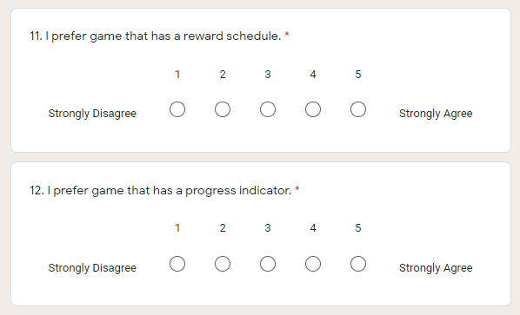

Figure shows the last two question in section B.

#### Survey Results

##### Acknowledgment of Notice

Out of 63 responses, 2 of the respondents did not agree to share their data. The way the survey was programmed, once the respondent chose not to share their data, they will be disqualified from the survey. This choice is made due to the Personal Data Act Protection Act 2010 because every question asked in this survey is all personal data.

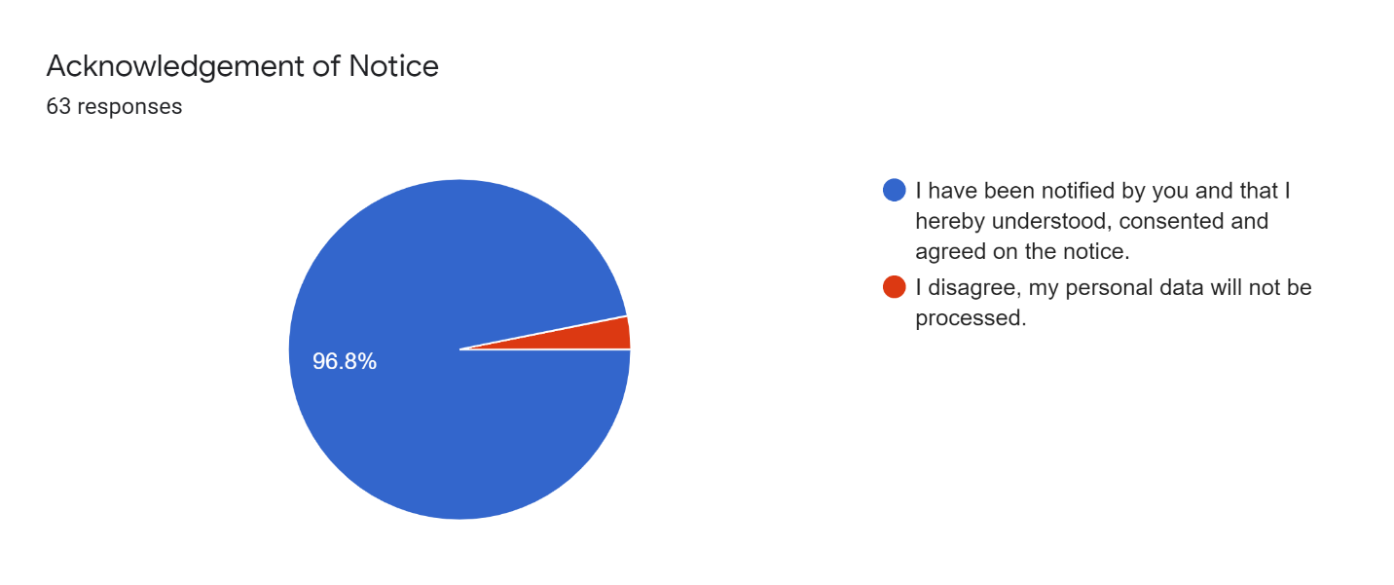

Figure shows the Acknowledgement of Notice pie chart from the response of the respondent.

##### Section A: Personal Information

The personal information was collected with the sole purpose of creating a proper segmentation and description for the target audience. It will be used to create personas (fictional characters that represent the specific user types). From Figure 12, there are 68.9% respondent are male, and 31.1% are female. From this question, the result from the next section might be skewed toward male preferences.

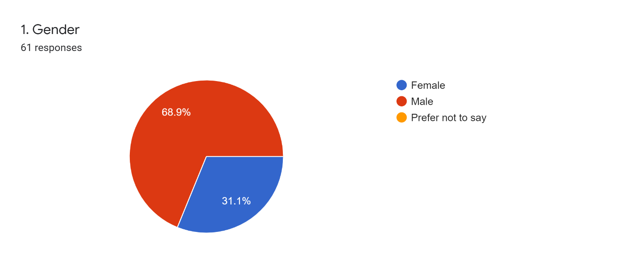

Figure shows the percentage of male and female respondents.

Age was the next vital factor to decide on the user persona. So again, age is an essential factor. With our target audience mainly targeting college students, 43 respondents are from the age gap 20-24 years old. Therefore it is excellent to gauge their preferences toward game elements in the next section to create a game persona.

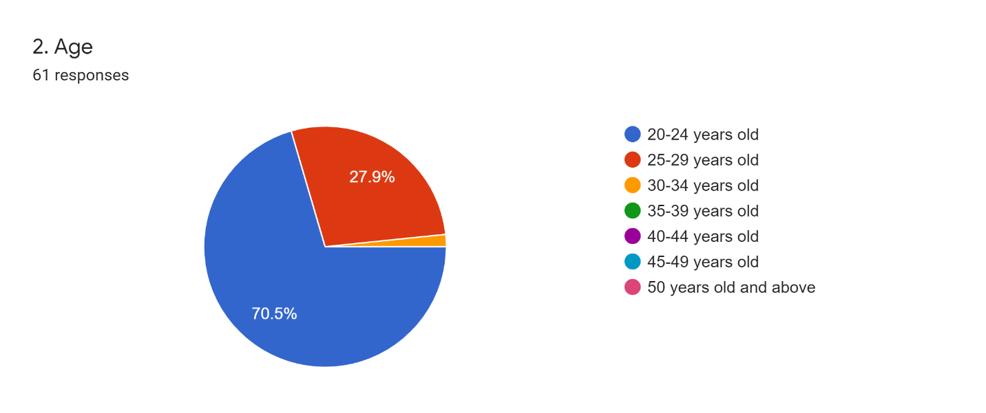

Figure shows the age group for our respondent.

From the highest educational level questions, it is found that every respondent is at least completed tertiary education. This is a great finding that shows the relevancy of the survey in targeting our target audience segment.

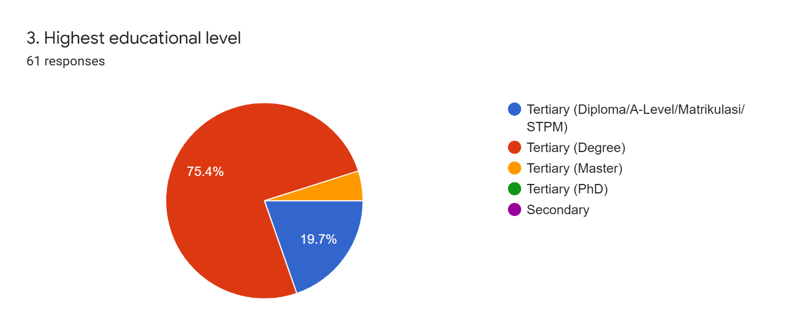

Figure shows the survey respondents' highest educational level.

The employment question shows that at least 30% of the respondent are full-time employed, but at least 65% are full-time students. Therefore, there are many choices available for the respondent to choose. Because due to different environments, the respondent's ways of relieving stress or their pain-point might be different (Kumar, et al., 2020). Therefore, it is better to have a large pool of choices.

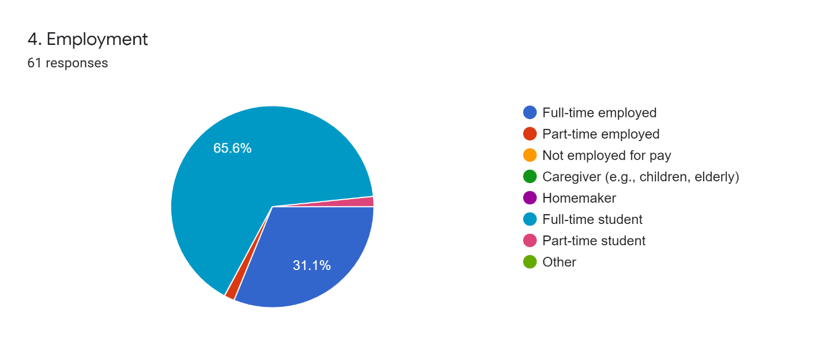

Figure shows the survey respondents' employment.

##### Section B: Determinant of game personas

Start with a question that asks whether our respondent spent time playing a game. Unfortunately, it has unexpected six respondents who did not play games. Therefore, the next question will have six fewer responses.

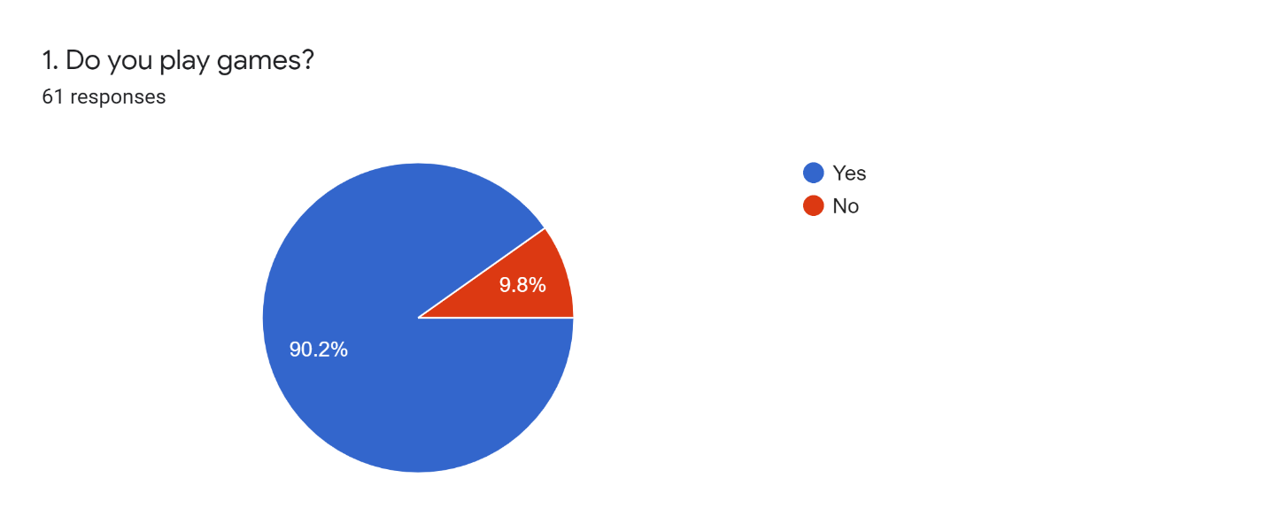

Figure shows the result of the survey whether respondent in playing games.

From the response in Figure 17, more than 40% of respondents spent more than 10hours weekly playing games. The difference between the largest and second-largest quadrant was 22.8%, and there is at least a 10-hour difference in time spent playing a game.

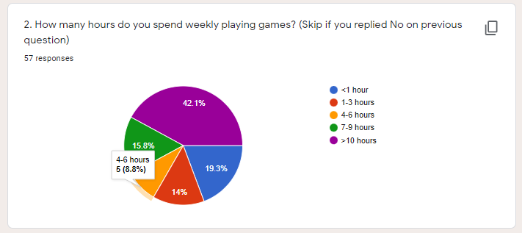

Figure shows the average time respondents spent weekly playing games.

The response in Figure 18 can be interpreted as the respondent would not like a game without a challenge. However, with the result is center-skewed, it can be assumed that most of our respondents prefer moderate difficulty rather than the challenge being too easy.

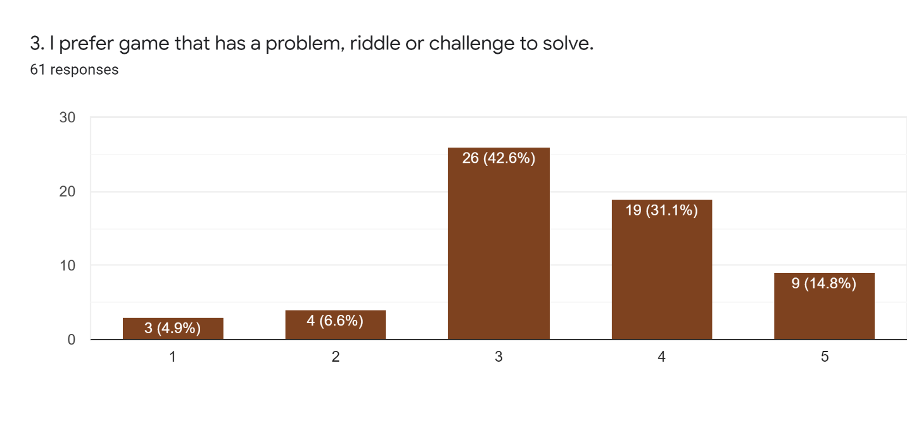

Figure shows whether respondents prefer a game that has a problem riddle or challenge.

From Figure 19, the graph is right-skewed. However, it shows that the survey respondent would prefer to pursue in-game achievements. Therefore, it would be wise to include some in-game achievement that is identifiable and achievable to fulfill our respondent's psychological needs.

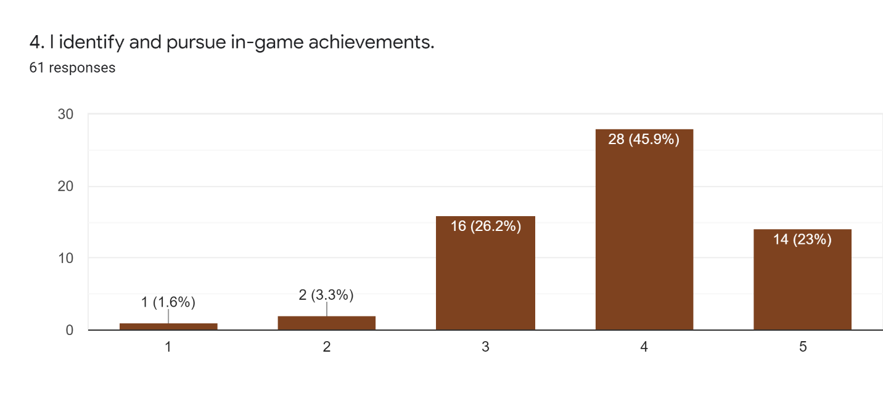

Figure shows whether the respondent pursue in-game achievement.

From Figure 20 and Figure 21, it would appear that the survey respondent is inconclusive about playing the game slow or taking a risk and speeding through a game. However, from Figure 20, it is slightly right-skewed, while Figure 21 is center skewed. From the pattern shown, it can be assumed that the respondent is looking for a game that has a pace to it without being too grindy and can still take some risk to speed through the game. Therefore, this game project must balance the right amount of challenge and be too grindy.

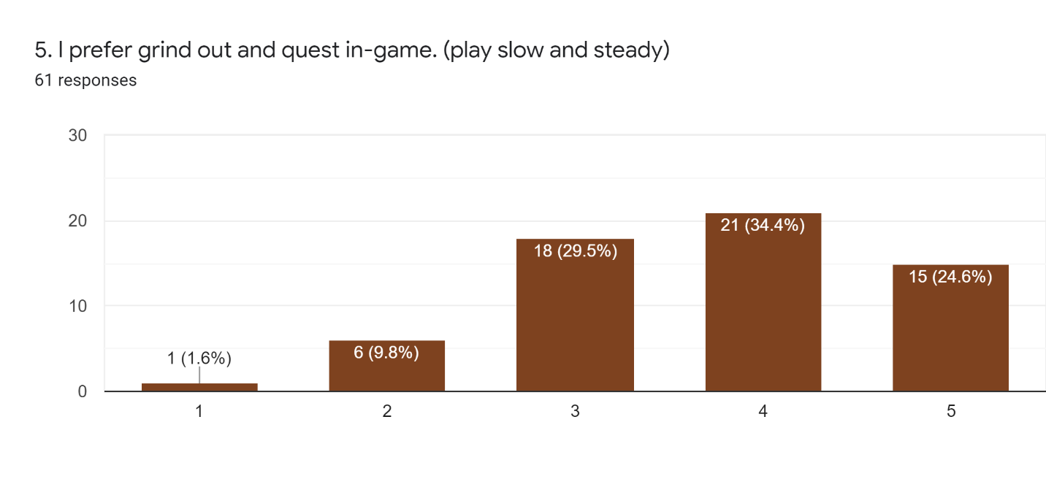

Figure shows whether the respondent prefers grinding a game.

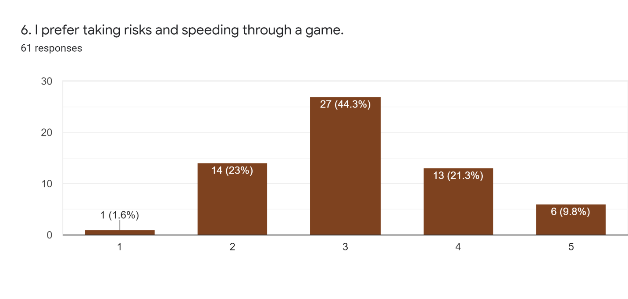

Figure shows the preference of survey respondents in taking a risk in a game.

From Figure 22, the response collected from the survey is skewed to the right. This response can be interpreted as the respondent would prefer to play the game socially with friends. To play the game socially with friends, there are a few ways to achieve it. This will be explored during the ideation phase.

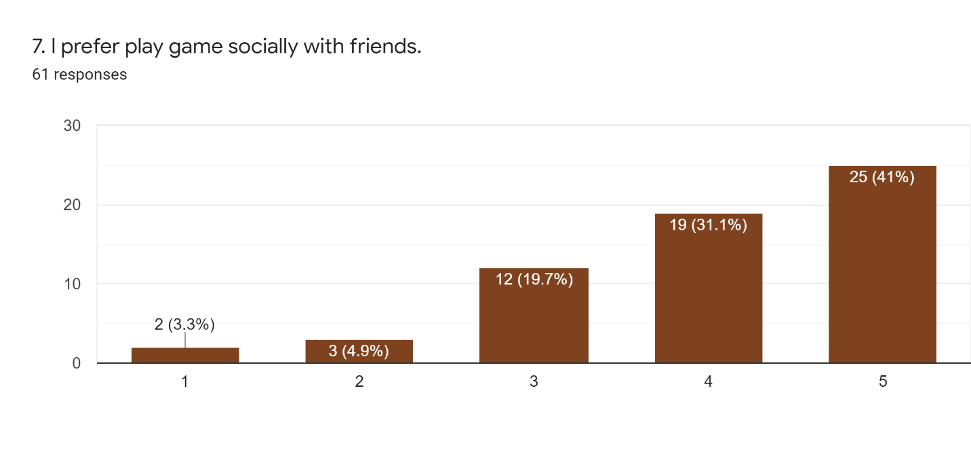

Figure shows that our respondents would love playing games socially with friends.

From Figure 23, the result is not directly in contrast to Figure 22. However, from the center-skewness, it would appear that the respondent is indecisive whether they prefer to play a game as a single player. This situation can be further accessed in the ideation phase.

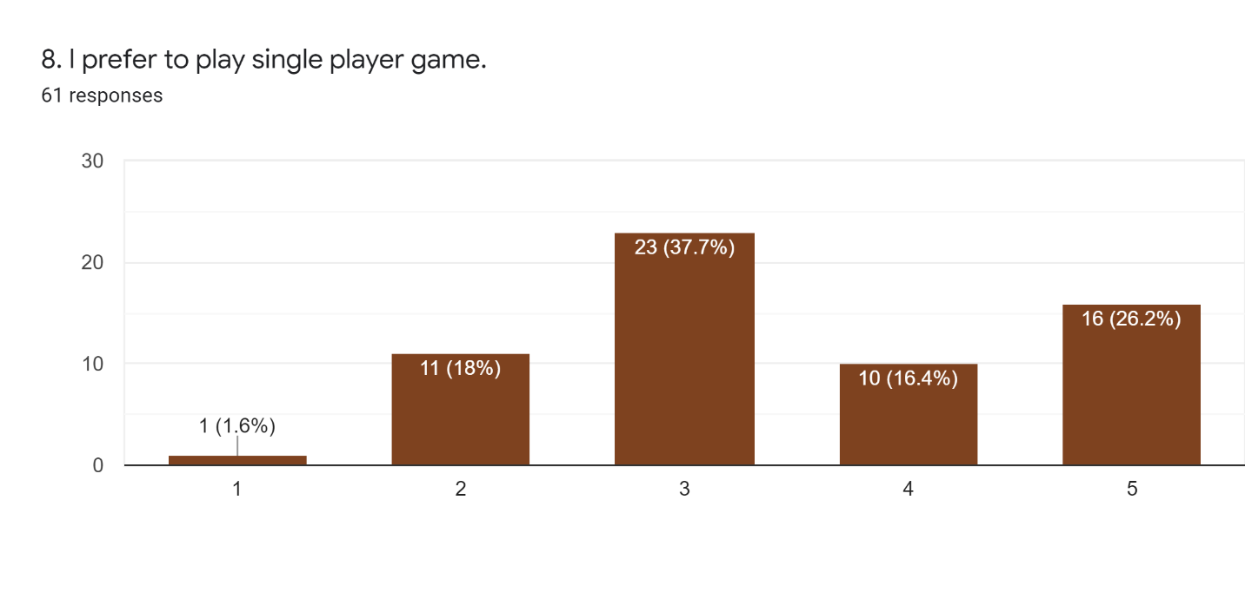

Figure shows the preference of survey respondents against the single-player game.

From Figure 24, the response for pursuing in-game ranking in leaderboards across all choices except "Strongly Disagree" is at a minor 5-6% difference. This result can be deduced from the competitiveness of the respondent. Therefore, there is a need to address how in-game leaderboards are being applied to the game project.

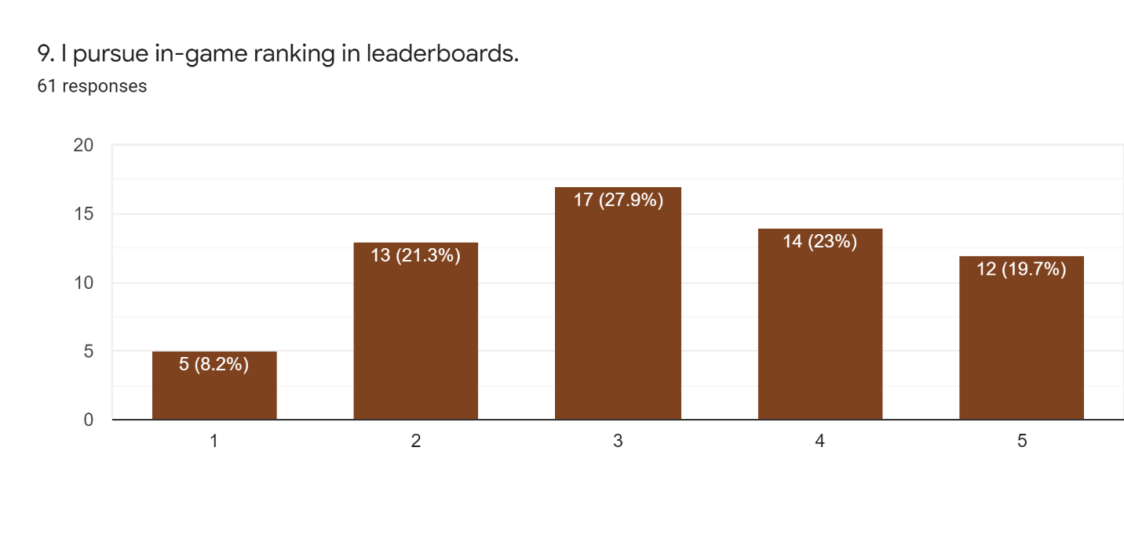

Figure shows whether our survey respondents prefer in-game leaderboards.

From Figure 25, many respondents like to play a game with an interactive storyline. This could be achieved by including quest, Non-Playable Characters with a narrative storyline that can represent story-telling (Milne, 2021).

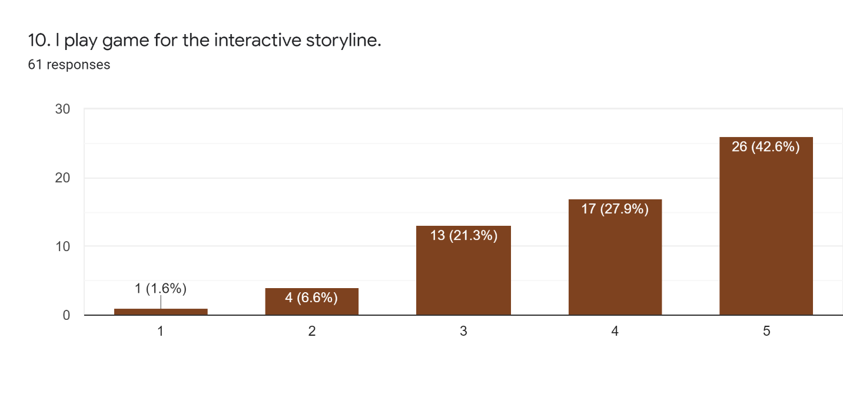

Figure 25 shows whether the respondent likes interactive storylines.

A game with a reward schedule is highly preferred by the respondent from the survey, as shown in Figure 26. Therefore, there is a need to implement a reward schedule to encourage players to come back to the game or motivate the player to complete the game.

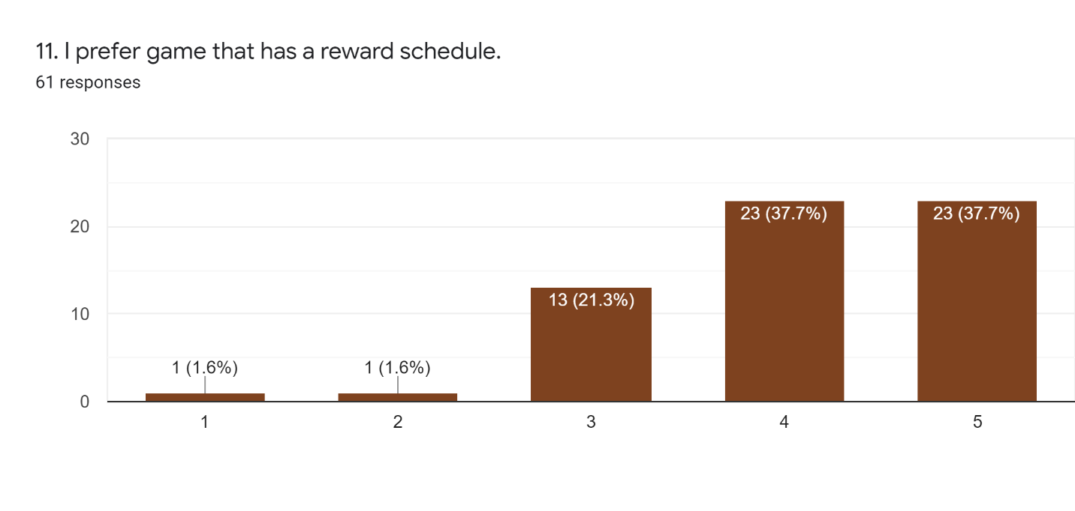

Figure 26 shows the preference of the respondent towards the rewards schedule.

Figure 27 shows that the respondent would like to have a clear progress indicator. Therefore, it is worthwhile to have a look into this during the ideation phase.

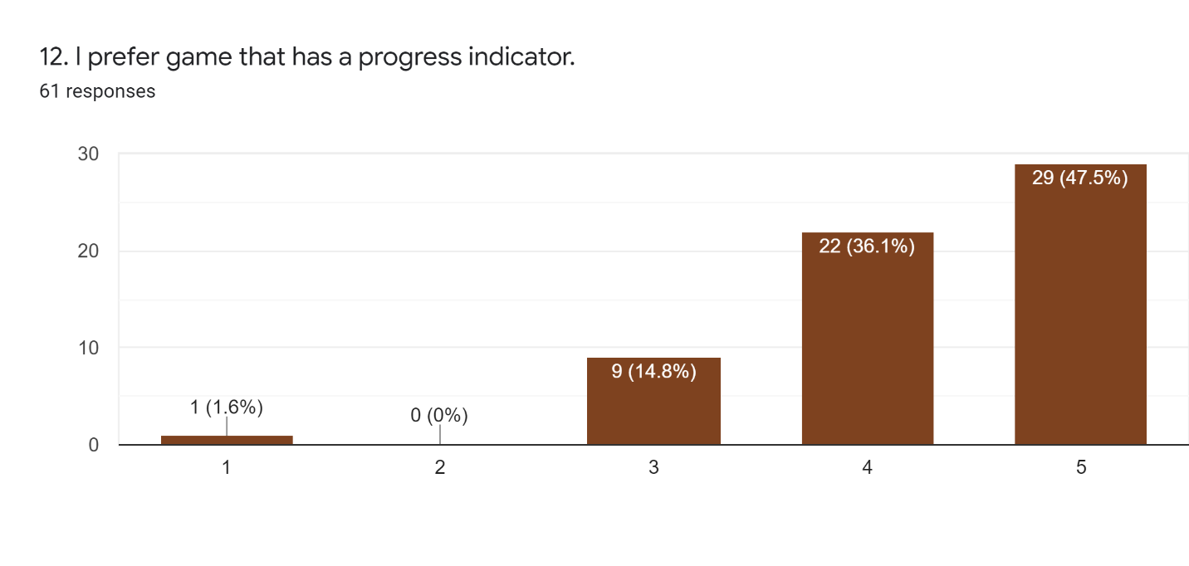

Figure 27 shows that the respondent's preference toward progress indicator.

From the response from the survey gathered, out of 10 questions that ask about player preferences, there are 6 of the response are right-skewed, with only 4 of them center skewed. Within the 6 right skewed responses, 2 of them are contradicting with their counterpart. The first difference being questions number 5 and 6, which is "I prefer to grind out and quest in-game. (play slow and steady)" and "I prefer taking risks and speeding through a game." Secondly is between question number 7 and 8, which is "I prefer to play game socially with friends." and "I prefer to play a single-player game."

Despite a small group of 61 usable responses, two pairs of questions fit on the other end of the spectrum. In such cases, the experts recommended to focus on general user needs and motivation, such as the need for competence satisfaction (Deterding, 2015; Huotari & Hamari, 2017). Therefore in the Design phase, the main task is to design a feasible solution adapted to the result from both the context and user analysis.



### Success Metrics

The success metrics of this project will be following the research objective of the project.

## Ideation

The ideation stage starts after the analysis of the context, and user analysis has been done. Ideation is the phase where developing gamification begins. In this stage, brainstorming is done to develop a comprehensive lists of gamification design ideas.

The brainstorming was done with a Mash-Up technique by (Salvi, 2020), which originated from (IDEO, 2021). Initially, there are four steps, which are "Frame," "Narrow," "Generate," and "Mash-Up." Starting with "Frame" was by articulating the How Might We statement. Then "Narrow" it down by picking two broad and unrelated categories. Next, "Generate" was to list as many elements of that two category experience within two minutes. Lastly, "Mash-Up" combined the items from two lists to ideate as many new features/services/products.

However, Salvi modified the Mash-Up technique by reducing it into three steps, retaining the initial "Frame." But on the second and third step was slightly different. Instead of picking two broad categories, each participant was asked to select a post-it per category and place them in their ideation canvas. Lastly, in step 3, participants are expected to develop a solution that fits the elements picked up in step 2 within 6 minutes.

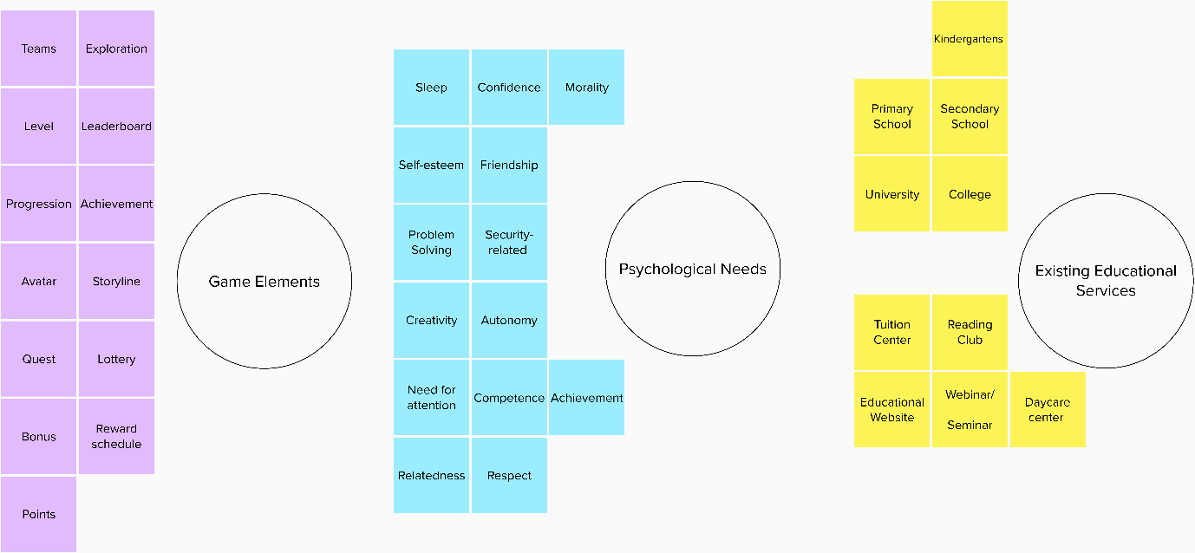

Figure shows the Mash-up mapping in Mural.

Figure 28 is the Mural setup that was used to set up the Mash-up ideation method. This mapping exercise was done within 15minute on each topic to serve as an inspiration and an actionable input for the following step. The topics that were chosen were Game Elements, Psychological Needs, and Existing Educational Services. The initial brainstorming idea was to look for how to apply the element from different topics creatively and apply it in the project.

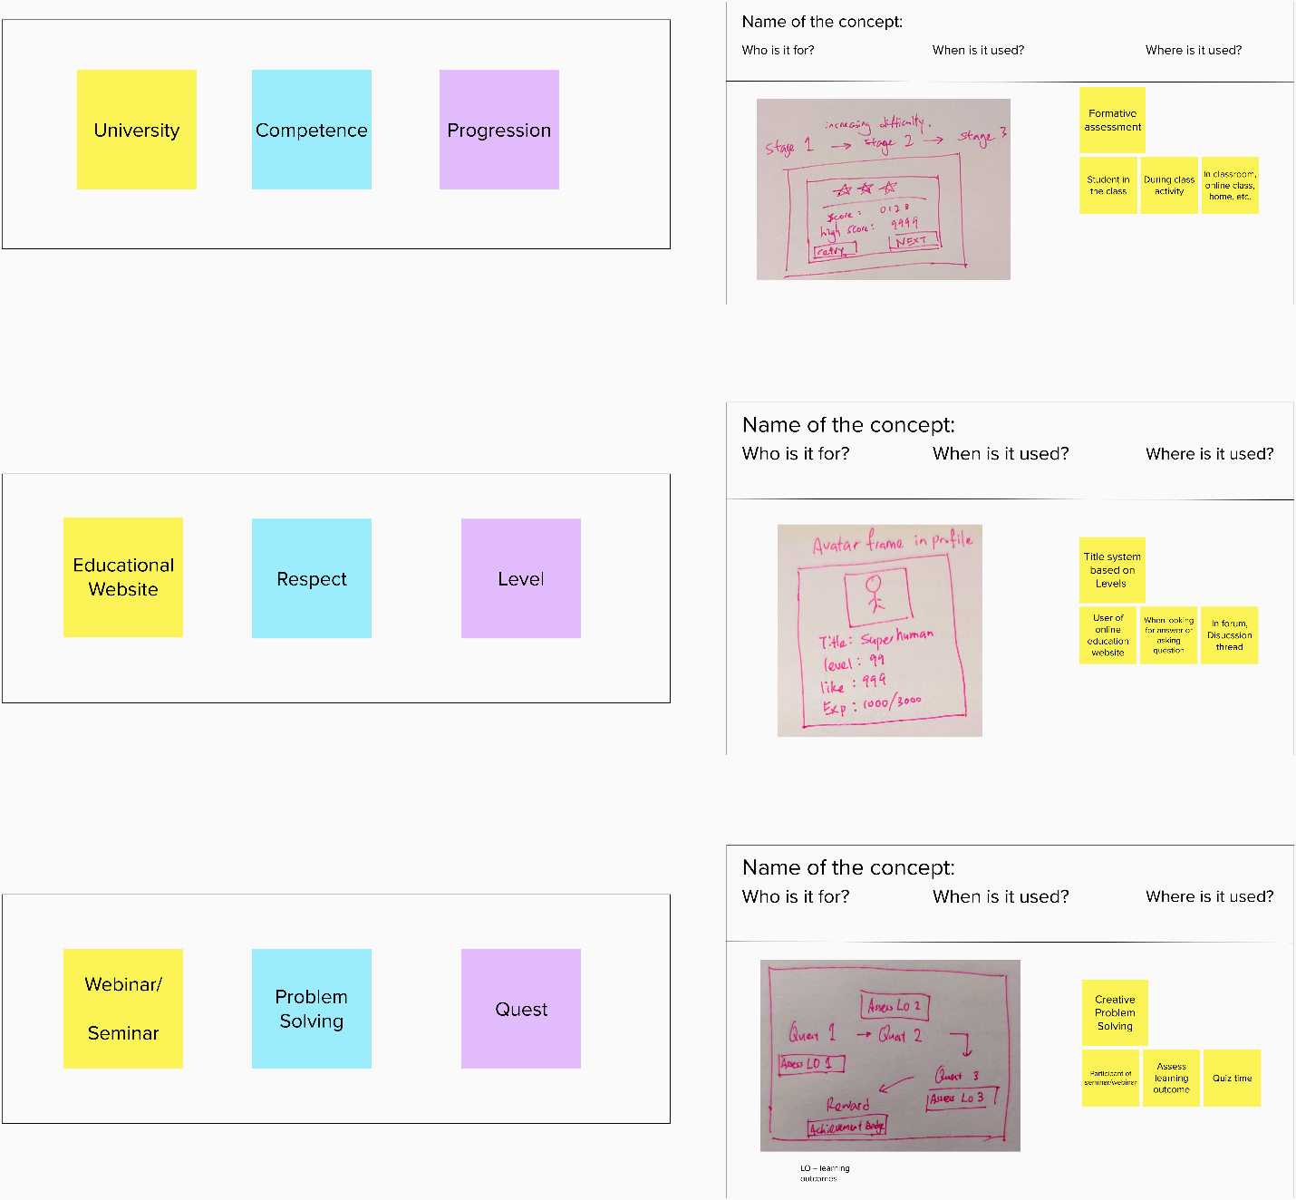

Figure shows the selected insight from the mapping on a side and the final sketch/concept resulting from them.

Figure 29 shows two columns of content. The left column was the three post-its, each one from different categories. While on the right column is the solution that embodies the three post-its chosen on the left. One example that came up as a solution is for "Webinar/seminar," "Problem Solving," and "Quest" was a creative problem-solving concept that relies on a quest system that embodies the learning outcome of topics for the participants of the webinar to used to assess their understandings toward a subject during a quiz. Then, all of the ideas are consolidated to create a list of ideas for the Design phase.

## Design

After collecting ideas, concrete gamification designs for the project can be developed. In this stage, the paper prototype is produced for the rapid development of prototypes. The sample of the paper prototype is shown in Figures 30 and 31. These are the few design ideas that came up from the ideation phase and aimed to fit the general user needs in the design phase.

Figure 30 shows two separate portions, top, and bottom. The top part targets to solve navigation issues by incorporating "Item," "Avatar info," and "Game save" into a section. The is a vertical group of buttons on the left, while additional space on the right lists out the immediate status of the character in-game. The scenario on the paper prototype proceeded to open the "Item" button, the right side of the menu changed to the inventory view. When using an item, it will show which character to use on "P1" or "P2". Continuation from the "Item" button is the "Stats" button, which shows the character's status in much detail.

The bottom section is designing a paper prototype on the battle user interface. To emphasize on playing game socially with friends, this section has two characters where the player can control to fight the enemy. With this implementation, players can either risk fighting the monster with only one surviving character or play it safe by fleeing the battle to try it again. Next was the "Attack" button, which will directly lead to target selection. At the same time, the "Magic" button will bring the player to a magic menu then to target selection. Finally, the "Item" button will bring up an item window that allows the player to use the item when in the battle.

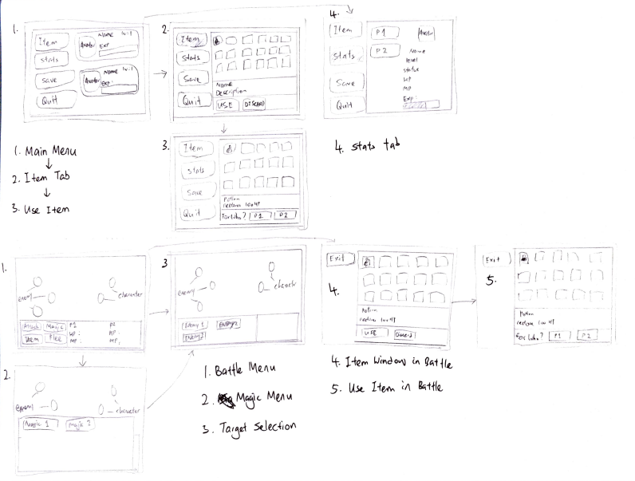

Figure shows two portions, top and bottom, where a paper prototype is devised from the ideation concept.

Figure 31 top left section is the design done to combat the needs of progressions. With road blockade, the player will know that some quests are required to be done to progress. Therefore, it will fulfill the general needs of progress indicators in-game. However, with that blockade progression, there can also be a challenge for the player to take a risk to challenge a more challenging area without going through the predestined site, or they would choose to play it slow.

Next, for quality conformance, it is suggested to have a Title Screen. Therefore, in Figure 31, top right section, there is a design for the game Title Screen. It is simple with a game title, “New Game” button, and “Exit Game” button. The “Continue Game” button will only show if there is a prior save file detected. The “New Game” button will bring the player to the starting scene, while the “Continue Game” will bring the player to their last saved location.

Next, a reward screen is engineered in the paper prototype in the third quadrants on the bottom left in Figure 31 to fulfill the “Competence” psychological needs ideation. To exert a meaningful effect and the satisfaction of the player, the game must be able to quantify their effort. Human motivation has a fundamental connection between the feeling of personal satisfaction, vitality, interest, and well-being (Deci & Ryan, 2008). Therefore, a summary at the end of each battle or quest will be a great propeller to boost the player's motivation.

Also, in the fourth quadrant, which is the bottom right corner of Figure 31, it fits the quality conformance of dialogue with Non-Playable Character (NPC), a common practice for an RPG game. It is common for the dialog element to occupy the bottom one-third of the screen (Pesce, 2020). Therefore, the design was just a simple dialogue box with the NPC name and NPC dialogue text.

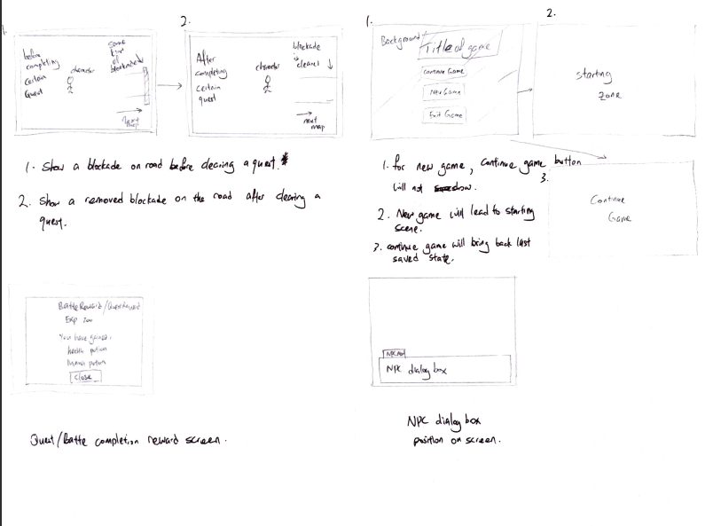

Figure shows four portions, top left, right and bottom left, right where a paper prototype is devised from the ideation concept.

## Implementation

The implementation stage can be summarized as to carry out a pilot prototype for evaluation of the project. The development is started based on the paper prototype in the Design phase. The development is conducted in an iterative cycle where each cycle is slightly different from the other. For instance, a Character sprite is created, then, in turn, the animation is attached to the Character asset. Then a C# Script is created to attach to the Character asset to make the Character move. Afterward, play testing is done by the developer to ensure that the feature is working correctly. The flowchart structure of the process would be as shown in Figure 32. The feature is then implemented in the prototype of the project.

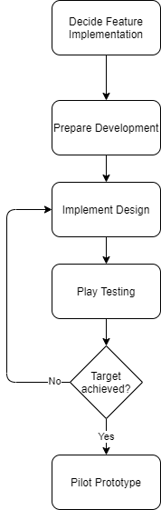

Figure 32 shows the flowchart of the implementation phase.

## Evaluation & Monitoring

The Evaluation and Monitoring phase aims to investigate whether the project meets its predefined objectives from phase 1 and is used to set as a metric for gamification evaluation. In this phase, playtesting is conducted with multiple users. Playtesting refers to the observations of users while undertaking a task in a game (Groening & Binnewies, 2019). The observation will be conducted via Google Meet (video conferencing platform). The participants are required to turn on their webcam and unmute their microphone when playtesting is undertaken. The playtesting session, however, will not be recorded. From observing the user, their behavior and expression are more effective in describing their playtesting experience. For example, the user might show occasional brow frowning but cannot describe with words that they experience discomfort when undergoing a specific task. From the observation in playtesting, a list of improvement will be consolidated and include in the future iterative cycle.

## Gantt Chart

The duration of this individual project is two semesters that span from April 2021 to November 2021. The first semester is in April 2021 – July 2021 is to prepare Initial Allocation Form and get approved by the panelist. Then write an Initial Detail Proposal Planning that is in the Proposal Phase and Requirement Analysis Phase. Next, the second semester is in August 2021 – November 2021 is to develop a functioning prototype and completing the documentation. Figure 33 below show the Gantt Chart that indicates the timeline of each task for the individual project.

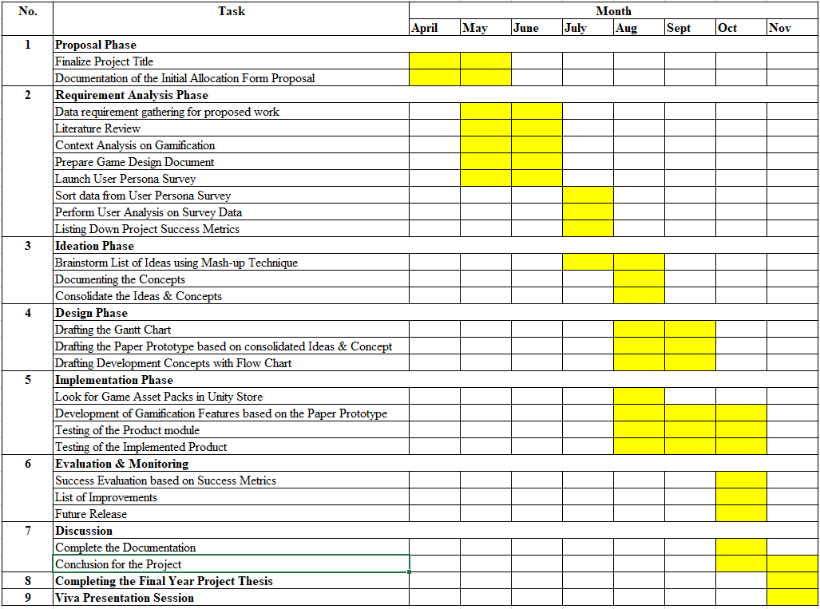

Figure shows Gantt Chart for the individual project.

## Conclusion

This research methodology section covers the implementation of the project for every phase in detail. The upcoming section will discuss the system development, including the code snippets and comprehensive system view.

# Project Development

## Introduction

This section contains the feature explanation of Bullfinch – Gamification of Use Case Diagrams. To summarize and provide a brief introduction, Bullfinch is a game-based learning system to give the eager learner with an engaging learning environment. Therefore, this chapter will start with the resources used in the game. Then navigation structure of the game will be illustrated with a diagram. Apart from that, the function of each subsystem of the game will be explained in detail, along with code snippets and system view. Lastly, the screenshot of the prototype will be shown to illustrate how does the game function.

## Assets

Assets stand for a shorthand for anything that goes into a video game – character, objects, sound effects, maps, environments, etc. (Unity Technologies, 2021). For example, as shown in Figure 34, this project mainly includes character and creature art, animation, font, sound effects, particle effects, UI design, and music. All asset used in this project is obtained from OpenGameArt.Org with credit to their respective author in a license file.

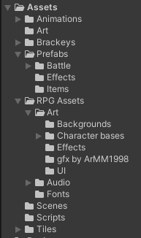

Figure 34 shows the screen capture of the asset categorizing in Unity.

## Prefabs

Unity’s Prefab system allows to create, configure and store a GameObject complete with its components, property values, and child GameObjects as a reusable Asset. GameObject is the fundamental object in Unity that represents characters, props and scenery. They do not accomplish much in themselves but act as a container for Components, which implement the functionality (Unity Technologies, 2021). The Prefab Asset act as a template that can create new Prefab instances in the Scene. Prefab is extremely useful because any edits made to a Prefab are automatically reflected in the instances of that Prefab, therefore allowing easy changes across the entire Project without making the same edit to every copy of that Asset. For example, the Prefabs store the GameObject with Script attached to it, creature stats, and items in this project. One of the essential Prefabs in this project is the EssentialLoader GameObject in Figure 35 which has 5 GameObject attached to it, such as UI Canvas, Player, GameManager, AudioManager and BattleManager. Each of the GameObject will be explained in detail in other sections.

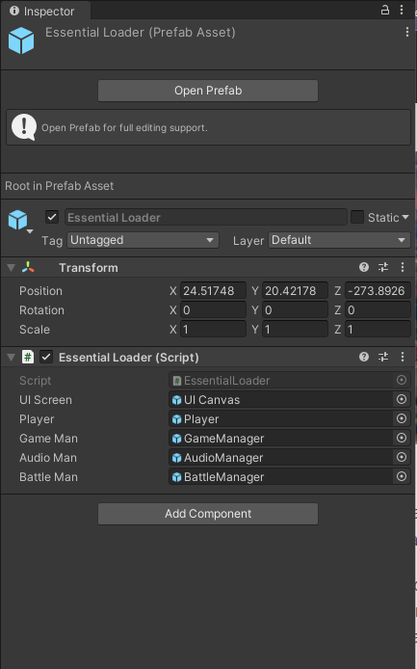

Figure 35 shows detailed information about the current selected GameObject.

## Scene

A scene is a logical container that can contain all or part of a game or application. One can build a simple game in a single scene or use one scene as a map with a different environment, obstacles or decoration. For example, as shown in Figure 36, multiple scenes are used as the map for progression with varying mechanics in this project. There are maps scene, special quests scenes and user interface scenes which include various components and GameObjects. While in Figure 37 shows AestonTown Scene with all the GameObject in it.

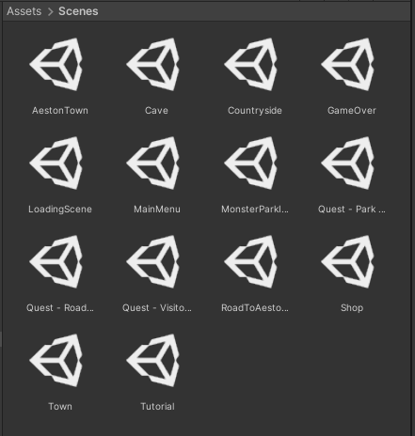

Figure 36 shows all the Scenes in the project.

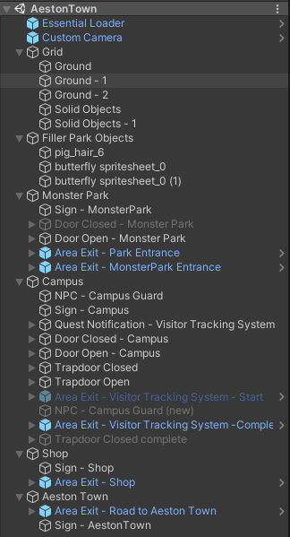

Figure 37 shows all the GameObject in the AestonTown Scene.

## Project Structure

As mentioned in section 2.6, Unity is the selected software for Bullfinch – Gamification of Use Case Diagram. Therefore, a walkthrough of the quest chosen will be used as the run-through for this report. Figure 38 shows the project structure of this application.

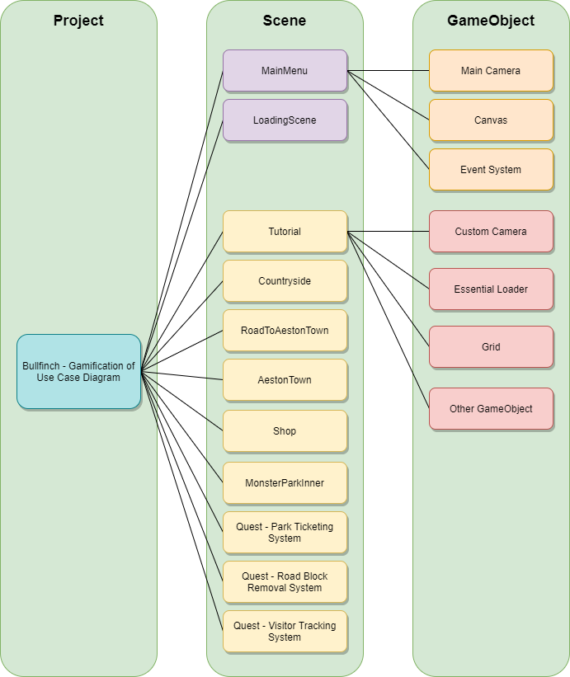

Figure 38 shows the Project Structure.

There are many scenes involved in Bullfinch – Gamification of Use Case Diagram. It is necessary due to the nature of game design and required game progression. When users start the application, they will be greeted by the MainMenu. Then as the user choose the option, they will be shown a LoadingScene and brought into the Tutorial. In the project structure, MainMenu and LoadingScene Scenes contain the same general GameObject. The rest of the Scene has three same general GameObject and other GameObject to make the application functional.

For example, Custom Camera is different from Main Camera GameObject. The Custom Camera is fitted with C# Script that will follow the in-game avatar, while the Main Camera is just positioned as a static GameObject to show the Tiles properly.

## Navigation Structure

Users can navigate in the game by controlling an in-game avatar known as Tim. Users can move the avatar by using the keys “WASD” or Arrow Keys “↑←↓→”. There is a designated area for the user to cross over into different scenes. For example, in Figure 39, users can move from Tutorial to Countryside but never go backward. Few scenes have a condition to be fulfilled to be unlocked or locked. For example, the Quest scene will only show if the player takes on a quest, and once completed, they could never be reaccessed.

However, users can access the in-game menu from any scene with a yellow arrow by pressing “Right mouse click”, and they can perform more action or exiting the game.

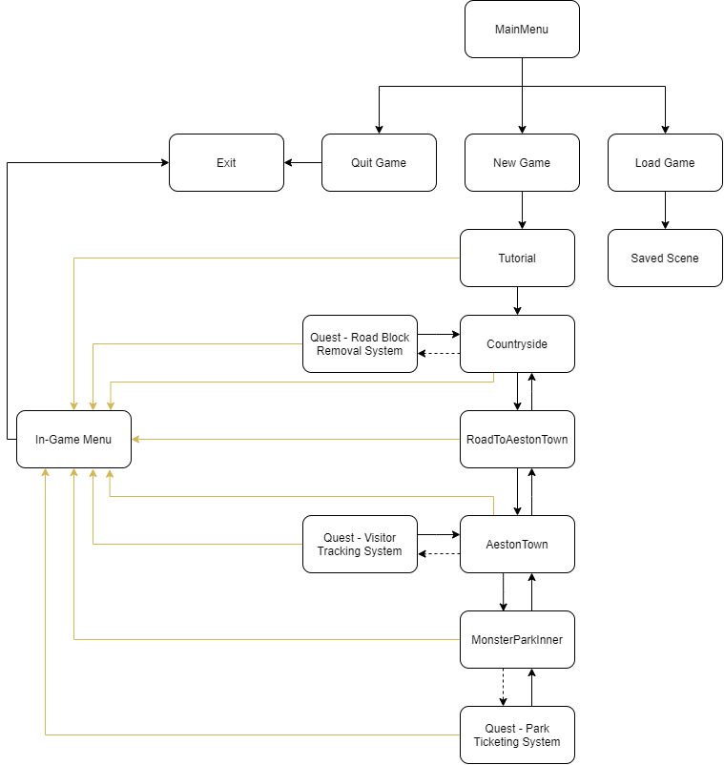

Figure 39 shows the navigation structure.

## Creating Tile map for the environment

To develop a map for players to move around in the game, the first element that needs to be considered is to create the ground that allows movement for the character. Therefore, a GameObject of Tilemap component is required. The Tilemap component is a system that stores and handles Tile Assets for creating 2D levels. When creating a Tilemap, the Grid component is automatically parented to the Tilemap and acts as a guide when laying out the Tiles onto the Tilemap onto the Scene as shown in Figure 40.

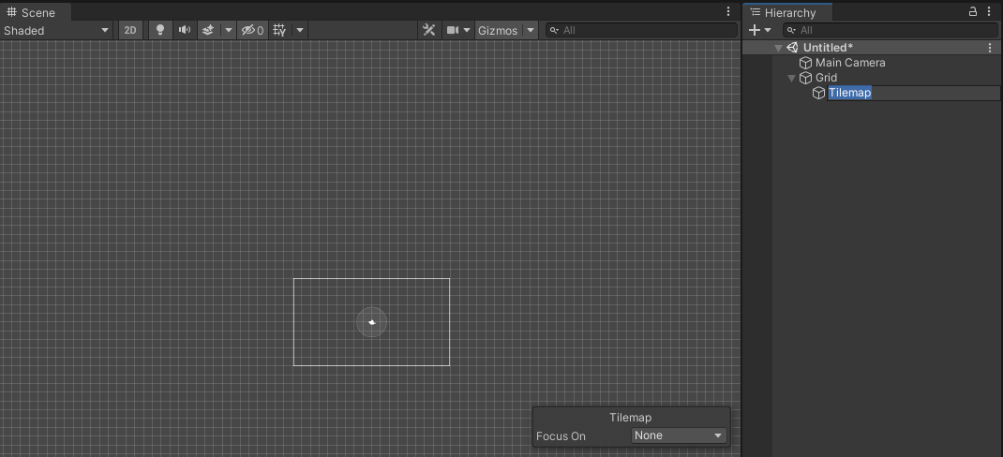

Figure shows the sample Tilemap being created with the Grid component laid out.

In this project, the tilemap was set up by importing the PNG image file from OpenGameAsset.org by ArMM1998 called Zelda-Like Tilesets and Sprite (ArMM1998, 2017). The PNG image file can be imported into the project by using Tile Palette. By selecting a new palette, as shown in Figure 41. Then the Tiles can be painted onto a Tilemap. To show a correct layer on the map, the Sorting Layer in the Tilemap Renderer component is changed to the Background layer, and the Order in layer is changed appropriately. In the project, 5 Tilemap has been created in every scene and follows the general naming structure as shown in Figure 43, in which the front part is the name and after the “-” would be the Order in Layer. However, for “Solid Objects”, an additional component such as Tilemap Collider 2D, Rigidbody 2D and Composite Collider 2D is added. Composite Collider 2D uses the Tilemap Collider 2D to group neighbouring Tiles with the same Tilemap together. It helps to smooth out the corner and edges between Collider shapes. While the RigidBody 2D serve as a type of physics engine with Kinematics body type to ensure correct collision detection between Player and the “Solid Objects” shown in Figure 44. An example of a completed Tilemap is Figure 45, which encompasses five layers of Tiles.

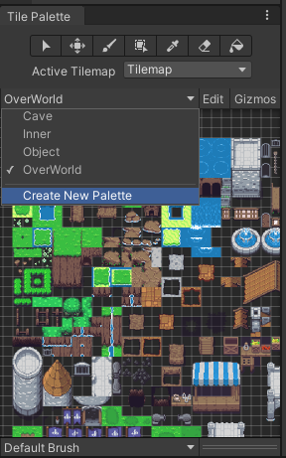

Figure shows the creation of a New Palette to store a specific group of Tiles.

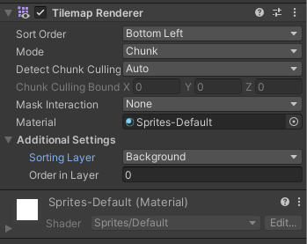

Figure shows the Sorting layer and Order in Layer of the Tilemap Renderer component in the Tilemap.

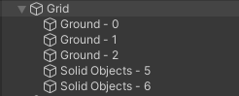

Figure shows the name structure of Tilemaps.

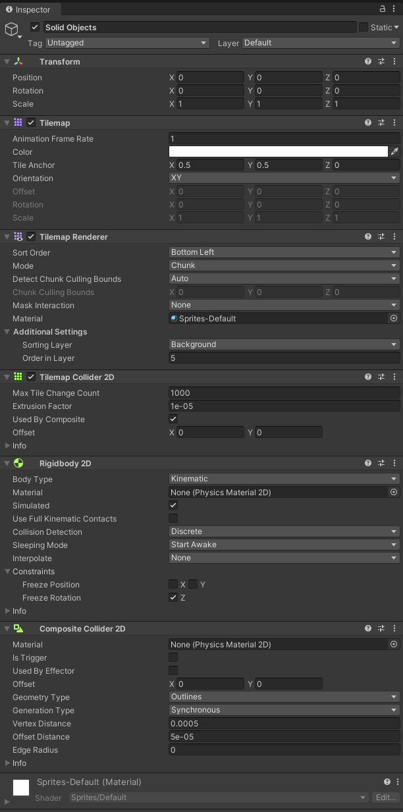

Figure shows the component attached to the Solid Objects Tilemap.

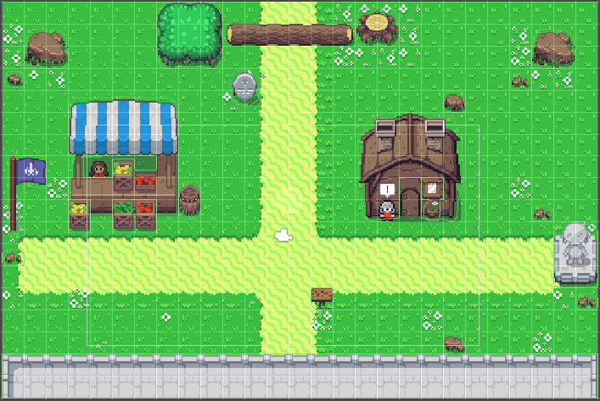

Figure shows the completed Tilemap of Countryside Scene.

## C# Script

The behaviour of GameObjects is controlled by the Components that are attached to them. Unity allows the creation of its Components using Scripts. Scripts allow triggering of game events, modify Components properties or responding to user input. Unity support C# (pronounced C-sharp) programming language. C# is the programming language used in scripting in this project.

Creating a new script is unlike other assets. It can be done by selecting Assets > Create > C# Script from the main menu, Figure 38. Furthermore, the newly created script was not empty. The completed script has an imported library and two class functions Start() and Update(). Conveniently, there are also comments on the function to explain what those functions do, as shown in Figure 39. Then the custom function can be added at the bottom.

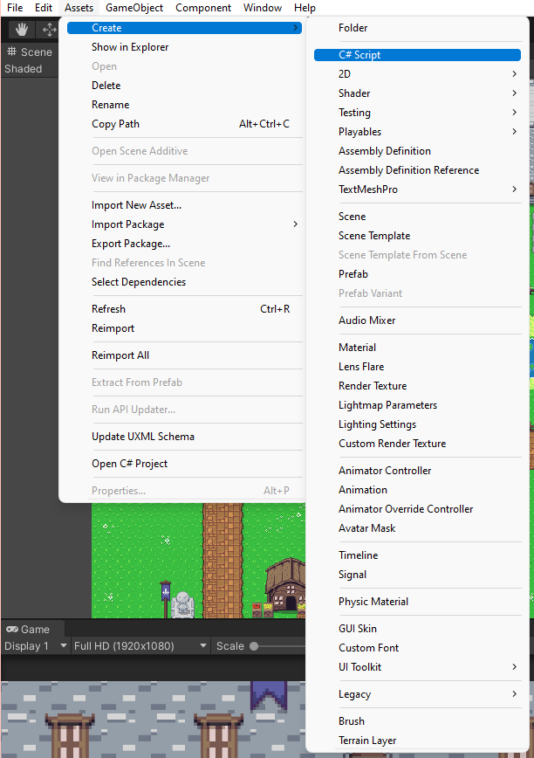

Figure shows the C# script creation process.

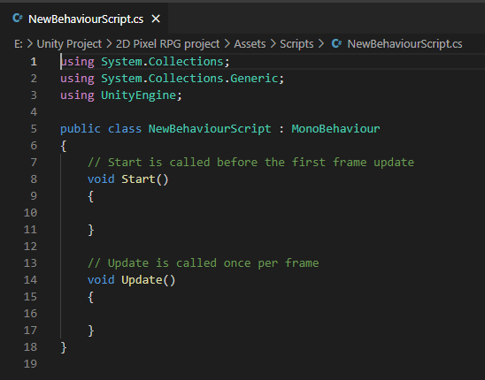

Figure shows the newly created script.

## Player



### Sprite sheet

The Player sprite is obtained from OpenGameArt.org by author ArMM1998 (ArMM1998, 2017). The PNG image file is placed in the Unity project directory, then opened with Sprite Editor in Unity shown in Figure 48. Before editing in the Sprite Editor, the entry on Sprite Mode has to change to “Multiple” as it contains many sprites, and Unity will be able to detect it. Afterwards, in the Sprite Editor, as shown in Figure 49, choose “Slice” on the menu bar, and “Slice”, Unity will automatically generate the appropriately sized sprite.

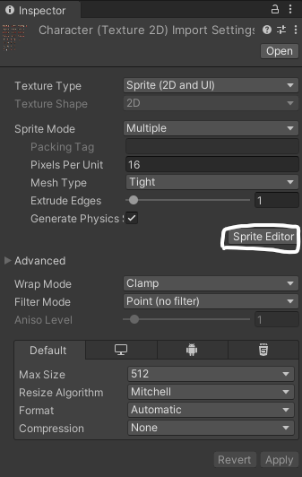

Figure 48 shows the detail of the PNG file when opened in Unity.

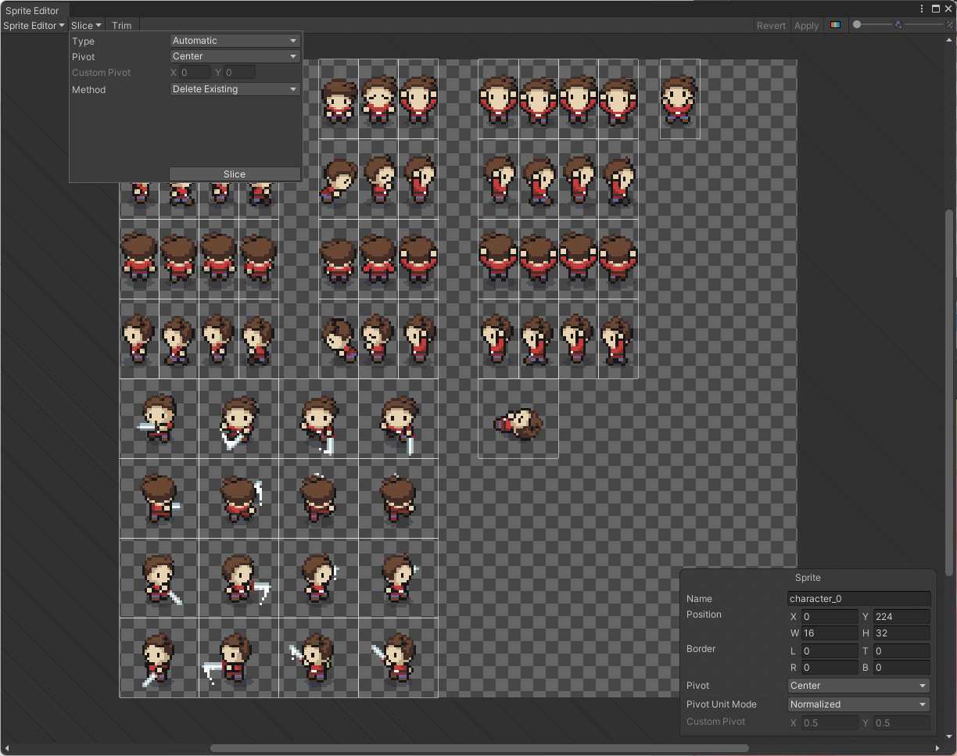

Figure 49 shows the Sprite Editor.

### Creating Script

To make the Player move in the game, a GameObject of Player is created with a sprite sliced from the sprite sheet. Then few more component is added into the GameObject such as a Circle Collider 2D, Rigidbody 2D and a PlayerController script. Circle Collider 2D essentially creates a circle-shaped area that allows GameObject to interacts with the 2D physics system. Rigidbody 2D is to allow proper physics simulation. Lastly, the Player Controller script is a C# script that allows for the character's movement.

­­ 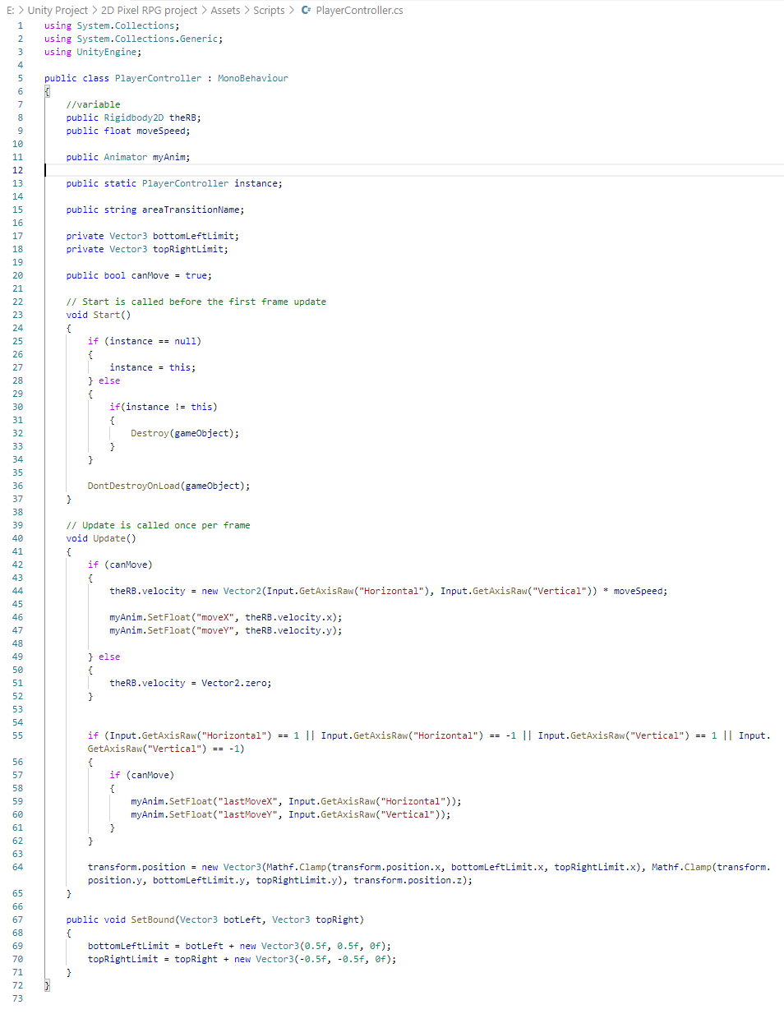

Figure 50 shows the complete code snippet of the PlayerController script.

Start the script off by declaring a few public variables. Public variable use in the script can be accessed directly from the Unity Editor. For example, Figure 50 has six public variables. Once the script is attached to a GameObject, as shown in Figure 51, there are variable names and a slot for the variable.

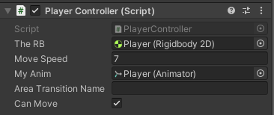

Figure 51 shows the PlayerController script attached to the Player GameObject.

To allow for movement, two conditions need to be considered: vertical axis and horizontal axis movement. Unity has an Input class that would enable reading the axes set up in conventional game input. Therefore, in Figure 52, that line of code allows for movement with Rigidbody 2D component with a proper velocity.



Figure 52 shows the code snippet that allows for movement.

### Animating the Player

Unity makes animating a breeze by having its animation tab. There are few steps to create an animation in Unity. For example, to create a Player animation:

1. Open Animation panel by going into Window > Panels > Animation > Animation.
2. Create a new clip.
3. Drag and drop the sprite into the Dopesheet.
4. Assign the sprite to a constant interval and press Play.

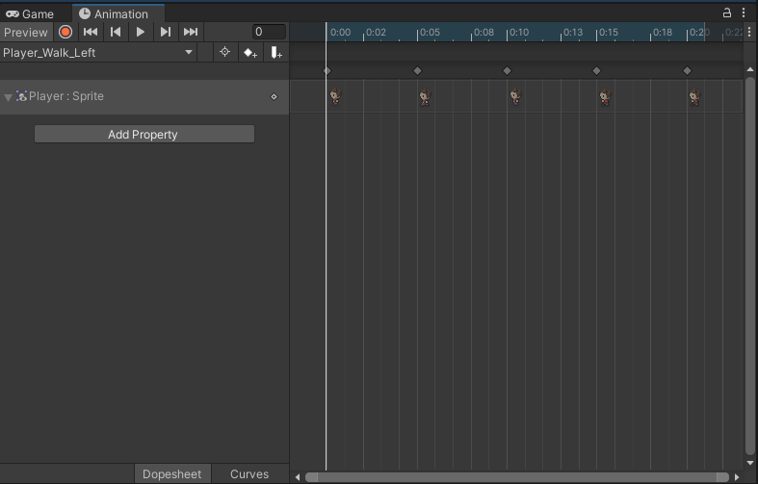

Figure 53 shows the Dopesheet in the Animation panel.

Then to allow the animation to be triggered based on user input, it has to be attached to the Animator Controller. Animator Controller allows arranging and maintaining a set of Animation Clips and associating the transition for a character or object. Therefore, to create an Animator Controller:

1. Open the Animator panel by going into Window > Panels > Animation > Animator.
2. Delete every existing animation clip and create a new Blend Tree, as shown in Figure 54.

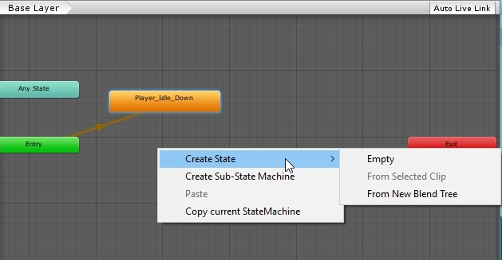

Figure 54 shows creating a new Blend Tree.

1. Create new parameters on the left panel. For example, two parameters are created for horizontal axes, “moveX” and vertical axes “moveY” for player movement shown in Figure 55.

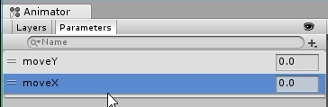

Figure 55 shows the creation of the parameters.

1. Create the Motion animation at the Inspector panel of Blend Tree in Figure 56 and adding the Motion animation clip from the saved animation.

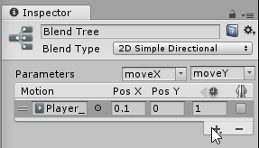

Figure 56 shows the Blend Tree properties.

1. The Pos X and Pos Y are edited accordingly to fit the movement motion. For example, to move left set the Pos X to -0.1. To move right, set the Pos X to 0.1. Then the inspector allows checking the movement as shown in Figure 57, where the red dot will shift according to the axes.

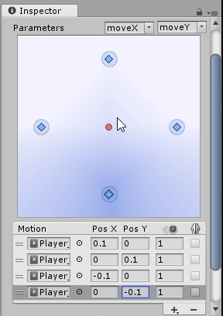

Figure 57 shows the motion checking window.

1. Create a public variable in the PlayerController script to attach the Animator.
2. These two lines in Figure 58 is inserted into the PlayerController script to allow input to trigger the Animator animation.

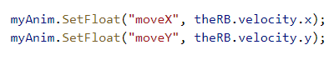

Figure 58 shows the code snippet.

Lastly, to make sure that the Player does not clip out from the boundary of the map, the code snippet in Figure 58 was the Mathf.Clamp() function to make sure the Player does not move out from the edge of the map.



Figure 59 shows the code snippet.

## Camera

The Main Camera GameObject created by the scene was a fixed static camera. To make sure that the camera follows the player around the map, a script has to be attached to the GameObject. Therefore in this subsection will include an explanation to the code snippet of the CameraController script.

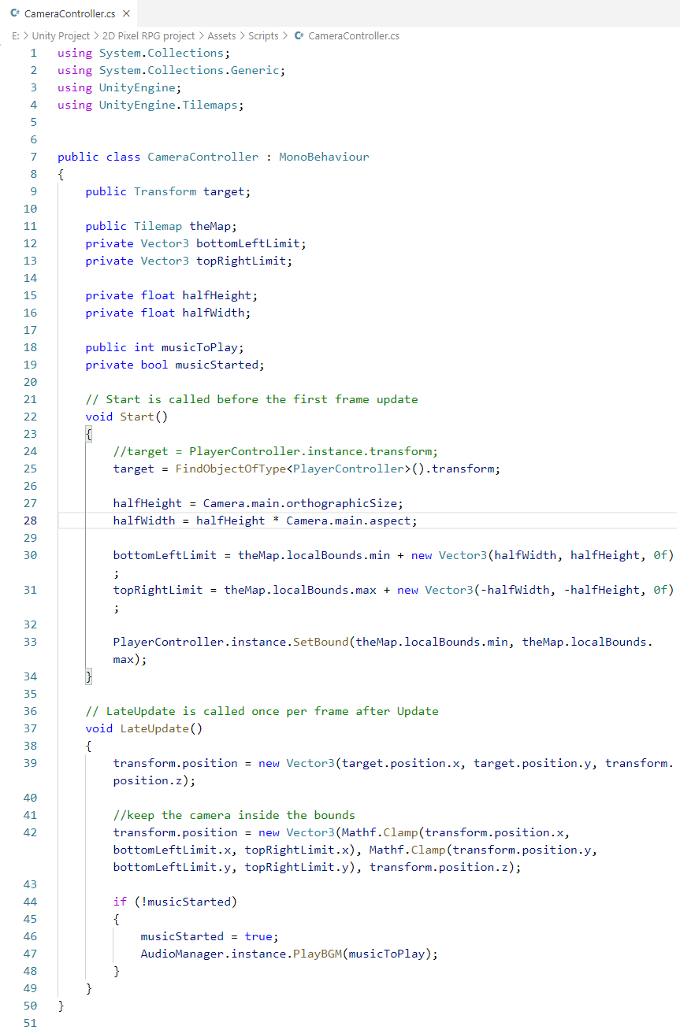

Figure shows the code snippet for the CameraController script.

The script class function is slightly different, where here instead of Update(), LateUpdate() is used. Update() is called once every frame update, but LateUpdate() is called once every after frame update. Therefore, LateUpdate() will be a step slower or get the input later than Update(), which help to make sure that it gets the input earlier than the next frame to keep the focus on the Player avatar not to cause a stuttering effect.

The CameraController script starts by creating two public variables and multiple private variables. The private variable will not be able to be accessed in the Unity Editor. Then in the Start() function, the script will find the Player GameObject by checking whether it has PlayerController script component and get its position by “.transform” function. Next, the camera will always place the Player avatar in the centre in Figure 61. Therefore, it is only taken half of the camera's height and half of the width into account.

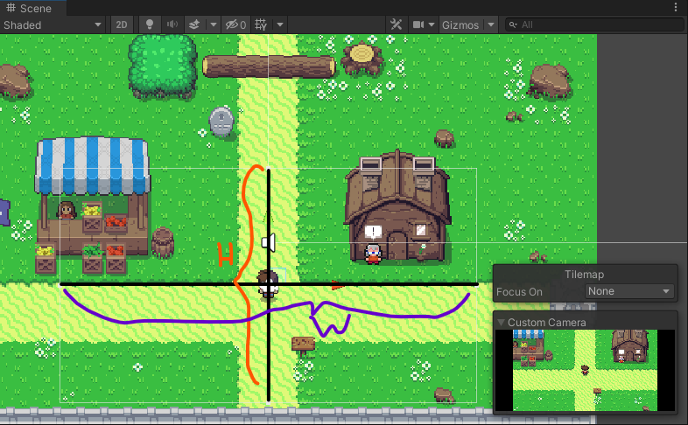

Figure shows how the camera positioned the player avatar.

Currently, the camera will be able to follow the Player GameObject as the Player move. However, when the player stands at the map's edge, the Camera is not bounded by the tilemap and shows the black area. Therefore, a bottom left limit, and top right limit is set based on the tilemap size. The LateUpdate() function is called to keep the camera inside the boundary.

Lastly, the Camera GameObject is called Custom Camera and placed in Prefabs for easy access in every scene.

## Essential Loader

Essential Loader GameObject is the most crucial GameObject that has an EssentialLoader script attached to it. EssentialLoader script makes instantiating the general GameObject in a scene to every scene by simply placing Essential Loader GameObject into Prefabs. Also, it simplifies the process to instantiate the other GameObject into one and reduces the error-prone from adding one by one GameObject into the Scene.

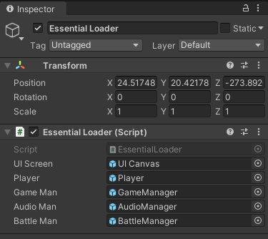

Figure shows the component details of the Essential Loader GameObject.

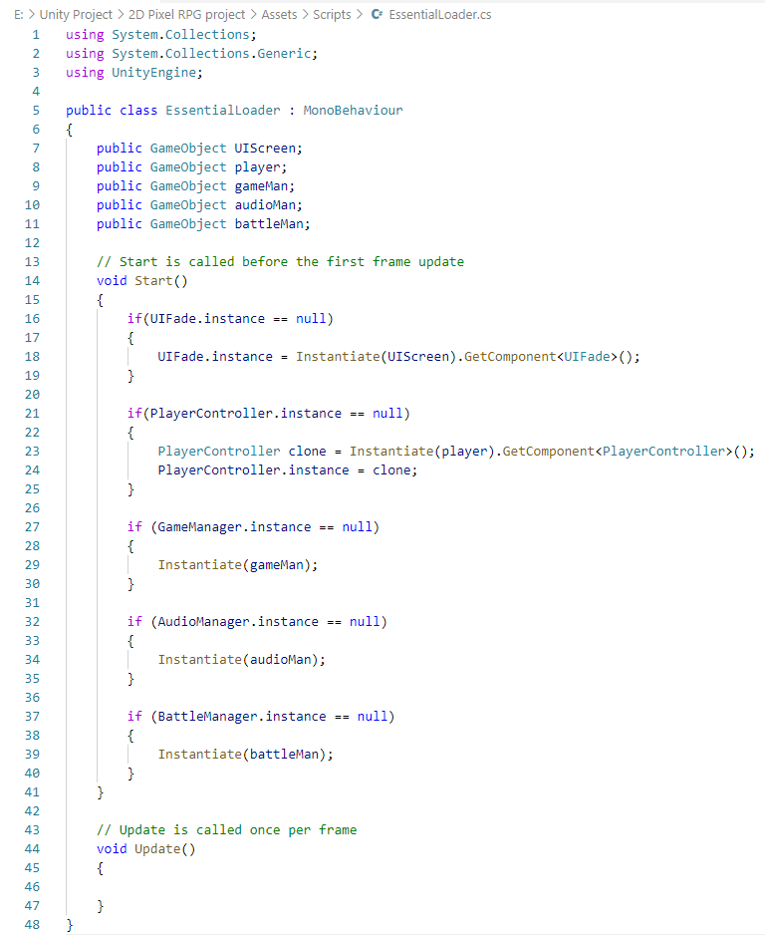

Figure shows the code snippet of the EssentialLoader script.

The purpose of the EssentialLoader script is to instantiate the GameObject in every scene if the script was not already in the scene. The if-else condition is added to prevent creating too many instances if they already exist.



### UI Canvas

UI stands for User Interface, and in Unity, it is a GameObject-based UI that uses Components and Game View to arrange, position, and style the user interfaces (Unity Technologies, 2021). Therefore this UI Canvas GameObject contains children GameObject for a different operation which will be explained next. Figure 64 shows all the children GameObject within the UI Canvas GameObject.

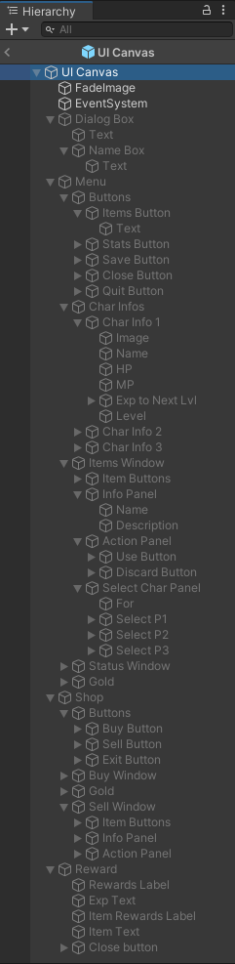

Figure shows the UI Canvas Hierarchy.

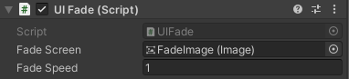

Figure 65 shows the UIFade Script component in UI Canvas.

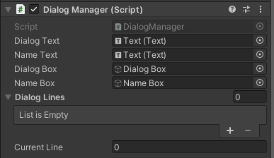

Figure 66 shows the DialogManager Script component in UI Canvas.

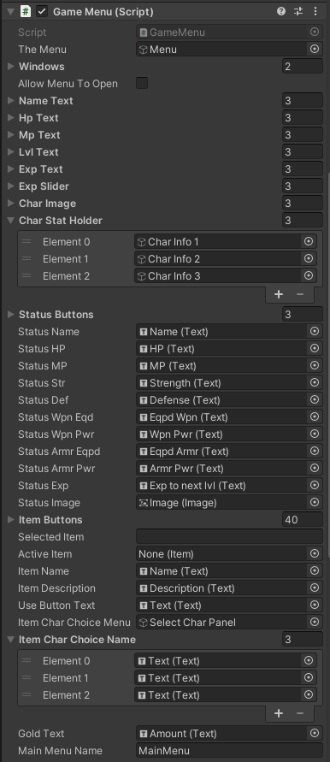

Figure 67 shows the Game Menu Script component in UI Canvas.

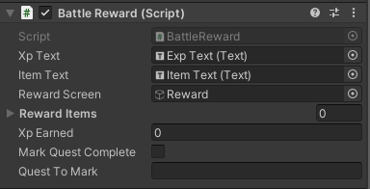

Figure 68 shows the Battle Reward Script component in UI Canvas.

#### FadeImage

FadeImage GameObject is a black coloured image. It is being used by the UIFade script to FadeToBlack and FadeFromBlack when doing scene transition from scene to scene. The code snippet is shown in Figure 70. The shouldFadeToBlack and shouldFadeFromBlack is a public Boolean variable, and the script can be set up as an instance, so its variable can be used in any script.

The alpha component of colour specifies the transparency of the colour. Therefore, changing the alpha component with a fading speed can create the effect of fading to black or fading out from the black.

For the FadeImage GameObject to be accessed by the UI Canvas GameObject, the UIFade Script is attached as a component. The FadeImage GameObject is attached to the script as a variable, as shown in Figure 65.

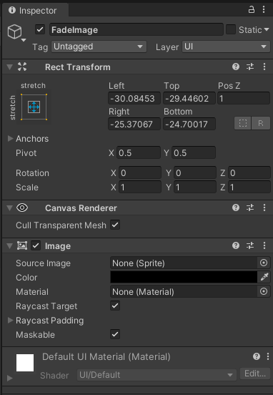

Figure shows the detailed properties of FadeImage GameObject.

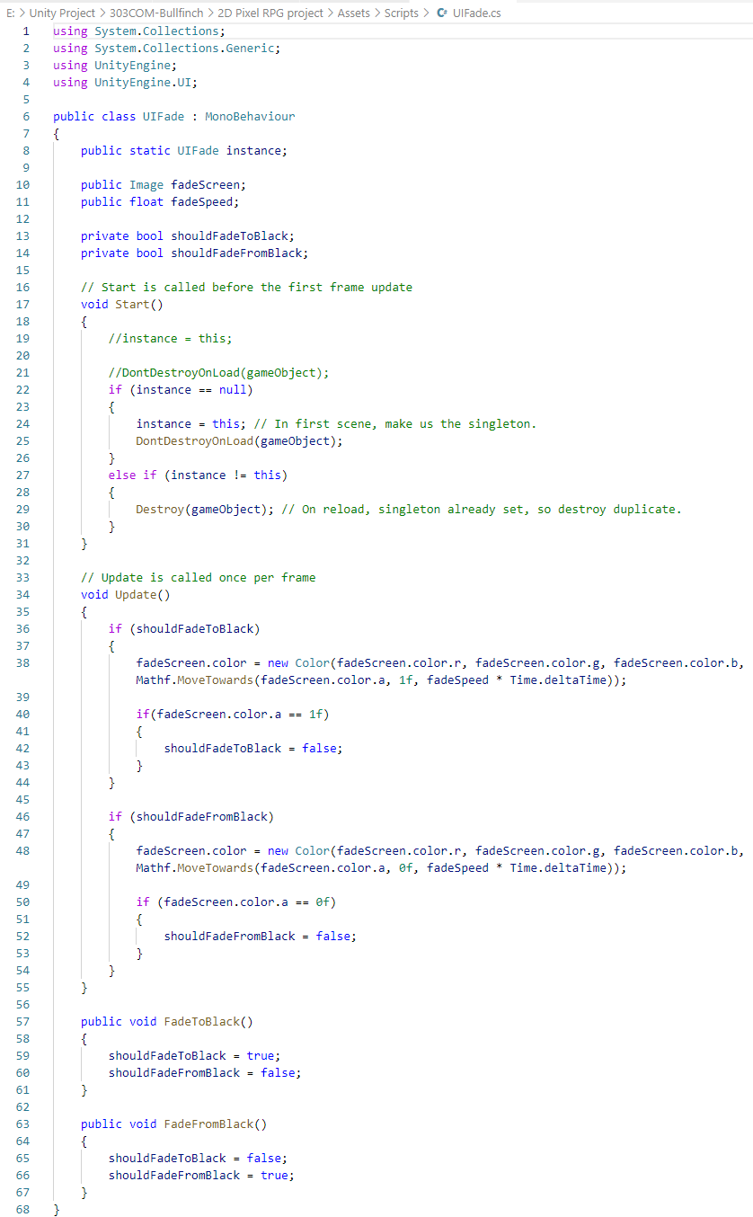

Figure shows the code snippet for the UIFade script.

#### Dialogue Box

The dialogue box interface conveys the Non-Playable Character are said in the game world for the player. It is also best used for any number of events, such as collisions, direction pointing or giving quest.

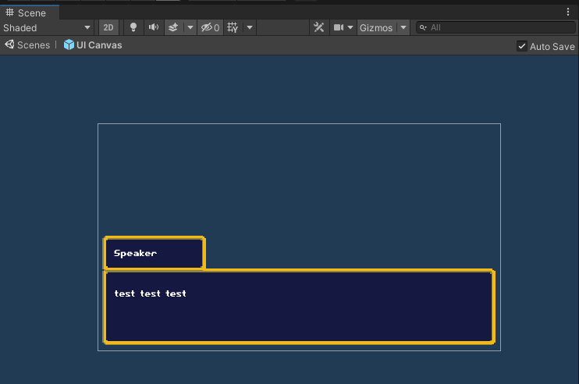

Figure 71 shows the dialogue box shows in a scene.

The source image was from CharlesGabriel from OpenGameArt.org. The colour of the panel was edited to make it darker blue.

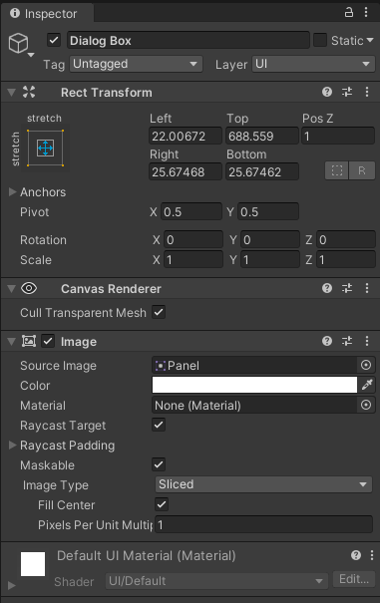

Figure 72 shows the detailed properties for Dialog Box GameObject.

The text in the dialogue box was edited to be larger in font size, the font is changed to “Pixelnauts”, and the font colour is changed to white.

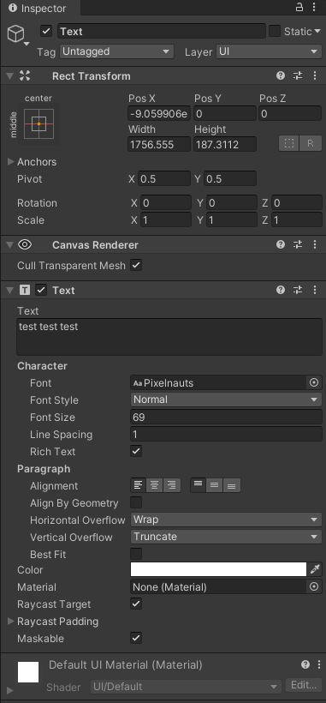

Figure 73 shows the detailed properties for Text Gameobject in the Dialog Box.

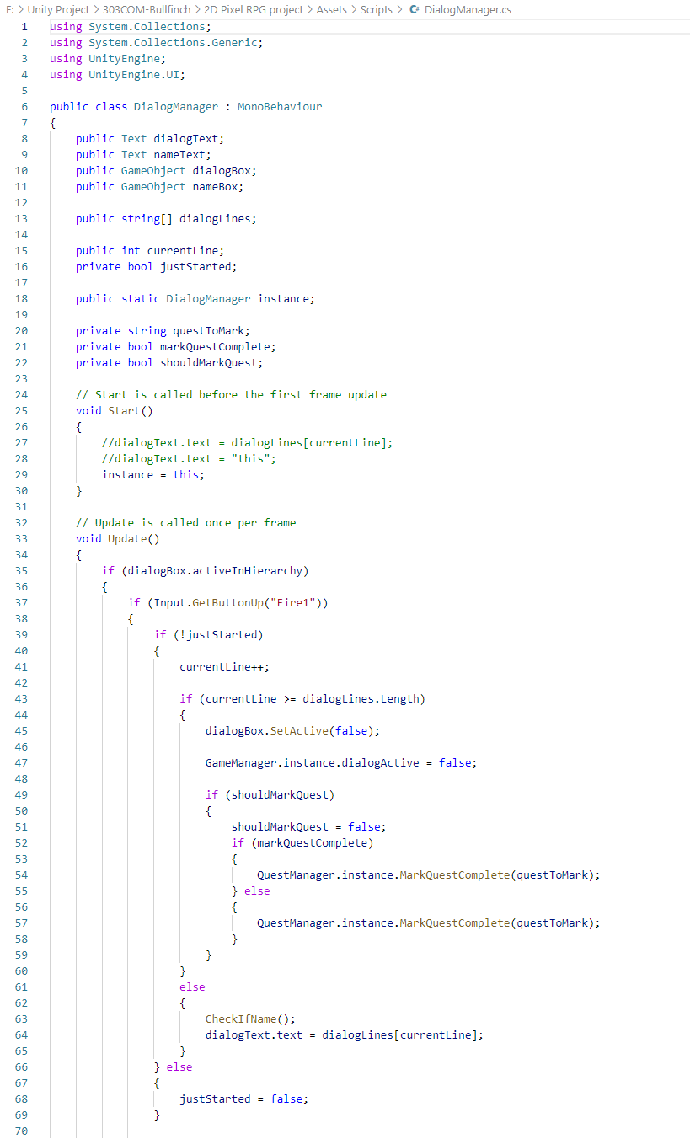

Figure 74 shows the code snippet for the DialogManager script (Part 1).

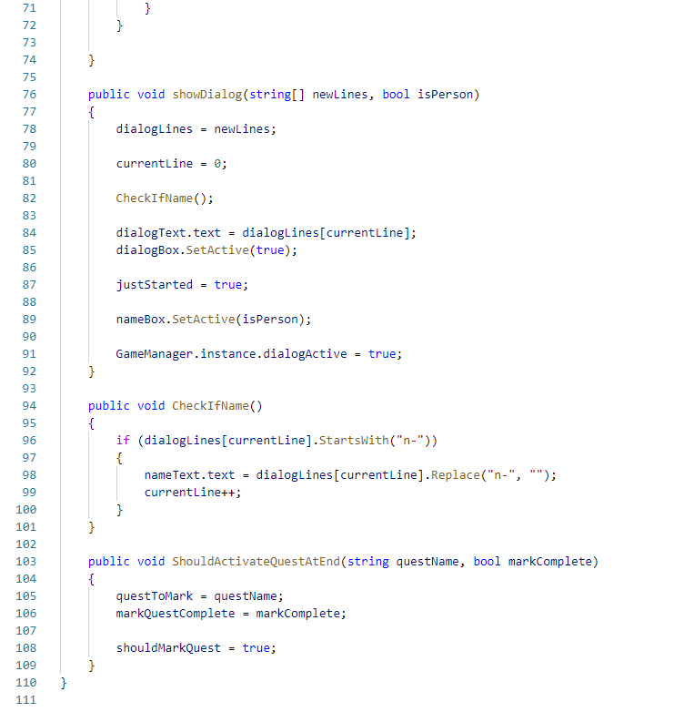

Figure 75 shows the code snippet for the DialogManager script (part 2).

#### Menu

Figure 76 to Figure 79 shows all the available Menu User Interface in the Scenes Panel. Every User Interface shown here is preset on the Scene Panel for the GameObject. The GameMenu script will be handling the interaction between mouse input and updating the user interface with data on the screen.

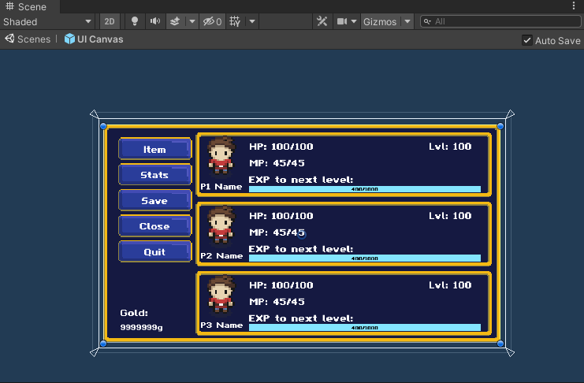

Figure 76 shows the in-game menu when the player right-clicks on their mouse.

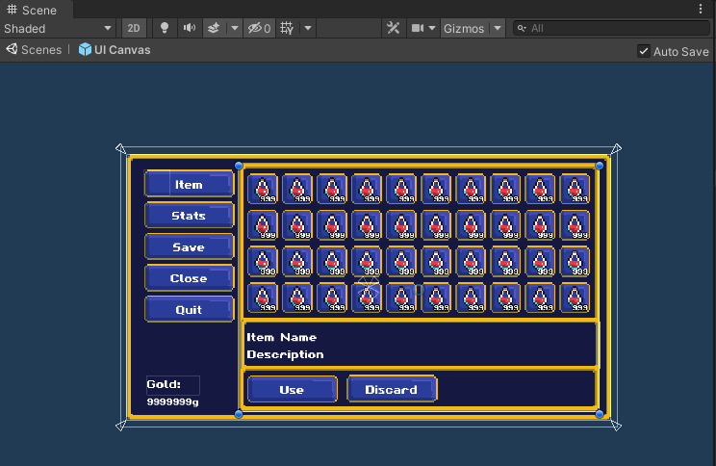

Figure 77 shows the in-game menu Item tab.

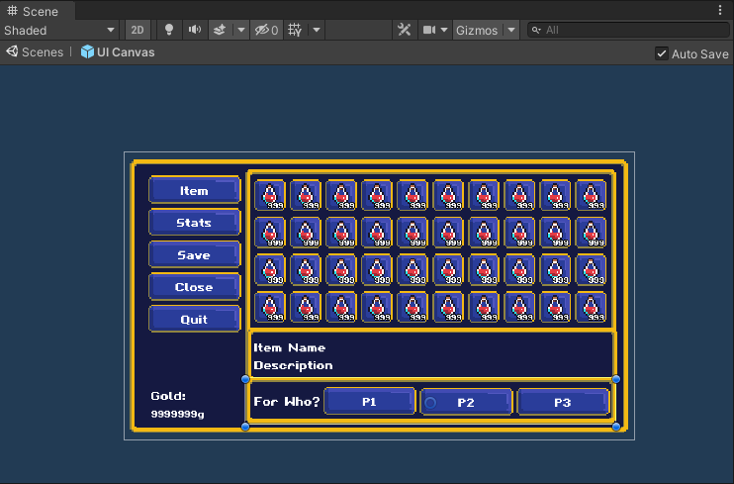

Figure 78 shows the item used for which character.

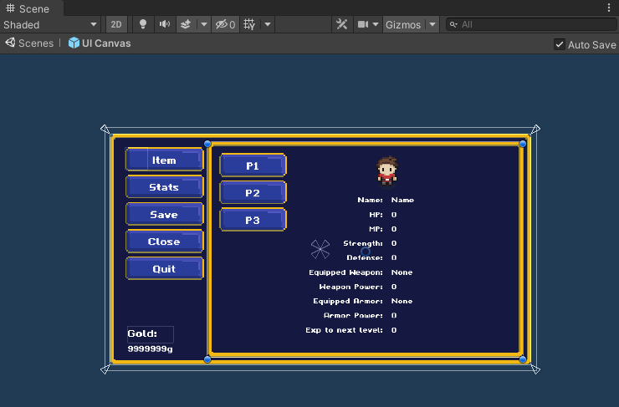

Figure 79 shows the in-game menu Stats tab.

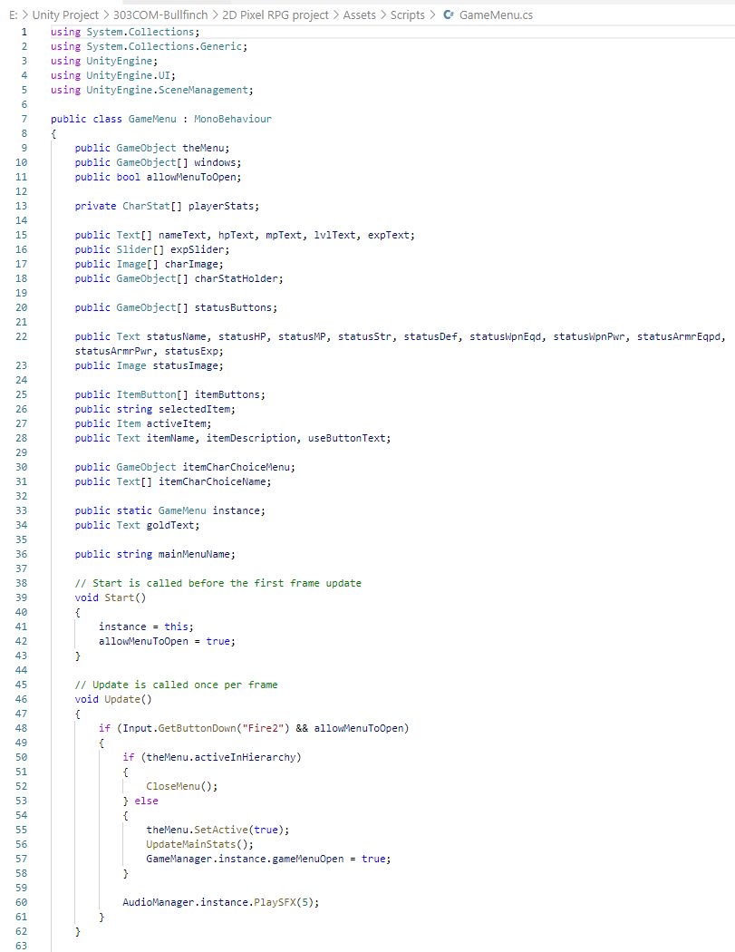

Figure 80 shows the code snippet for the GameMenu script (part 1).

Figure 80 shows the variable that is required to assign the GameObject in the Unity Editor. That GameObject is then able to be used in the script to perform a specific task. In the Update() that is called once every frame, if the menu is allowed to be open under certain circumstances and the right mouse click is detected, the Menu will open. There is also another check to close the menu, which is if the Menu is already open, right-click will close the Menu. When the menu is open, to stop the Player from moving, a condition is set in the GameManager script to check if the Menu was open and stop detecting directional input. Lastly, when the menu is open, there will be a sound effect that follows it.

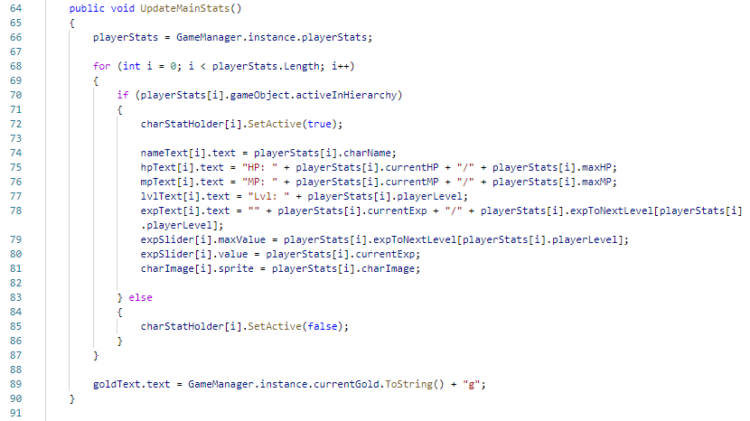

Figure 81 shows the code snippet for the GameMenu script (part 2).

Figure 81 is a function that will update the player stats on the main character info tab shown in Figure 76. The player stats are all governed by the GameManager script, which will be discussed in the next section.

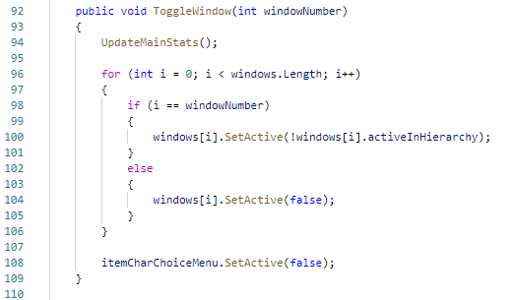

Figure 82 shows the code snippet for the GameMenu script (part 3).

In Figure 82 is a function to toggle between menu tabs on the left. By checking the array of windows assigned in Unity Editor, it allows to activate and deactivate the window if it is not already active.

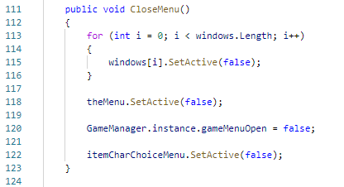

Figure 83 shows the code snippet for the GameMenu script (part 4).

In Figure 83 is a function to turn off the Menu. It deactivates the menu, the side window and allows the character to move again.

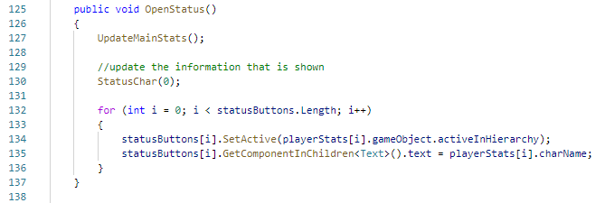

Figure 84 shows the code snippet for the GameMenu script (part 5).

Figure 84 is a function that activates when the Stats button is pressed. It will activate the chosen player stats on the screen based on the character name chosen shown in Figure 79.

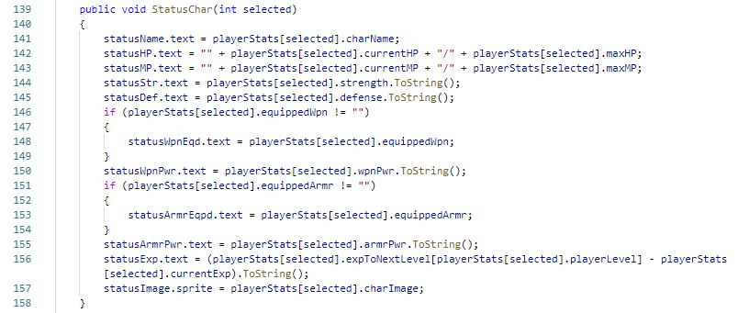

Figure 85 shows the code snippet for the GameMenu script (part 6).

In Figure 85, a function is called in OpenStatus() to assign all the text on screen with chosen player stats.

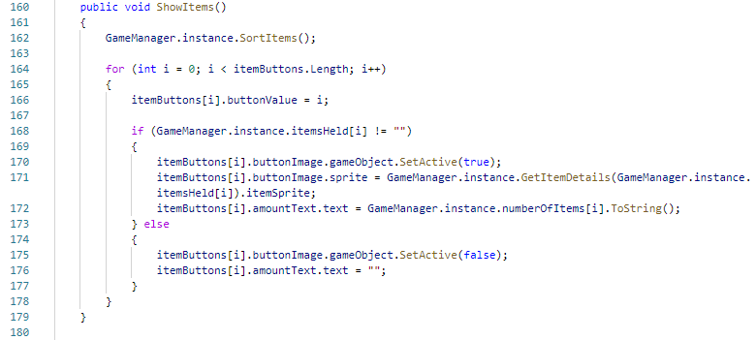

Figure 86 shows the code snippet for the GameMenu script (part 7).

Figure 86 is a function to show the item available on the player. To prevent random items on random slot, the item is first sorted out by calling SortItem() from the GameManager script. Then for each item is assigned a slot in the item button shown in Figure 77.

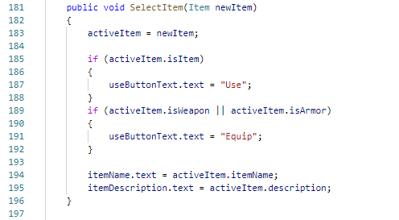

Figure 87 shows the code snippet for the GameMenu script (part 8).

Figure 87 is a function to be triggered when an item is selected in Item tabs. It will change the button text to “use” or “equip” based on selected items.

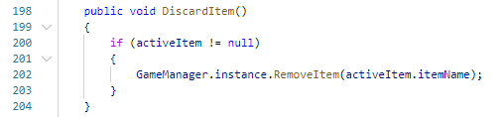

Figure 88 shows the code snippet for the GameMenu script (part 9).

Figure 88 is a function that is triggered to discard items from inventory.

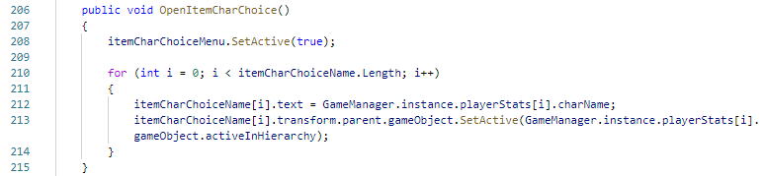

Figure 89 shows the code snippet for the GameMenu script (part 10).

Figure 89 is a function that is triggered when an item is being used or equipped. Another menu will be bought up to choose the active character name, as shown in Figure 78.

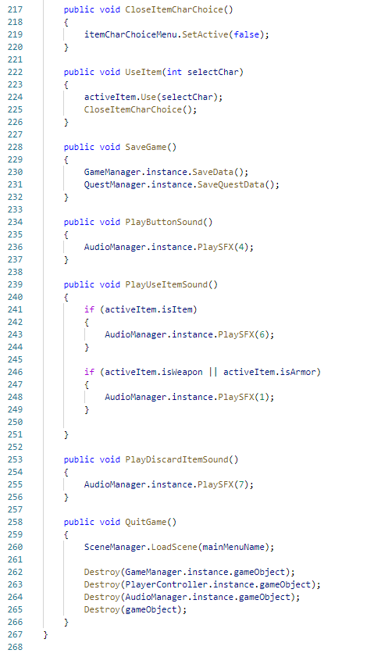

Figure 90 shows the code snippet for the GameMenu script (part 11).

In Figure 90, the CloseItemCharChoice() is to close the Figure 89 script. UseItem() is being run when the button is pressed, and it is attached as shown in Figure 91. SaveGame() function is run when the Save button is pressed. Most of the data required to be stored are the player stats and quest data. Therefore the process was done by GameManager script and QuestManager script. Then all the similar audio functions are set up to be assigned to the button OnClick() function to play specific sound effects. Lastly, QuitGame() function is to quit the game. Therefore, Destroy() function is being called to destroy all the scripts.

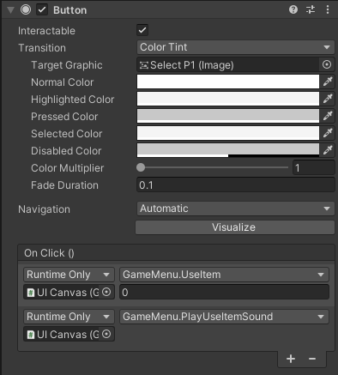

Figure 91 shows the OnClick() function in the button in Unity Editor.

#### Shop

Shop user interface is similar to the item tab in the Menu from the previous section.

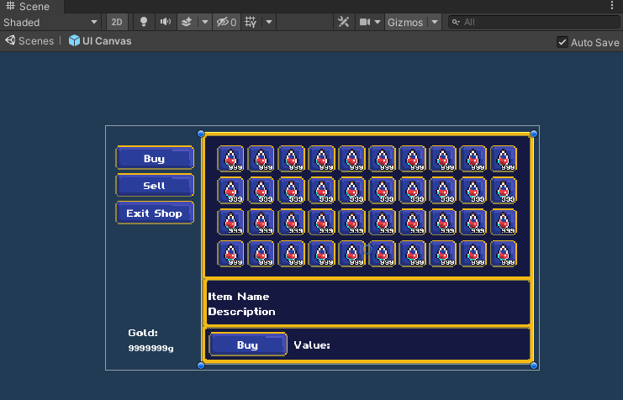

Figure shows the Buy tab in the Shop user interface in the scene panel.

The item from the buying section will be retrieved from the Shopkeeper script, which is usually attached to a Non-Playable Character (NPC) GameObject. For example, Figure 93 shows the item that the NPC would sell.

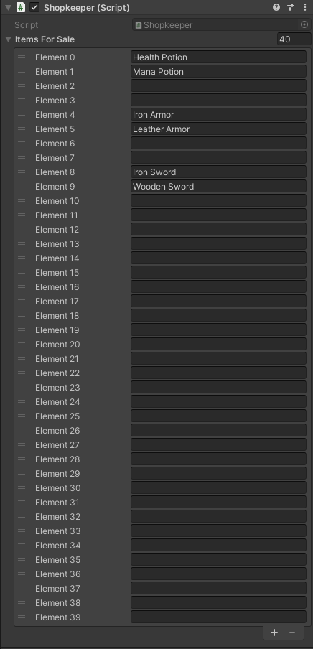

Figure shows the item list from a Shopkeeper NPC in Scene.

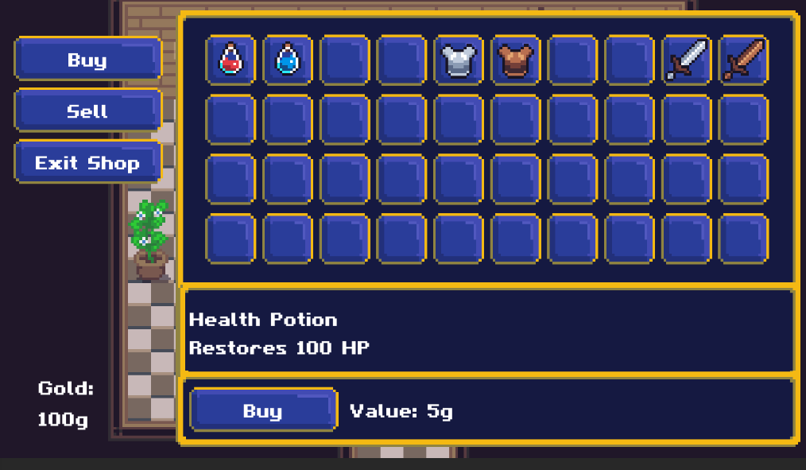

Figure shows the Shop user interface in the game.

While in the selling section, the inventory info is retrieved from player data in the GameManager script.

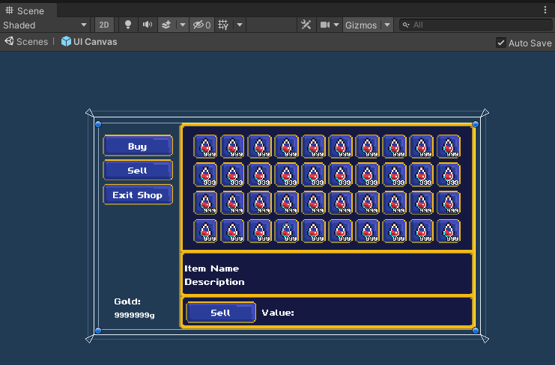

Figure shows the Sell tab in the Shop user interface in the scene panel.

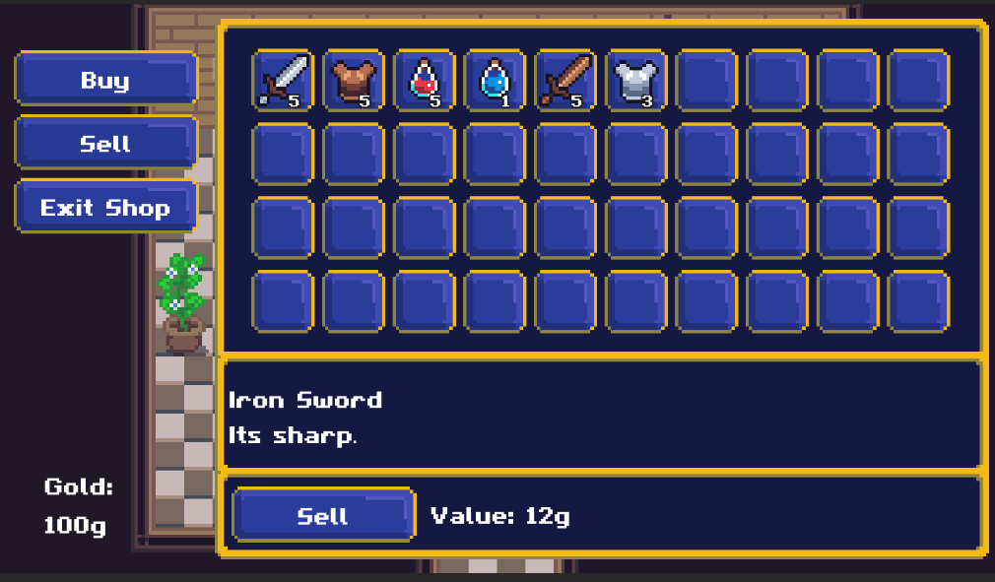

Figure 96 shows the Sell tabs in the game.

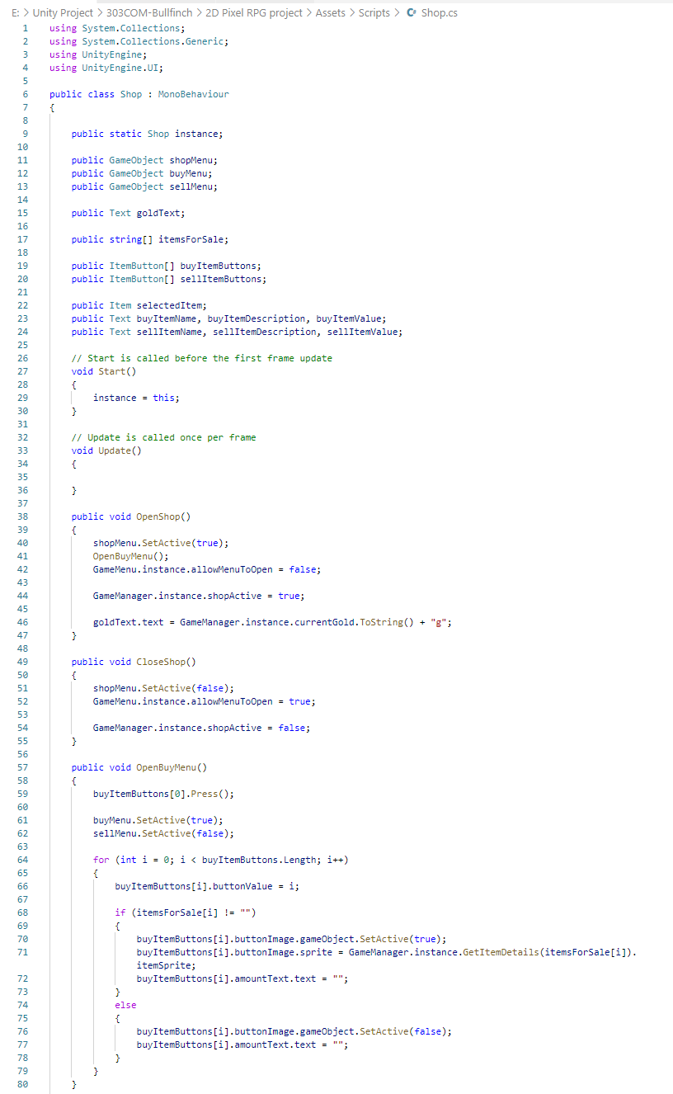

Figure shows the code snippet for the Shop script (Part 1).

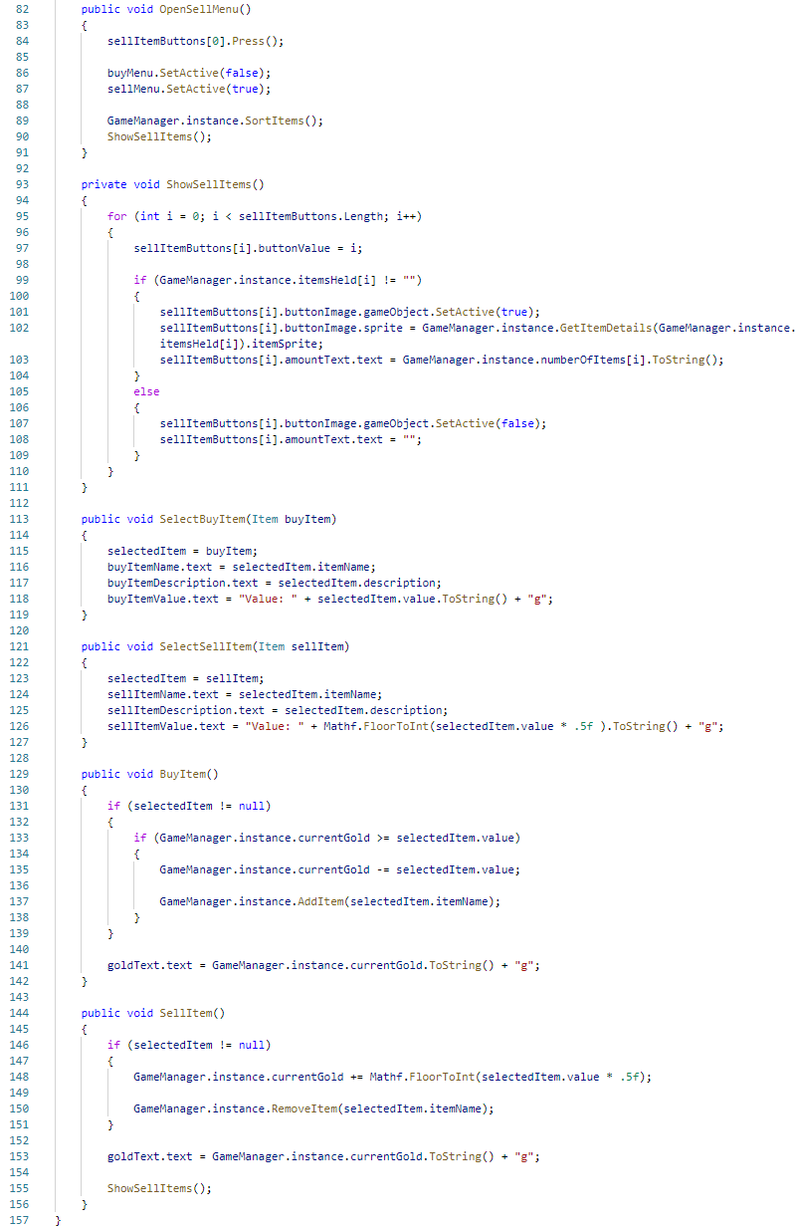

Figure shows the code snippets for the Shop script (Part 2).

#### Reward

The Reward user interface is shown on-screen whenever the user completes a specific task. The function of this user interface is to inform the user about their rewards for the task done.

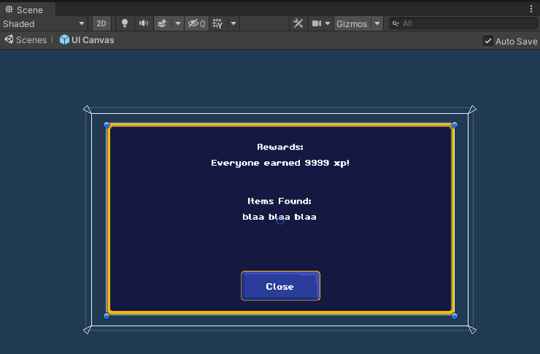

Figure 99 shows the Reward GameObject in the scene panel.

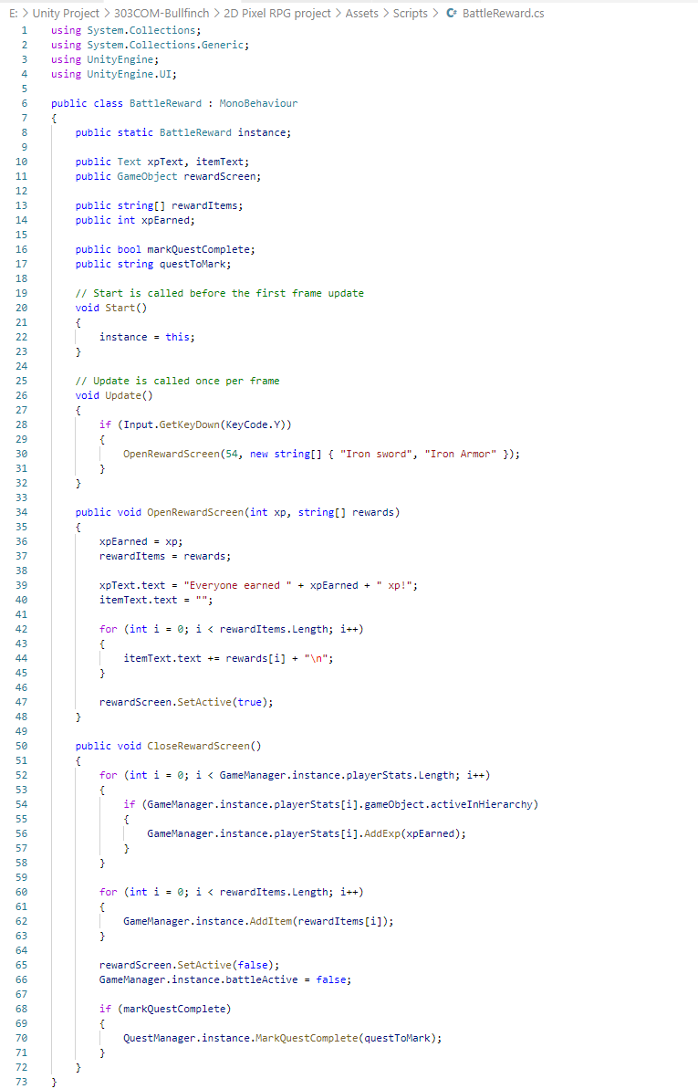

Figure 100 shows the code snippets for the BattleReward script

To prompt this user interface, another script can create an instance of the BattleReward script with OpenRewardScreen() function that has the reward parameters. For example, quest reward can be prompt on the screen by attaching QuestReward script on a GameObject as a component, as shown in Figure 101.

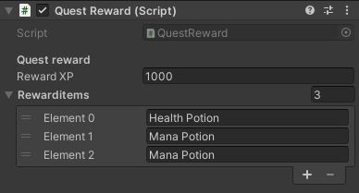

Figure 101 shows the component of RewardScreen GameObject.

### GameManager

GameManager GameObject in this project holds the data of the player. For example, players' character level in game, items that player has in their inventory, quest data that player had completed, or just started. The GameManager GameObject holds two components: GameManager script and QuestManager script, as shown in Figure 102.

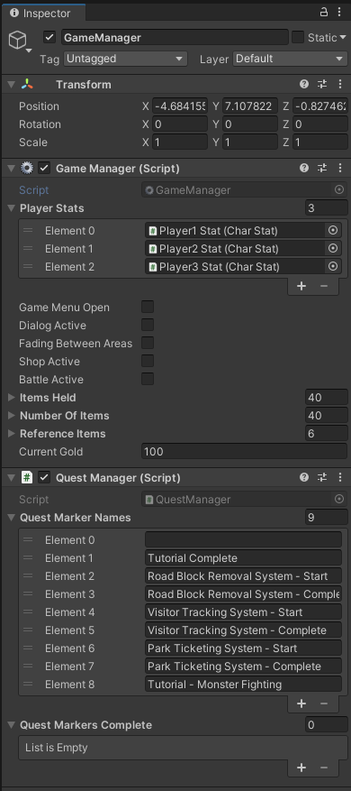

Figure 102 shows the component details of the GameManager GameObject.

#### GameManager Script

GameManager Script is required for every scene. Therefore, during the starting update, it is required to check for an instance of GameManager is running. If it is running, check whether if it is a clone instance or a current instance. Unity will make clones of instances that are set to DontDestroyOnLoad(). Therefore it might break the game data recording. While in the Update(), it is required to check for the condition to stop player character from moving during a certain event. For example, when talking to an NPC, the player should not move around, so PlayerController.instance.canMove is set to false.

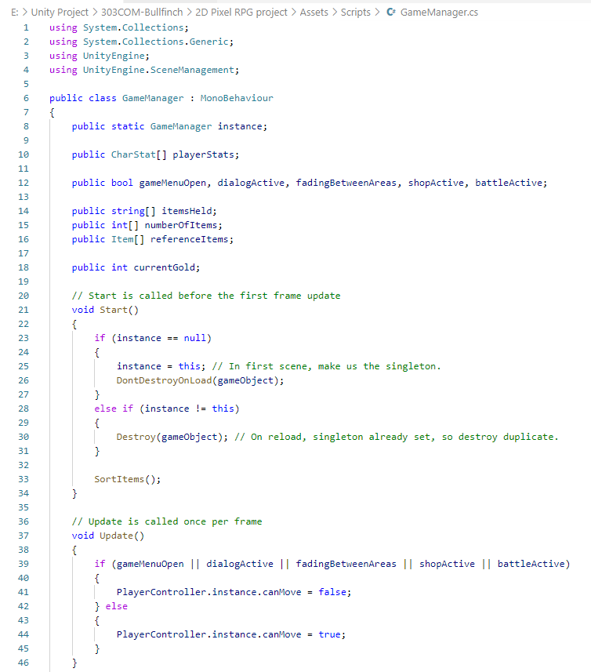

Figure 103 shows the code snippet for GameManager script (Part 1).

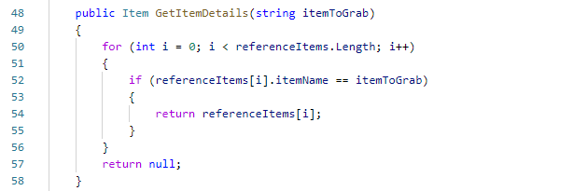

Figure 104 shows the code snippet for the GameManager script (Part 2).

The function in Figure 104 is to grab the item data stored in Prefabs. To cross-check whether the item in player inventory or shop exists in the Prefabs if there is, then a reference item is located, the item data is returned.

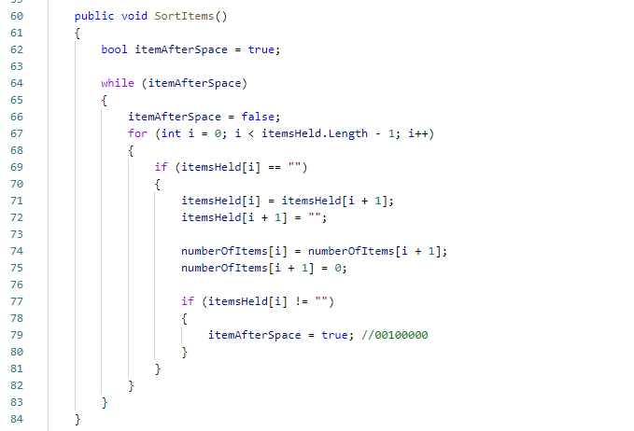

Figure 105 shows the code snippet for the GameManager script (Part 3).

The function in Figure 105 is to sort the item in player inventory. Due to there is a discarded item and selling item feature, it would be wise to have an item sorting function.

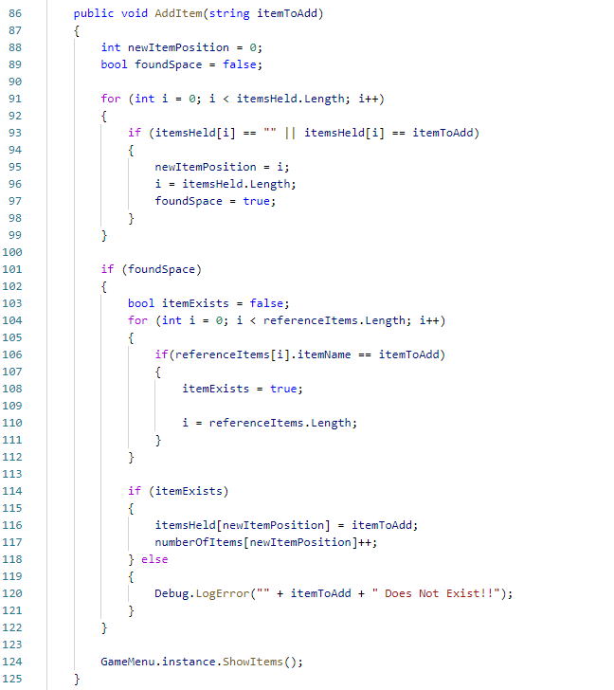

Figure 106 shows the code snippet for the GameManager script (Part 4).

The function in Figure 106 is a function that allows an item to be added to player inventory. Firstly it checks for whether if there is a space for the new item to be added. Once it finds the space, it will check whether the item is in the prefabs list. If it exists, then it will add to the position.

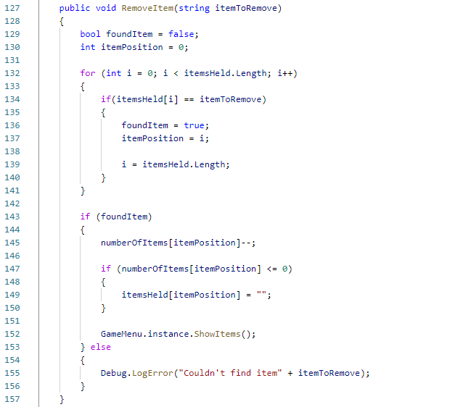

Figure 107 shows the code snippet for the GameManager script (Part 5).

The function in Figure 107 is a function that allows item removal from the player inventory. The script work for both selling item to shop and manual discarding of item from inventory. It works similar to adding items into inventory, but vice versa. Instead of adding, it removes the item.

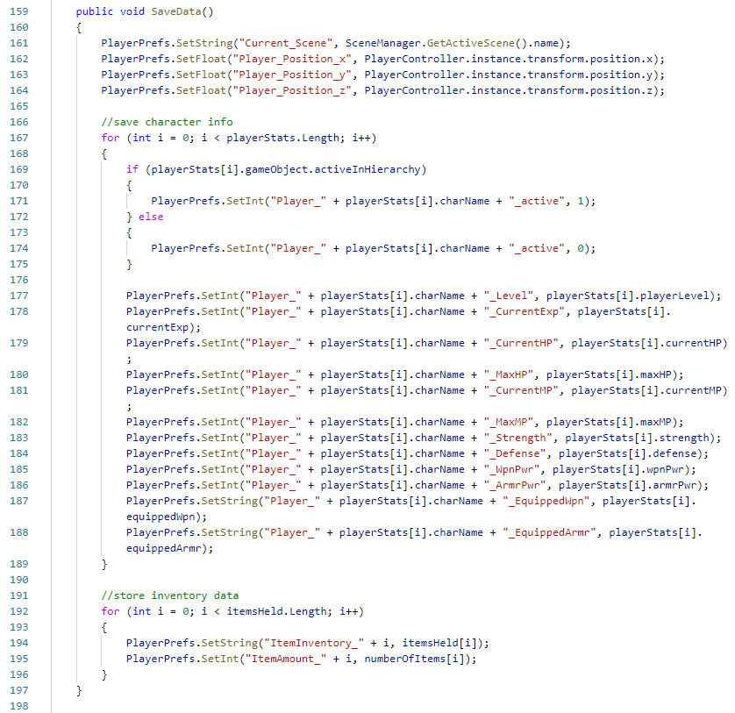

Figure 108 shows the code snippet for the GameManager script (Part 6).

This function in Figure 108 is an essential feature in the game: to save data so that the user can reload into their previous location with all their player data intact. It will be frustrating if the user has to restart the game every time they play. Therefore, using the built-in class of PlayerPrefs allows storing Player data between game sessions. It works as storing string, float and integer values into the current platform registry (Unity Technologies, 2021). All the data was save into PlayerPrefs registry by using SetFloat(), SetString() and SetInt() function.

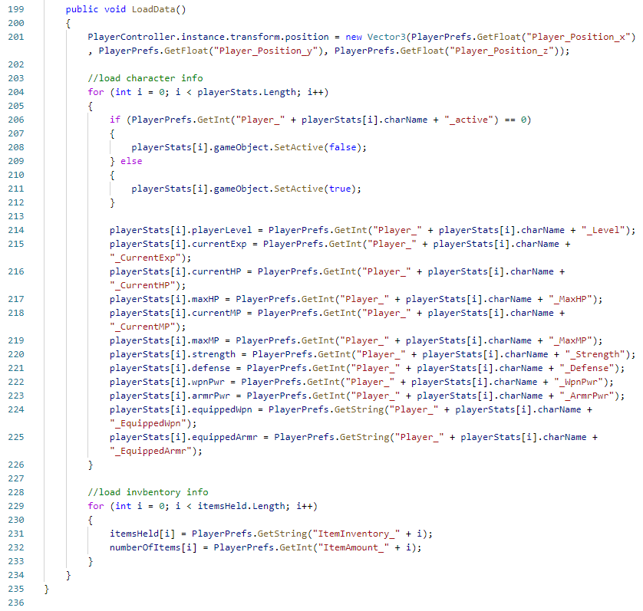

Figure 109 shows the code snippet for the GameManager script (Part 7).

This function in Figure 109 is also an essential feature in the game. This LoadData() functions allow the user to load their data back into the game by using GetFloat, GetInt and GetString to the assigned variable for each data.

#### QuestManager Script

This script acts as the quest backlog for checking whether a quest name exists in the system. It also keeps a record of the completion of the quest.

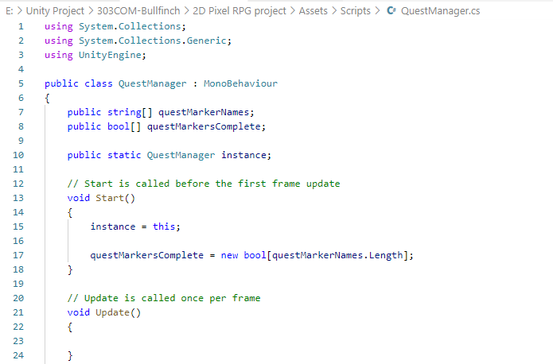

Figure 110 shows the code snippet for the QuestManager script (Part 1).

Figure 110 shows creating a completion quest marker based on the total amount of available quests.

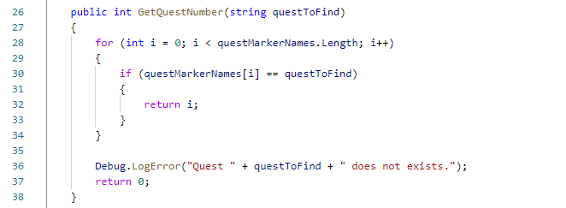

Figure 111 shows the code snippet for the QuestManager script (Part 2).

Figure 111 shows the function to get the quest from the quest list set on the Unity Editor. For example, Figure 112 shows the quest list in Unity Editor.

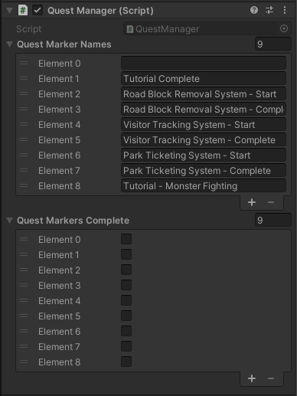

Figure 112 shows the QuestManager script component in GameManager GameObject.

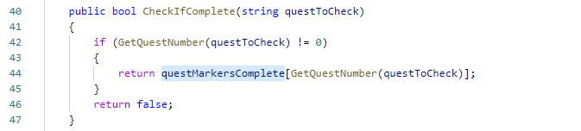

Figure 113 shows the code snippet for the QuestManager script (Part 3).

Figure 113 shows the function to check for quest completion. It is separated into different functions to allow more flexibility when checking for quest completion.

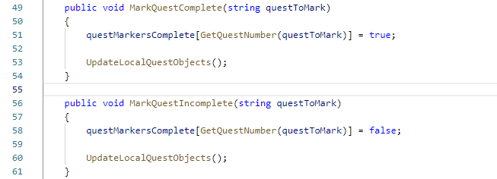

Figure 114 shows the code snippet for the QuestManager script (Part 4).

The two functions shown in Figure 114 are to mark the quest completion and update the quest object tied to the quest.

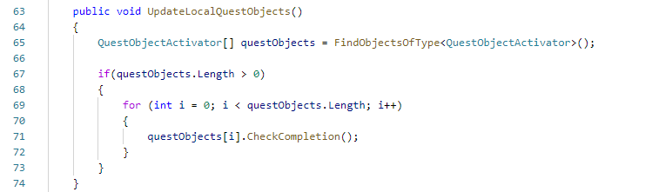

Figure 115 shows the code snippet for the QuestManager script (Part 5).

There is a script called QuestObjectActivator that act as the component of another GameObject. Thus, it acts as a script that functions to activate and deactivates the GameObject. The code snippet of the script is in Figure 116, with the sample in Figure 117 attached to a GameObject and activating another GameObject based on the quest.

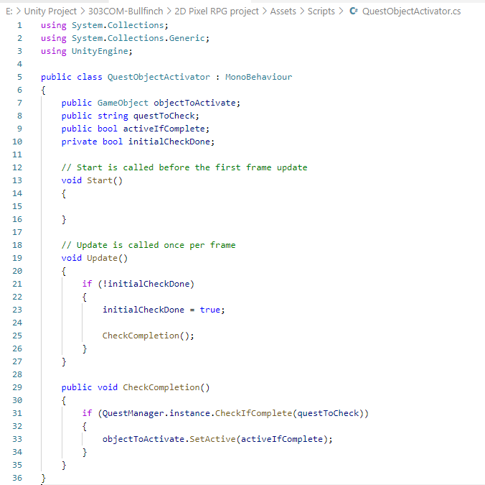

Figure 116 shows the code snippets of QuestObjectActivator Script.

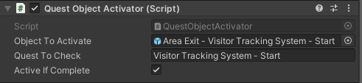

Figure 117 shows the QuestObjectActivator as a component of a GameObject.

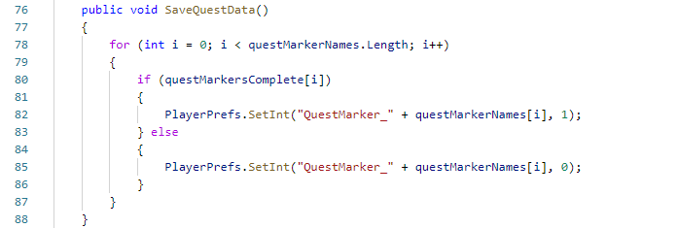

Figure 118 shows the code snippet for the QuestManager script (Part 6).

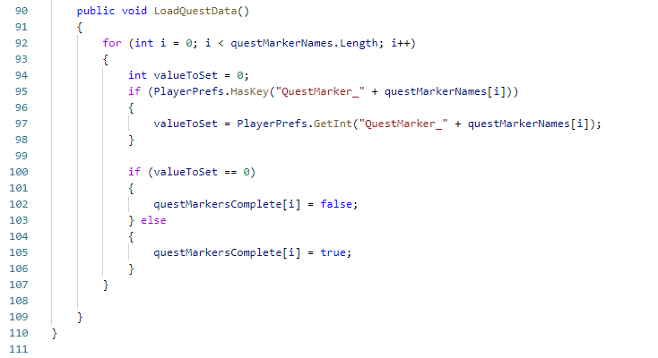

Figure 119 shows the code snippet for the QuestManager script (Part 7).

Figure 118 and Figure 119 perform the data saving and reloading similar to the explanation in GameManager Script. In addition, it saves the value to PlayerPrefs with the name and the value 0 or 1 to indicate true or false.

### AudioManager

AudioManager GameObject handles the audio of the game. Therefore, an instance is created to allow this script to be accessible from another script. To play any sound effect or background music, another script can access the function of PlaySFX or PlayBGM() with the number of which song as input parameters. The list of song and sound effects are obtained from OpenGameArt.org by Mega Pixel Music Lab. The list of sound effects and songs is shown in Figure 121.

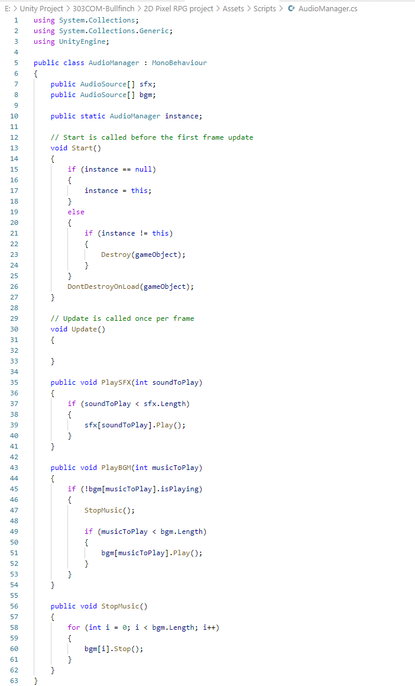

Figure shows the code snippets Audio Manager script.

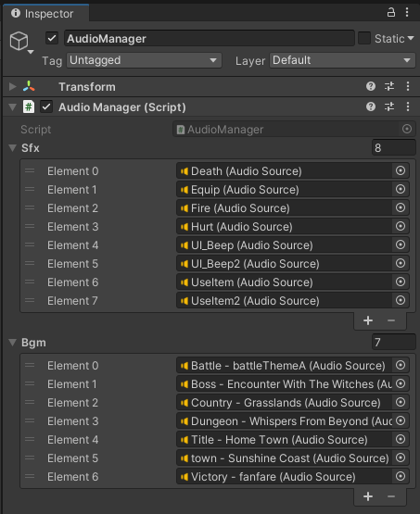

Figure 121 shows the component details of AudioManager GameObject.

### BattleManager

The player can encounter a monster in a designated zone where the grassy areas are darker green or in a cave. The RoadToAestonTown scene will be used as an example for this section, as shown in Figure 122.

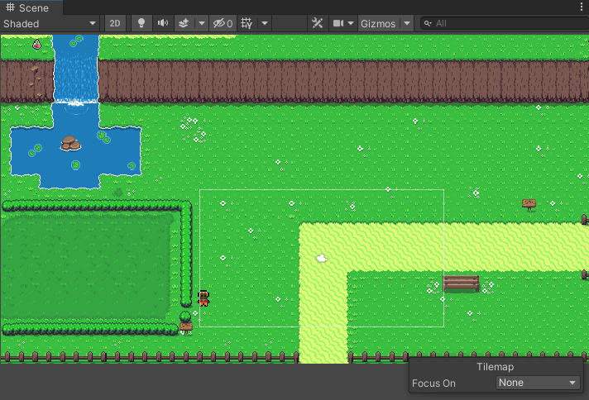

Figure shows the RoadToAestonTown scene in the Scene panel.

When the player is in the designated zone, a timer will count down when the player moves. When the timer hits zero, the screen will fade to black and change to the battle scene, as shown in Figure 123. That designated zone is created with a BattleStart script, where it is attached to a GameObject with Box Collider 2D component and is acting as a trigger for the script. In the BattleStart script, as shown in Figure 124, potential battles include enemies names and rewards. It also allows setting for to be triggered when entering, on staying or exiting the designated zone. The time between battles is the timer counting down for the player to encounter a monster in the zone. If the battle was with a specific monster, the script could disable flee function for the player. Lastly, if there’s a quest to complete, it will trigger completion for the quest based on the quest name.

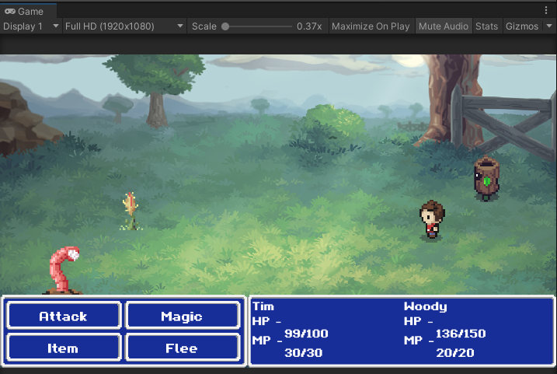

Figure shows the battle scene when the battle is started.

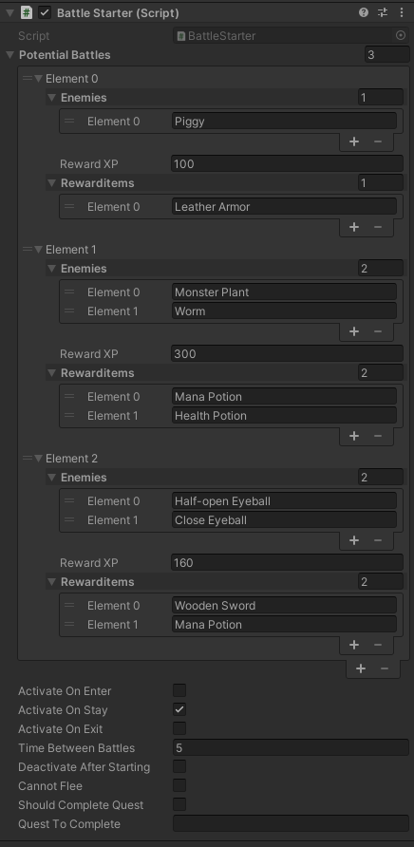

Figure shows the BattleStarter script as a component in Battle Zone GameObject.

The BattleManager script handles everything regarding battle shown in Figure 123, and it is a turn-based action alternating between player and monster. The player position and enemy position is the preset position in the scene. Thus, the player and enemy sprites will load into the scene with consistent positioning when the battle starts.

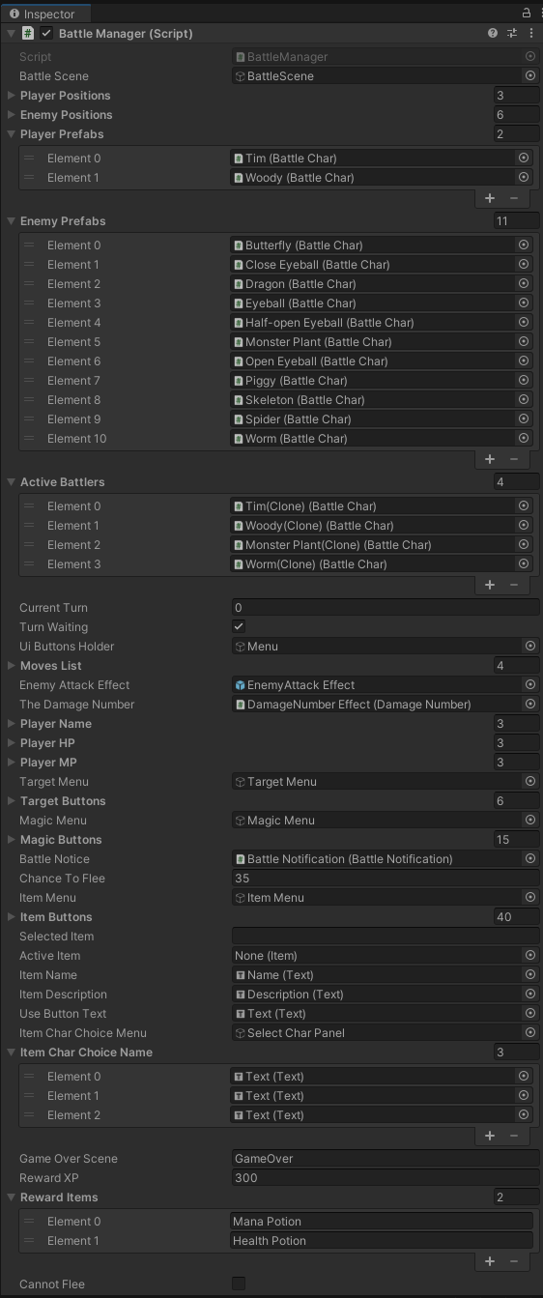

Figure shows the BattleManager script in BattleManager GameObject.

The player prefabs and enemy prefabs are set up on an array. The player prefabs contain the sprite of the player to be shown during the battle scene. At the same time, the enemy prefabs contain the sprite and the stats for the enemy, as shown in Figure 126.

When the battle is active, the Active Battlers shows the current active battler. The current turn act as the counter for which player or enemy turn to action. The rest of the section is the player's action and will not be deeply discussed. This is due to it was not being the spotlight feature of this application.

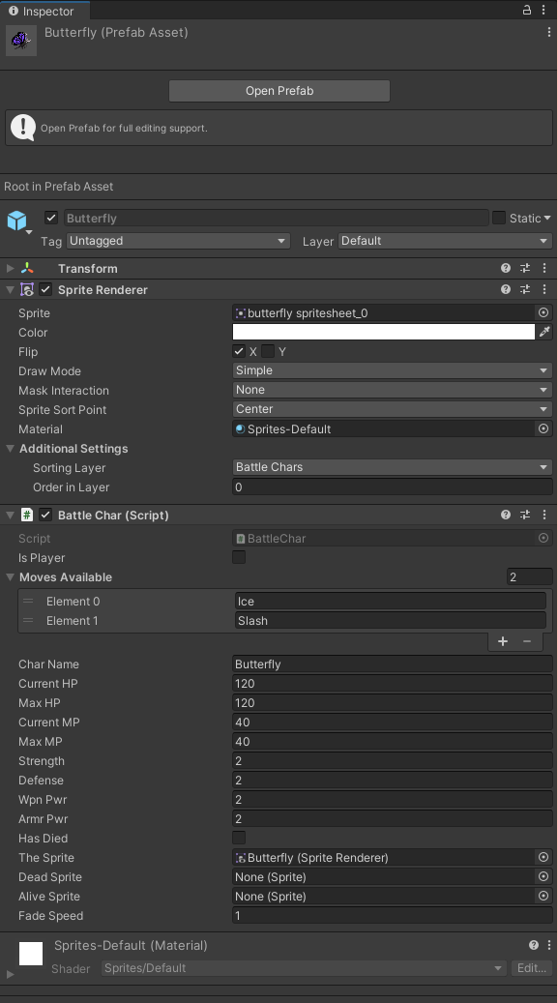

Figure 126 shows the Butterfly enemy prefabs component details.

## Use Case System

The Use Case System is the core feature of the system. Every part and functionality that is mention in the previous section is a complement to this core feature. Therefore, a sample scenario will aid in describing the flow of the entire Use Case System. The sample scenario would flow through the first level of use case related quest in the system.



### Scenario

The figure below would be a Countryside scene the player will encounter after leaving the tutorial scene, as shown in Figure 127. NPC that need help would have an exclamation mark in a chat box appear on top of their head. The player can interact with the NPC by using the Left Mouse Button (LMB) near the NPC. However, if the player did not understand the exclamation mark, all the interactable elements in the scene will guide the player to interact with the NPC in need. For example, a fallen tree blocks player progression in this scene, as shown in Figure 128.

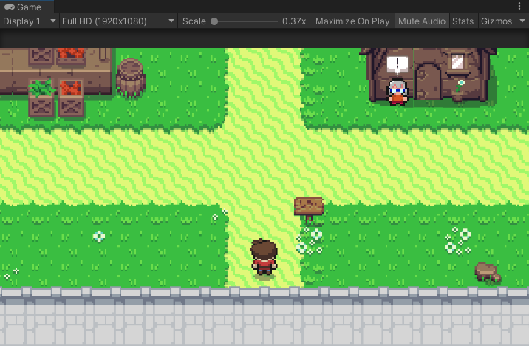

Figure shows the players perspective when they left the tutorial scene.

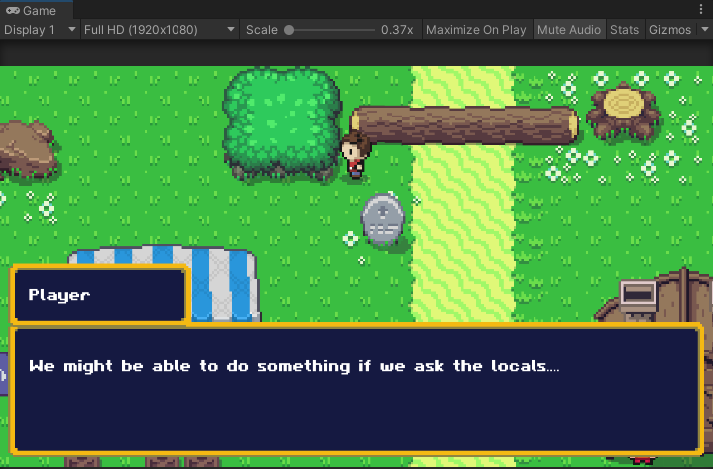

Figure shows the dialogue box prompt when the player interacts with an interactable element in the game.

Therefore, the player will be guided to the NPC in need. Talking to the NPC in need will accept the quest, and a quest area will be unlocked. For example, in this scenario, the Old Lady NPC would outline what happened and what the player should do to help, as shown in Figure 129. Then, the door beside Old Lady NPC would be opened, as shown in Figure 128. After that, the player can interact to the Old Lady NPC again if that player forgets the dialogue.

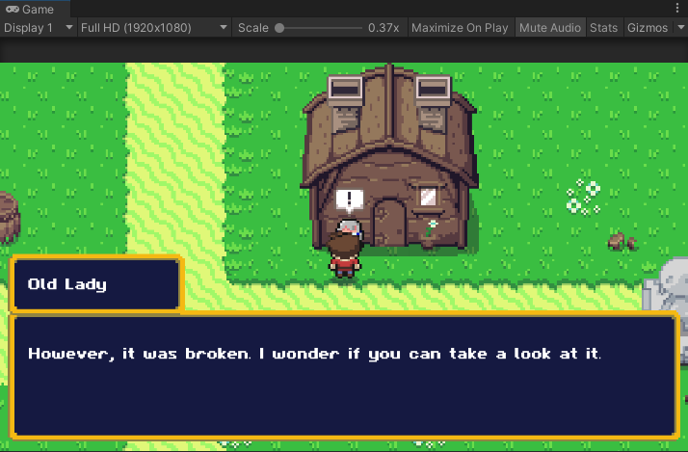

Figure shows the dialogue box that prompts up when interacting with the Old Lady NPC.

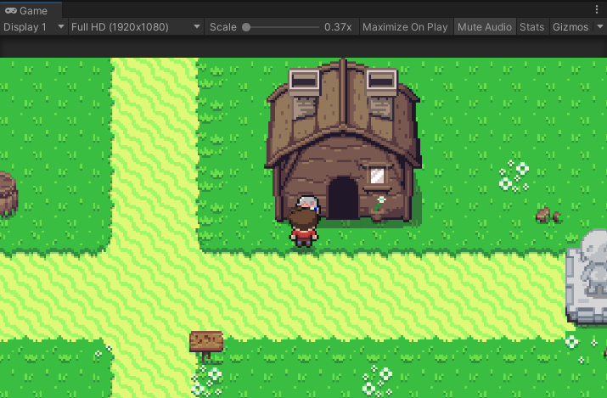

Figure shows the door that opened after the player was done talking to the Old Lady NPC.

When the player enters the quest areas, they will be greeted by an NPC, the overseer of the entire system. If the player wants to understand more info regarding the quest can interact with the NPC. For example, in this quest, the player would be greeted by a manual and an NPC upon entering the quest area, as shown in Figure 131.

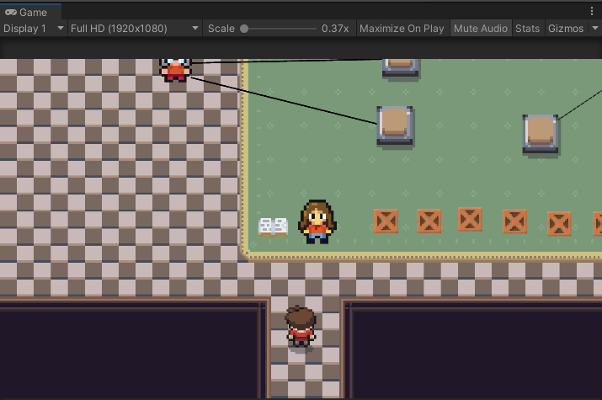

Figure shows the player perspective upon entering the quest area.

To complete the quest, the player would need to fix the broken system. The broken system is a Use Case Diagram simulation that requires fixing. The crate is the Use Case, which has a Use Case condition attached to it. At the same time, the switch on the floor act as the designated spot for the crate to be placed into. The NPC on the side is the Actor for the use case diagram. The black lines on the floor, with arrows or dotted arrows, are the Use Case diagram relationships. Players are expected to understand Use Case Diagram symbols and notation before attempting the system. To understand what is the Actors need, the player can interact with the Actor NPC. For example, in Figure 130, the Villager Actor explain her need.

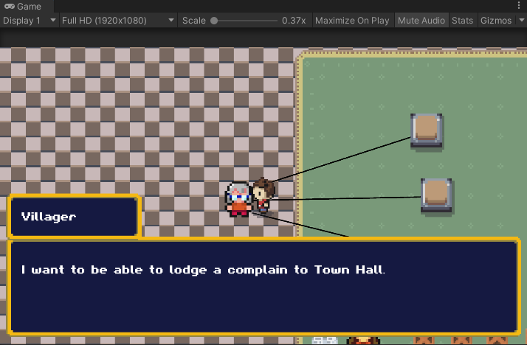

Figure shows the interaction between the player and the Actor NPC.

Next, the player can interact with the crate to understand what Use Case is attached and then push it to the switch. If the crate is on the correct switch, the switch will turn green, and the player cannot push the crate. If the crate is in the wrong switch, it will turn red, and the player can push the crate away. However, as the difficulty increase, the stage will forbid player from correcting their mistake. The player would need to reset the scene to work on the quest again.

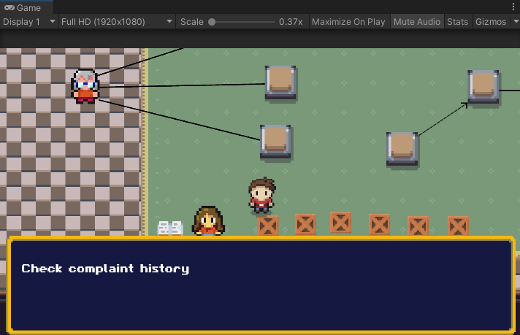

Figure shows the dialogue prompt on the crate.

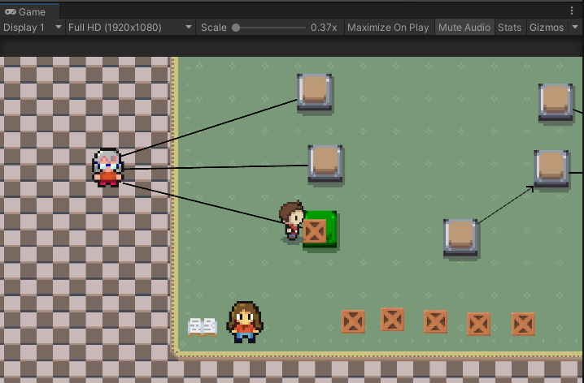

Figure shows the switch turns green if the answer is correct.

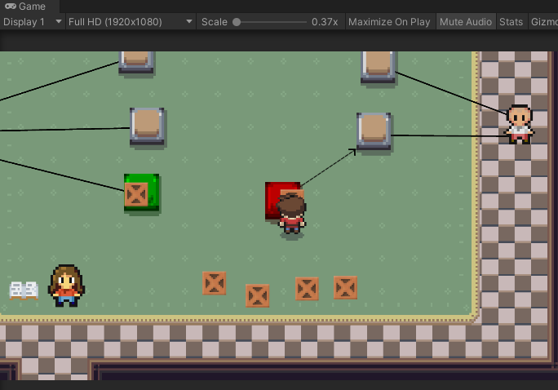

Figure shows the switch turned red if the answer is wrong.

When the all the crate is pushed onto the correct location, the quest is cleared. Then a reward screen would pop out in front of the screen with all the rewards clearly stated. The NPC that acts as the quest area's overseer will have an exclamation mark on top of its head. The player would have to chat with the NPC, and the quest will be officially marked as complete. The area will be sealed off when the player goes out from the quest areas after the quest is completed. If the player did not interact with the overseer NPC and leaves the quest area, the quest is not complete, and the player can go back to talk with that NPC to complete it.

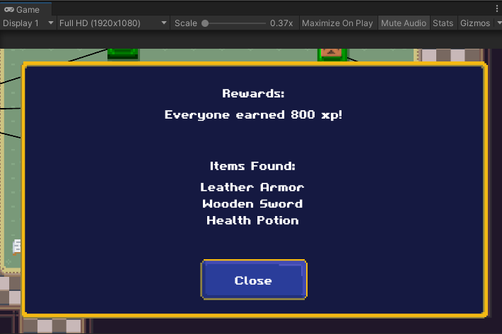

Figure shows the reward screen that prompt after all the switch is in the correct position.

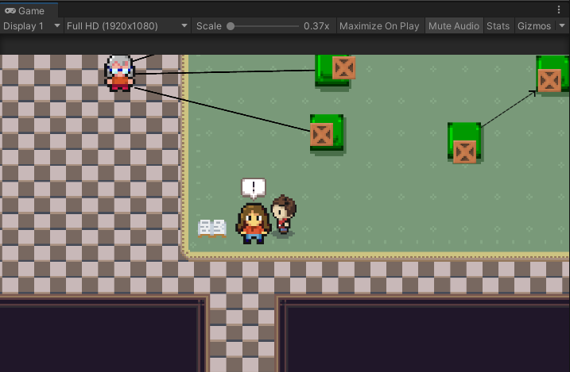

Figure shows the exclamation mark on top of the overseer NPC.

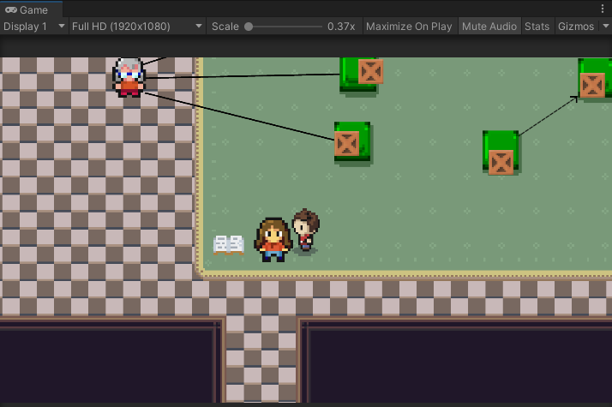

Figure shows the removal of the exclamation mark once the player talks to the NPC.

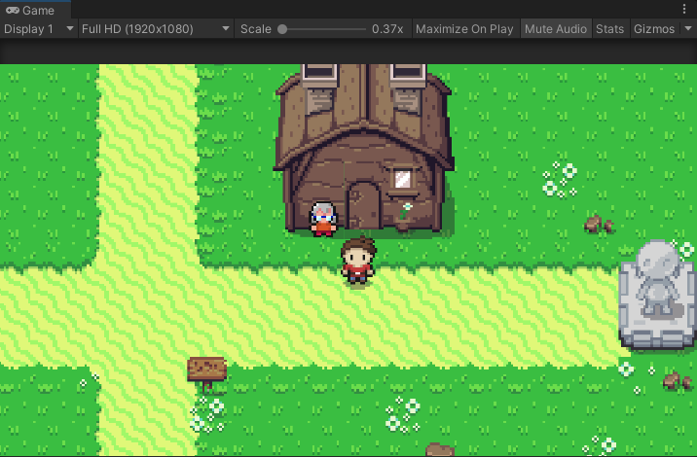

Figure shows the door behind is closed upon player leaving with quest completed.

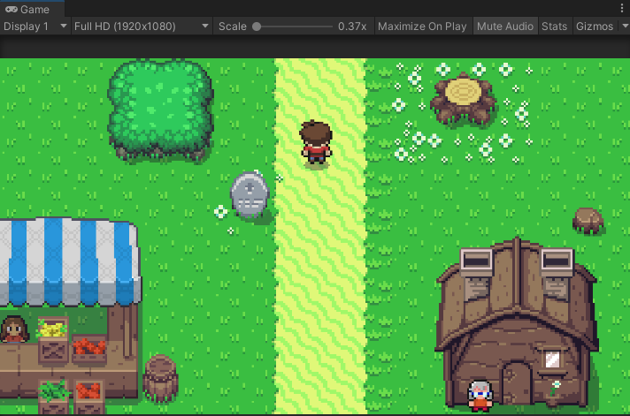

Figure shows the obstacle being removed upon the player completes the quest.

### The switch

The detection of the correct crate happens at the switch. The switch has a script component called PressureDetection. The component is shown in Figure 141. The script component is used together with a Box Collider 2D set to IsTrigger. Therefore it will send a signal when something enters the designated spot. The signal is then catch by using OnTriggerExit2D() and OnTriggerStay2D() within the PressureDetection script.

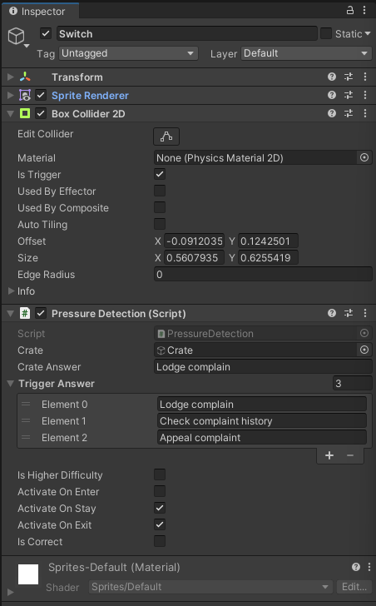

Figure shows the component detail of the Switch GameObject.

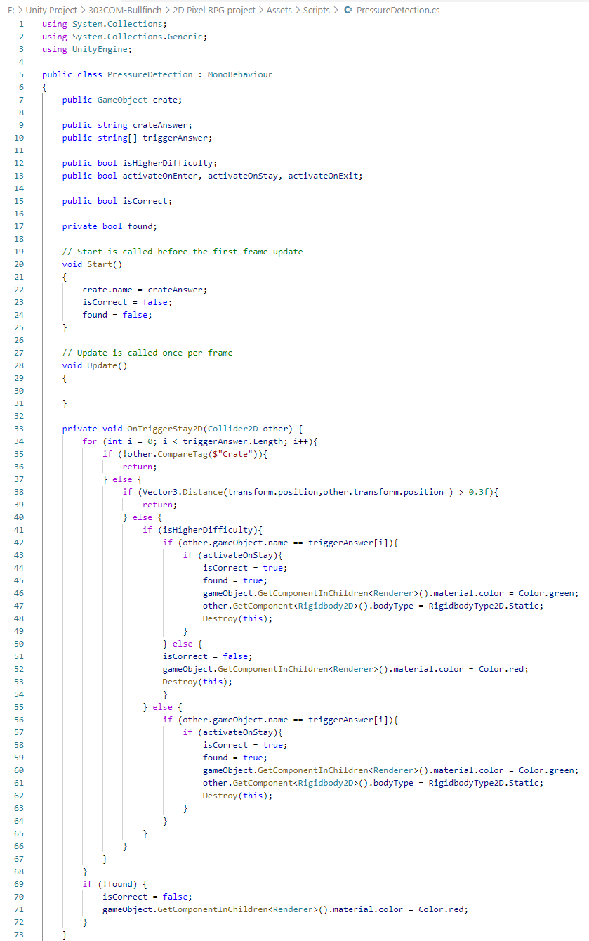

Figure shows the code snippets of the PressureDetection script (Part 1).

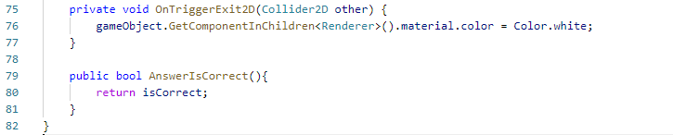

Figure shows the code snippets of the PressureDetection script (Part 2).

In the Start() function, the crate GameObject assigned as a variable to the script is given a name, the Use Case name. Then when the crate enters and stays inside the Box Collider 2D trigger area, it will send a signal to OnTriggerStay2D() and trigger the function in it. The crate GameObject has the tag “Crate” on it. Therefore, at the outermost layer, the if-else statement checks for that, so it does not activate accidentally by having the player enter the switch trigger area. Next, it checks if the crate's position stops in larger than 30% of the area of the switch trigger area. Lastly, if a greater difficulty is intended, the switch will function differently if the switch colour turns red. A greater difficulty is intended to force the player to reset the entire quest before attempting again. In contrast, a standard difficulty is for the player to have a trial and error mentality.

Then, to have the switch remove the colours, the OnTriggerExit2D() function is used to detect the crate's exiting from the switch trigger area.

### NPC Dialogue

The dialogue system in the project uses a Non-Branching Dialogue. It is the simplest form of interaction (Ellison, 2008; botttos, 2021), walking up to an NPC and initiating the conversation. The NPC then delivers their lines, and the conversation ends.

There are also certain events where the same NPC would have different things to say, but the player will never have control over the conversation. The only decision making involved is whether or not to talk to the NPC.

## Future Work

This section will talk about the support and maintenance for the system to improve it. Unfortunately, due to the lack of project period, the feature set mentioned will be a future development.



### Patch System

There is only 3 Use Case scenario in the system. Therefore to provide more Use Case scenarios instead of a One-Off system, there is a need to develop a patch system. The patching system would generally have three components described in Figure 144.

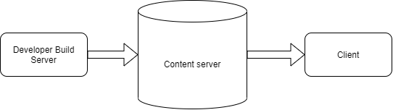

Figure 144 shows the component of a patching system in the plan for the future.

The patching system has to be a different executable, as files cannot be edited as long as the main system is active. So first, by looking into the content server, the patching system would have to look for a text file called “version.txt” then read the text file. The text file will have a version number in it, for example, “0.1”. Next, the patching system will check against the current system version number to ensure that the version number in the content server is greater than the Then it will access the “patch.txt” file in the content server, where the “patch.txt” file will list out the file list to download and replace.

### Use Case Scenario

More Use Case Scenario will be added to the system via the patching system in the future. The Use Case Scenario will attempt to combine daily lifestyle into the system. It would allow an easier understanding of the business processes that are carried out systematically.

### Game Design Element

Some Game Design elements mentioned in the report section 2.7.1 are implemented in this project. However, due to project time constraint, not every Game Design Element are implemented. Below are the table of Game Design Element that is implemented,

Table shows the Game Design elements that are in the project.

|  |  |  |
| --- | --- | --- |
| **Game Design Element** | **Implemented (Yes/No)** | **Appearance in Project** |
| Points | Yes | Experience Point |
| Performance Graph | Yes | Levels |
| Badges | No | - |
| Leaderboards | No | - |
| Avatars | Yes | Player controlled in-game character |
| Meaningful Stories | Yes | Questing |
| Teammates | Yes | Another character that assists the main character |

The Game Design elements that are not implemented will be introduced in the future. For example, additional teammates or support characters are at work. In addition, it will act as a collectable to fuel the social relatedness of the player and motivate the player to collect it.

## Conclusion

This project development section starts with an introduction to the primary game term used in game development. Then introduce map creation for in-game world generation to allow a better understanding of the process of map creation. Next is about important essential GameObject in the system and how to set it up. Before closing, a walkthrough of a demonstration of the Use Case system was done. Lastly, some sneak peek of future work in progress that is planned.

The upcoming section will discuss Evaluation and Results, including a unit test and a usability test.

# Evaluation and Results

## Introduction

This section contains the evaluation of test cases, and the result of the test cases. The unit testing will be separated by scenes in Unity. The unit testing will be conducted in Unity Editor, whereas the usability testing is conducted over an interview via Google Meet video conferencing platform.

## Unit Test

### Navigate in “MainMenu” Scene

|  |  |  |  |  |
| --- | --- | --- | --- | --- |
| No. | Test Case | Expected Result | Test Result | Comment |
| 1 | New Game | Screen fade to black. Then player will be shown into Tutorial Scene | Pass |  |
| 2 | Continue | Will not be shown if there is no save data detected. | Pass |  |
|  |  | Will be shown if there is save data detected | Pass |  |
| 3 | Exit Game | Exit from the game | Fail | Nothing happened, because the script does not work in Unity Editor. But it work properly when compiled. |

### Navigate in “Tutorial” Scene

|  |  |  |  |  |
| --- | --- | --- | --- | --- |
| No. | Test Case | Expected Result | Test Result | Comment |
| 1 | View Signboard 1 | When user stand in front of the signboard and press Left Mouse Button, a dialog user interface pop out with preset dialog in it. User are also able to go through all the message. When the message end, the dialog user interface will close. | Pass |  |
| 2 | View Signboard 2 | Pass |
| 3 | View Signboard 3 | Pass |
| 4 | View Signboard 4 | Pass |
| 5 | View Signboard 5 | Pass |
| 6 | View Signboard 6 | Pass |
| 7 | View Signboard 7 | When user stand in front of the signboard and press Left Mouse Button, a dialog user interface pop out with preset dialog in it. User are also able to go through all the message. When the message end, the dialog user interface will close. The door will open for player to progress to next map. | Pass |  |
| 8 | Exit the area | When the door is open, player can walk through the open door and the screen fade to black. Fade from black to show new map. | Pass |  |

### Navigate in “Countryside” Scene

|  |  |  |  |  |
| --- | --- | --- | --- | --- |
| No. | Test Case | Expected Result | Test Result | Comment |
| 1 | View Signboard | Show the message "Welcome to Llyn Village" when player interact with it | Pass |  |
| 2 | Talk to the Girl NPC in the stall | Show dialogue message when player interact with it | Pass |  |
| 3 | Interact with the fallen tree | Show dialogue message when player interact with it | Pass |  |
| 4 | Interact with the Old Lady NPC | Show dialogue message and unlocking a door beside the NPC when player interact with it | Pass |  |
| 5 | Interact with the Stone monument | Show some dialogue message when player interact with it. | Pass |  |
| 6 | Interact with the Stone marker | Show the message "Direction to Aeston Town" when player interact with it. | Pass |  |

### Navigate in “Quest - Road Block Removal System” Scene

|  |  |  |  |  |
| --- | --- | --- | --- | --- |
| No. | Test Case | Expected Result | Test Result | Comment |
| 1 | Talk to the Girl NPC | Show the preset dialogue | Pass |  |
| 2 | Talk to the Villager Actor NPC | Show the preset dialogue | Pass |  |
| 3 | Talk to the Townhall Clerk Actor NPC | Show the preset dialogue | Pass |  |
| 4 | Talk to the Guide Book NPC | Show the preset dialogue | Pass |  |
| 5 | Talk to Crate 1 | Show "Lodge Complain" dialogue | Pass |  |
| 6 | Talk to Crate 2 | Show "Check Complaint History" dialogue | Pass |  |
| 7 | Talk to Crate 3 | Show "Appeal complaint" dialogue | Pass |  |
| 8 | Talk to Crate 4 | Show "Check list of complaint" dialogue | Pass |  |
| 9 | Talk to Crate 5 | Show "Sent in worker" dialogue | Pass |  |
| 10 | Talk to Crate 6 | Show "Mark work completion" dialogue | Pass |  |
| 11 | Push Crate to incorrect switch | Switch will turn green and crate stop moving. | Pass |  |
| 12 | Push Crate to Correct switch | Switch will turn red | Pass |  |
| 13 | All the Switch turn Green | Reward Screen pop up, Exclamation mark pop up on top of Girl NPC, Girl NPC would have new dialog that will remove the fallen tree logs. | Pass |  |

### Navigate in “RoadToAestonTown” Scene

|  |  |  |  |  |
| --- | --- | --- | --- | --- |
| No. | Test Case | Expected Result | Test Result | Comment |
| 1 | View the Signboard | Show preset dialogue. | Pass |  |
| 2 | Talk to the Vince NPC | Show dialogue message and remove a bush. | Pass |  |
| 3 | Enter a battle with monster | Screen fade to black, turn into monster battle scene with specific UI | Pass |  |
| 4 | Exit the area | Screen fade to black, then fade from black to show new map. | Pass |  |

### Navigate in “AestonTown” Scene

|  |  |  |  |  |
| --- | --- | --- | --- | --- |
| No. | Test Case | Expected Result | Test Result | Comment |
| 1 | View the Signboard 1 | Show preset dialogue "Welcome to Aeston Town" | Pass |  |
| 2 | Talk to the Jimmy NPC | Show a preset dialogue. | Pass |  |
| 3 | View the Signboard 2 | Show preset dialogue "Shop" | Pass |  |
| 4 | Entering the Shop | Screen fade to black, then fade from black to show shop scene. | Pass |  |
| 5 | Talk to the Stan NPC | Show a preset dialogue. | Pass |  |
| 6 | View the Signboard 3 | Show a preset dialogue "Monster Park" | Pass |  |
| 7 | Entering the Monster Park | Screen fade to black, then fade from black to show MonsterParkInner scene. | Pass |  |
| 8 | View the Signboard 4 | Show a preset dialogue "Campus" | Pass |  |
| 9 | Talk to the Campus Guard NPC | Show a preset dialogue, then when finished chatting, unlock a trap door on the right. | Pass |  |
| 10 | Entering quest area | Screen fade to black, then fade from black to show quest area. | Pass |  |

### Navigate in “MonsterParkInner” Scene

|  |  |  |  |  |
| --- | --- | --- | --- | --- |
| No. | Test Case | Expected Result | Test Result | Comment |
| 1 | Talk to the Park Manager NPC | Show the preset dialogue and remove a blockade to allow player to access quest areas. | Pass |  |
| 2 | Entering quest area | Screen fade to black, then fade from black to show quest area. | Pass |  |
| 3 | Leaving through another entrance | Screen fade to black, then fade from black to show the monster park section at AestonTown. | Pass |  |

### Navigate in “Quest - Park Ticketing System” Scene

|  |  |  |  |  |
| --- | --- | --- | --- | --- |
| No. | Test Case | Expected Result | Test Result | Comment |
| 1 | Talk to Crate 1 | Show "Buy Ticket" dialogue | Pass |  |
| 2 | Talk to Crate 2 | Show "Make payment" dialogue | Pass |  |
| 3 | Talk to Crate 3 | Show "By cash" Dialogue | Pass |  |
| 4 | Talk to Crate 4 | Show "By credit card" Dialogue | Pass |  |
| 5 | Talk to Crate 5 | Show "Check ticket availability" Dialogue | Pass |  |
| 6 | Talk to Crate 6 | Show "Return Ticket" Dialogue | Pass |  |
| 7 | Talk to Crate 7 | Show "Check ticket info" Dialogue | Pass |  |
| 8 | Talk to Crate 8 | Show "Deny entrance" Dialogue | Pass |  |
| 9 | Talk to Crate 9 | Show "Approve Entrance" Dialogue | Pass |  |
| 10 | Talk to Crate 10 | Show "Sell ticket" Dialogue | Pass |  |
| 11 | Talk to Crate 11 | Show "Print ticket" Dialogue | Pass |  |
| 12 | Talk to Crate 12 | Show "Show ticket availability" Dialogue | Pass |  |
| 13 | Talk to Crate 13 | Show "Generate monthly report" Dialogue | Pass |  |
| 14 | Talk to the Supervisor NPC | Show the preset dialogue | Pass |  |
| 15 | Talk to the Clerk Actor NPC | Show the preset dialogue | Pass |  |
| 16 | Talk to the Ticket Inspector Actor NPC | Show the preset dialogue | Pass |  |
| 17 | Talk to the Guide Book NPC | Show the preset dialogue | Pass |  |
| 18 | Push Crate to incorrect switch | Switch will turn green and crate stop moving. | Pass |  |
| 19 | Push Crate to Correct switch | Switch will turn red | Pass |  |
| 20 | All the Switch turn Green | Reward Screen pop up, Exclamation mark pop up on top of Supervisor NPC, Supervisor NPC would have new dialog that will remove the obstacle to access monster park. | Pass |  |

### Navigate in “Quest - Visitor Tracking System” Scene

### Navigate in “Shop” Scene

### Navigate in “Town” Scene

#### Navigate in “battleScene”

### Navigate in “GameOver” Scene

## System Test

## Usability Test

# Discussion

# Appendix

Table The SafeAssign plagiarism checking percentage

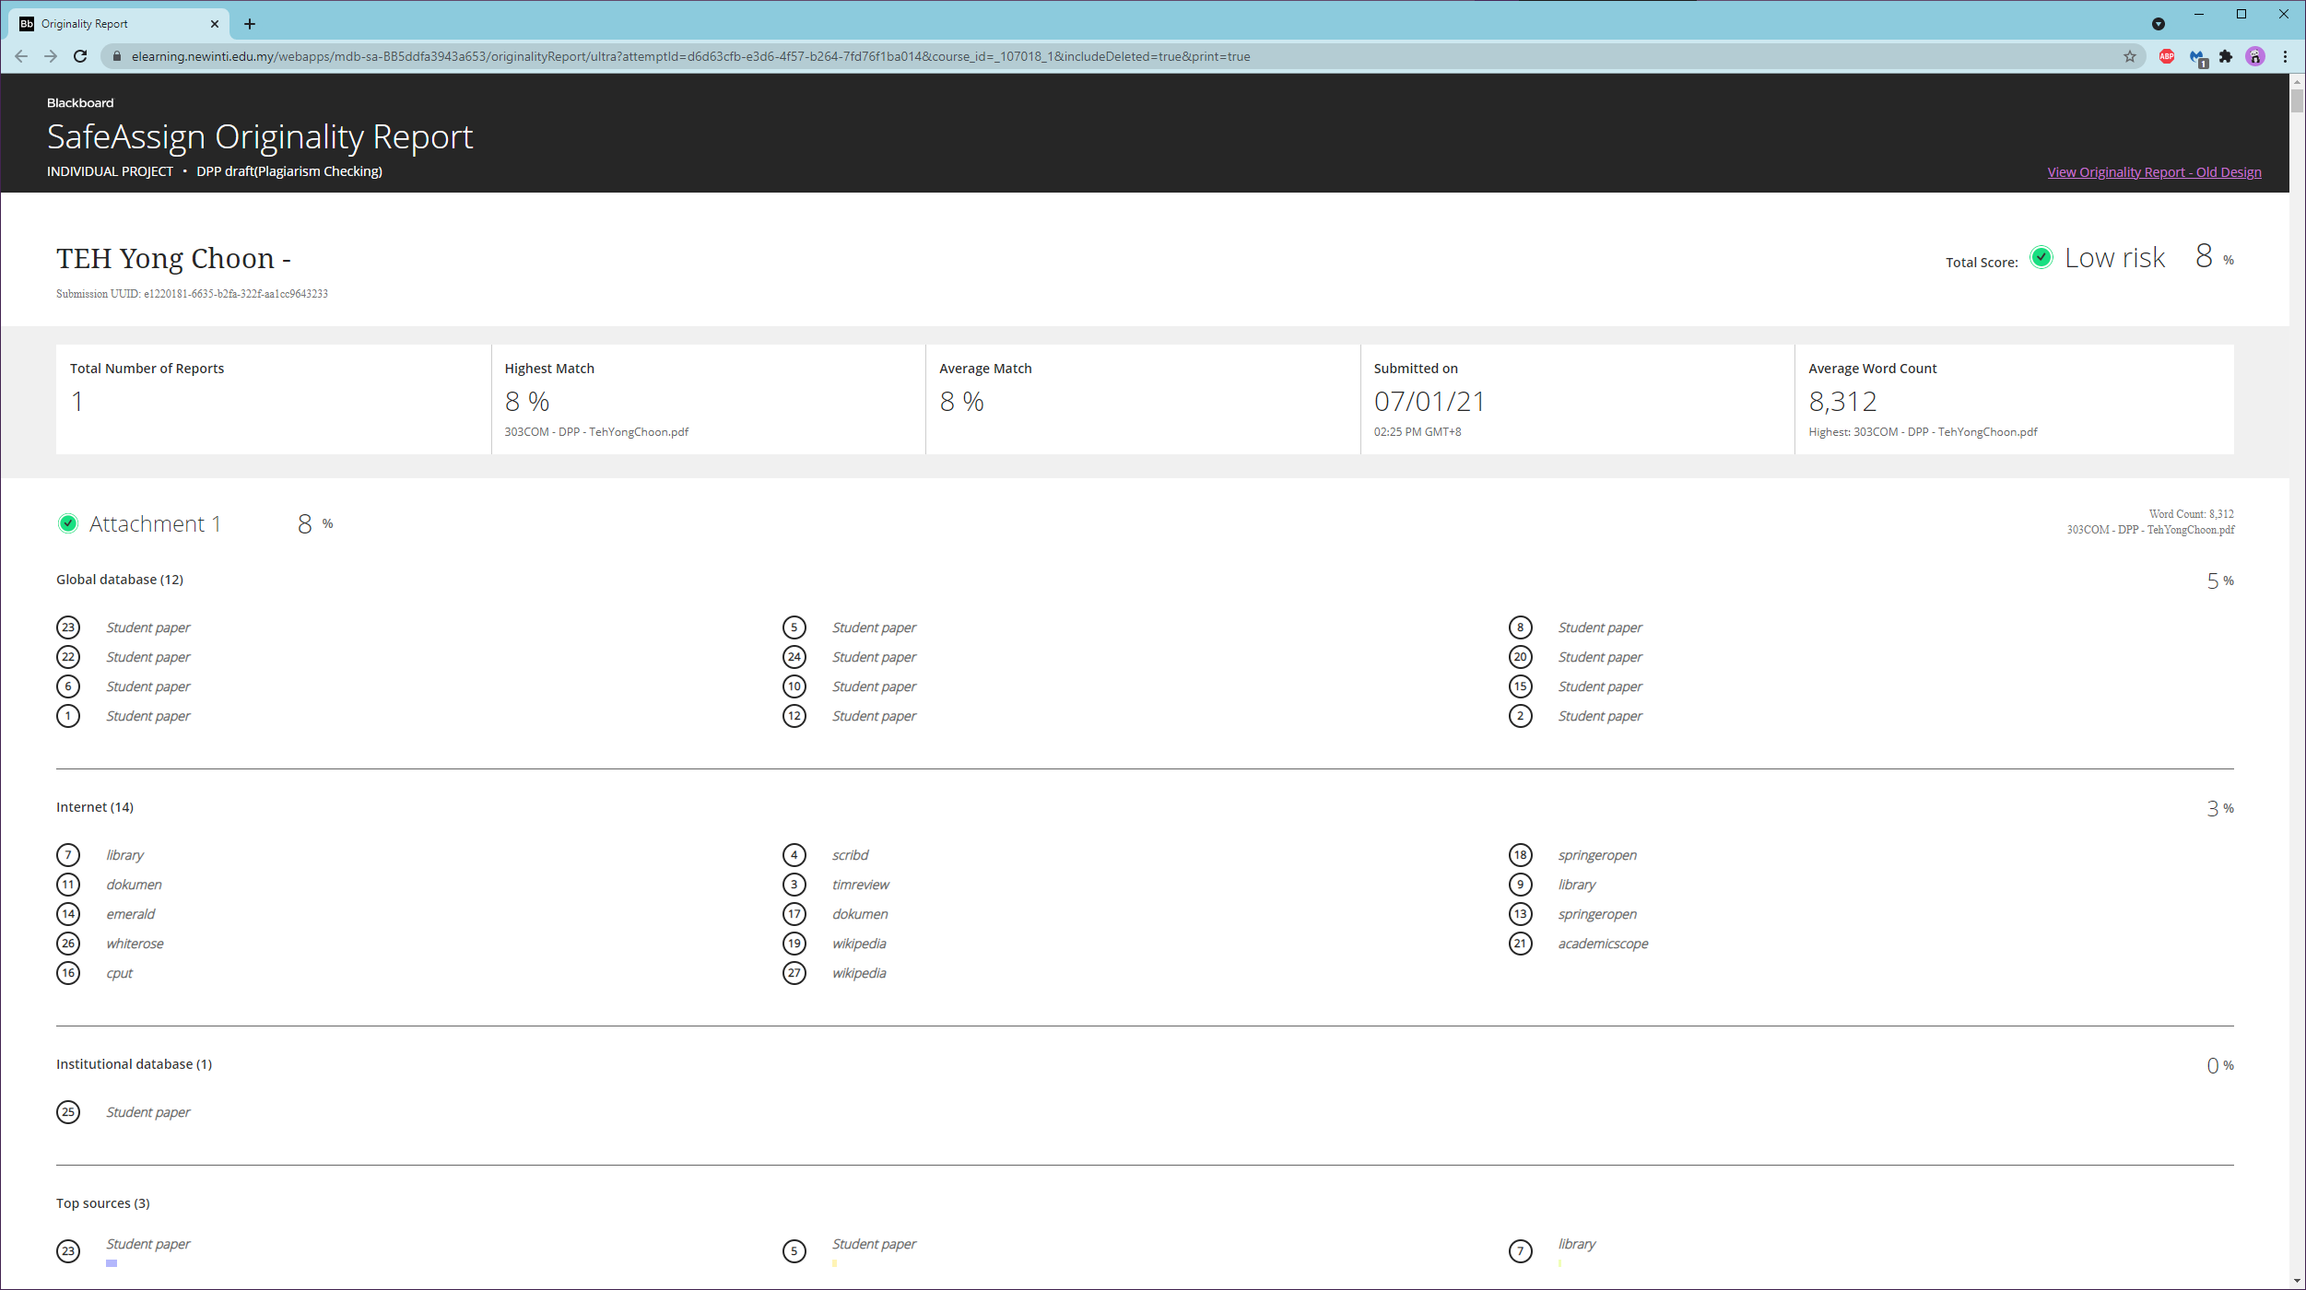

Table shows all the literature studies done for the game element usage for Figure 5

|  |  |  |  |  |  |
| --- | --- | --- | --- | --- | --- |
| **No** | **Reference** | **Study Purposes** | **Game elements** | **Key findings** | **Common themes** |
| 1 | (Albuquerque, et al., 2017) | To investigate whether gender stereotype threat in online gamified educational scenarios influences anxiety and performance | Points, badges, ranking, avatars and levels | * Differences in anxiety between control and experimental groups showed that changes in anxiety were significant in these groups (performance was equal for all approach | Learning performance |
| 2 | (Aldemir, et al., 2018) | To identify students' perceptions of game-based elements used in a gamified teacher education course | Challenges, leaderboards, narrative, rewards, badges, win state, points, teams and constraints | * Positive effects of narrative imagination components assume a unique role in developing successful gamified learning activity in the classroom. * The learners imagine that they involved in a virtual activity like in a real-life situation, and they associate themselves with the role or story idea in the narrative | Motivation and engagement, interaction and socialisation |
| 3 | (Aparicio, et al., 2019) | To propose a theoretical framework to identify the determinants of successful MOOCs and measure these factors empirically in a real MOOC context | Points, badges, levels and certificates | * Gamification proved to play a crucial role in the success of MOOCs | Learning performance, interactive learning and engagement motivation |
| 4 | (Adukaite, et al., 2017) | To study the extent to which six determined predictors (perceptions about playfulness, curriculum fit, learning opportunities, challenge, self-efficacy and computer anxiety) influence the advocacy to accept a gamified application by South African tourism teachers | Points, badges, progress bars, leaderboards and a storyline with visuals | * A significant direct relationship was found between playfulness and behavioural intention to use information technology and digital games. * The gamification application was perceived as enjoyable, fun and stimulating; teachers were willing to advocate for its adoption for tourism education * Perceived enjoyment was identified as a critical determinant | Motivation and engagement |
| 5 | (Barata, et al., 2017) | To perform a long-term study and identify how different students played and engaged in a gamified instructional course | Points, levels, leaderboards, badges and avatars | * Different student types could be identified in a gamified course, each representing a different performance level and approach to the course * The achievers, the underachievers, the disheartened students, the late awakeners, the regular students and the half-hearted students. Both achievers and regular students were considered the best-performing students. | Motivation and engagement |
| 6 | (Baydas & Cicek, 2017) | To identify the factors that may affect the gamification process in undergraduate education | Badges/medals, leaderboards or ranking, grades and points | * The students focused on earning badges, gaining a place on the leaderboards or just being successful rather than engaging in learning the content in-depth during the gamification process * Most of the students were entertained by this gamification learning process and were socially engaged with each other * The badges, medals and leaderboards decreased the efficiency of the feedback given by the researchers after each question, and the students mostly focused on the scores | Engagement, motivation, interaction and socialisation |
| 7 | (Bouchrika, et al., 2019) | To investigate how the gamification concept can affect student learning engagement and interactivity level with e-learning technologies and at the same time support sustained learning | Scores, badges and leaderboards | * Gamification can be recognised as a worthy means to attract learners for the uptake of educational systems and to enhance engagement | Learning engagement and interactive learning |
| 8 | (Buckly & Doyle, 2017) | To identify how an individual's learning style influences the experience of gamification | Achievements, avatars, badges, boss fights, collection, combat, content unlocking, gifting, leaderboards, levels, points, quests, social graph, teams and virtual goods | * Several relationships were found between learning styles and personality traits, as well as a relationship with learning performance and participation | Motivation and engagement, academic performance |
| 9 | (Chang & Wei, 2016) | To explore and identify engaging gamification mechanics for MOOC learners | Virtual goods, redeemable points, team leaderboards, 'Where is Wally' game, trophies, badges, peer emoticon feedback, memory-game interactions, checkpoints and skill points | * Virtual goods were the most engaging gamification mechanic to reinforce learner's good performance and participation * Leaderboards also motivated students' social engagement | Motivation and engagement, academic performance, interaction and socialisation |
| 10 | (Davis, et al., 2018) | To investigate how college students experience learning in a gamified informatics course | Experience points, leaderboards, level-ups and badges | * Non-gamers expressed somewhat less motivation to do well in the course than frequent gamers * There were virtually no differences between male and female students' perceptions of gamification | Learning achievement and engagement |
| 11 | (De-Marcos, et al., 2016) | To examine and compare students' learning performance between four instructional pedagogies; educational game, social networking approach, gamification and social gamification | Challenges, levels, points narrative, trophies, badges, challenges and leaderboards | * Combining gamification and social approaches produces better outcomes in terms of learning performance across the various evaluation items considered in this study | Academic performance |
| 12 | (Ding, 2019) | To promote student engagement in online discussions | Levels, experience points, badges and leaderboards | * The gamification approach had a positive influence on student learning engagement. * More students in the non-gamified group than in the gamified group reported that the platform was user-friendly * Failed to promote students' sense of community | Motivation, engagement, performance and social interaction |
| 13 | (Ding, et al., 2018) | To examine the influence of the gamification approach on student engagement in online discussions | Badges, experience points, leaderboards, progress bar, reactions, and awards | * The badges, leaderboard, progress bar and reactions appeared to have many direct and indirect effects on students' behavioural, cognitive and emotional engagement * Workload/two large projects/low engagement in online discussions | Motivation and engagement, interaction and socialisation |
| 14 | (Ding, et al., 2017) | To investigate the impact of specific game elements implemented in gEchoLu (a gamified online discussion tool) on students' learning motivation and engagement in online discussions | Badges, experience points, levels, progress bar, leaderboards and a thumbs-ups system | * Gamified learning system had positive effects on student behavioural engagement, emotional engagement and cognitive engagement * Badges, thumbs-ups, progress bars and avatars in the platform promoted student engagement in online discussions * Virtual gifts had no association with grades and were considered to have no value * The badge system was one of the least favourite game | Interaction and socialisation, motivation and engagement |
| 15 | (Ge, 2018) | To explore the effects of three rewards strategies on adult e-learners' learning performance in a gamified teaching process | Points and prize rewards | * The forfeit-or-prize reward pattern and the prize-only reward pattern could elicit a better learning outcome on e-learners than the no-prize-no-forfeit pattern * The forfeit-or-prize pattern could produce better knowledge retention for e-learners | Learning motivation, learning performance, learning anxiety |
| 16 | (Göksün & Gürsoy, 2019) | To examine the reflections of gamification activities used as a formative assessment tool based on academic achievement and student engagement in learning environments. | Levels, ranking, points, reports (leaderboards) | * Kahoot and Quizizz gamification applications presented positive views on learning motivation and engagement and on academic performance | Learning engagement and motivation, academic achievement |
| 17 | (Groening & Binnewies, 2019) | To investigate the motivational benefits of digital achievements as a game design element in gamification with a focus on performance and motivation | Badges and trophies | * Achievements have the potential to enhance performance; this enhancement strengthen over time * Achievement satisfy specific needs better than conventional goal-setting, such as the need for competence, autonomy or cognitive closure | Learning achievement and motivation |
| 18 | (Huang & Hew, 2018) | To implement a theory-driven gamification model in higher-education flipped courses and motivate students to participate in more out-of-class activities without compromising the quality of work | Badges, points, leaderboards and challenge task levels | * Gamification design based on the goal-access-feedback-challenge-collaboration (GAFCC) model successfully motivated learners to complete significantly more out-of-class activities than in the non-gamified instructional approach. * The GAFCC model motivated learners to produce higher-quality out-of-class activity artefacts than the non-gamified condition | Learning performance, motivation and engagement |
| 19 | (Huang, et al., 2019) | To propose a theory-driven GAFCC framework to design a gamified flipped course and to support students' behavioural and cognitive engagement | Badges (trophies), points, levels, and leaderboards | * Students in the gamified flipped-learning class had positive motivation to complete pre-class and post-class activities on time * Students presented higher quality artefacts * Students in the gamified flipped-learning group had better scores on post-course test than those in the non-gamified flipped-learning group * Positive behavioural and cognitive engagement were found in the gamified flipped-learning class | Behavioural and cognitive engagement |
| 20 | (Ioannou, 2019) | To present empirical outcomes from the application of the model of gameful design for learning in the socio-emotional education classroom, aiming to engage learners in perspective-taking and collaboration | Points and feedbacks | * A model of gameful design for learning can be realised with the interaction of tabletop technology, pedagogy and gamification * The application of this model enabled students to engage in collaborative learning | Group performance and learning engagement, social interaction and collaboration |
| 21 | (Jagušt, et al., 2018) | To present the results of an empirical study of three types of gamified learning activities – competitive, collaborative and adaptive – in lower primary mathematics classes | Leaderboards, points, badges and narratives | * Contributed to the sustainment and improvement of the performance levels of primary school students in digital mathematics lessons * The level of student performance can be significantly enhanced via the integration and careful combination of various game elements, including not only leaderboards and badges but also elements such as narratives and adaptive mechanisms based on individual performance | Engagement, motivation and learning performance |
| 22 | (Jurgelaitis, et al., 2019) | To examine the impact of gamification in a course for undergraduate computer science students | Leaderboards, badges, virtual currency, coins, content locking, and trading | * Students' grades increased significantly * Advanced students' intrinsic motivation and learning | Engagement, motivation, and learning performance |
| 23 | (Kuo & Chuang, 2016) | To use gamification in an online context for academic promotion and dissemination | Trophies, badges, collectable cards, leaderboards, levels, gifting and charity, virtual goods, points and challenges | * Gamification has the potential to attract, motivate, engage and retain users | Motivation and engagement academic performance |
| 24 | (Kyewski & Kramer, 2018) | To test whether badges, which could be received for successful task performance and specific activities within an e-learning course in a higher-education setting, had a positive effect on students' learning motivation and performance | Badges | * Badges have less impact on student motivation and performance than is commonly assumed * Students' intrinsic motivation decreased over time | Motivation and engagement, academic performance |
| 25 | (Landers & Armstrong, 2017) | To explore the effects of TETEM (the Technology-Enhanced Training Effectiveness Model) on gamification and describe the anticipated difference in valence to technology-enhanced training. | Points and leaderboards | * Participants had greater valence for gamified instruction versus traditional training based on lecture and PowerPoint * Individuals with poor attitudes toward game-based learning and limited experience with video games had poorer valence for gamified instruction than for lecture and PowerPoint instruction | Academic performance |
| 26 | (Lopez & Tucker, 2019) | To explore how individuals with different player types perceive and interact with gamified applications | Points, content unlocking and avatar | * Player type correlates with individuals' perception of game elements and performance in the gamified application * Participants who interacted with the gamified application did better than those in the non-gamified application | An individual's player type, performance, motivation and social interaction |
| 27 | (Lo & Hew, 2018) | To assess students' mathematics achievement and cognitive engagement | Digital points, early-bird badges, task completion badges, levels with a progress bar and a leaderboards | * Students in flipped-class instruction performed significantly better in terms of test scores than those in the traditional and online independent study groups * Flipped instruction with gamified concept favourably advanced students' cognitive engagement * Peer interactions in the flipped classroom were crucial to promoting students' mathematics performance and cognitive engagement | Motivation, peer interactions, cognitive engagement and academic performance |
| 28 | (Mekler, et al., 2017) | To review and discuss gaps in previous research via systematic evaluation of the impact of individual game design elements on both user motivation and behaviour | Points, levels and leaderboards | * Points, levels and leaderboards significantly increased the number of tags generated in the image annotation task relative to the plain condition * Points, levels and leaderboards did not significantly increase competence need satisfaction compared to the plain condition | Motivation and academic performance |
| 29 | (Özdener, 2018) | To reveal the effects of applying game-based elements in courses that use a Wiki environment on the participation rates of undergraduate students in Wiki-based course activities and students' academic performance | Achievements, badges, gifting, leaderboards and points | * Academic performance and motivation in gamified instruction were better compared to non-gamified instruction * There was a greater amount of participation in Wiki activities when gamification elements were included | Motivation and engagement, academic achievement, interaction and socialisation |
| 30 | (Rachels & Rockinson-Szapkiw, 2018) | To determine the effectiveness of a mobile gamification application for Spanish instruction compared to face-to-face foreign language instruction | Points and achievement levels | * No significant statistical difference in self-efficacy and learning achievement between a gamification class via Duolingo and a traditional face-to-face learning environment | Achievement and student academic self-efficacy |
| 31 | (Tsay, et al., 2018) | To assess the use of gamification to facilitate a student-centred learning environment within an undergraduate Year 2 Personal and Professional Development course | Badges and leaderboards | * Student performance was significantly higher amongst those who participated in the gamified system than in those who engaged in non-gamified instruction * Behavioural engagement in online learning activities showed a positive relationship with course performance | Motivation and engagement, academic performance interaction and socialisation |
| 32 | (Wu, 2018) | To develop a productive mobile learning (m-learning) atmosphere that enables focused immersion students to learn, enhancing their gratification, decreasing their cognitive load and advancing their learning performance | Points, levels and leaderboards | * The gamification pedagogy of m-learning could motivate students to learn by using video game design and game elements, game mechanics and game dynamics * The gamification pedagogy could stimulate students to focus on learning scenarios with high media richness and could enable students to interact with the course material during learning | Learning performance, autonomous motivation, engagement and collaborative interaction |
| 33 | (Zainuddin, 2018) | To investigate students' learning performance and perceived motivation in a gamified flipped classroom and a non-gamified flipped classroom | Points, badges, leaderboards and certificates of achievement | * Students were optimistic about perceived competence autonomy and relatedness, and better performance and could achieve good results in tests * The gamified flipped-class setting fostered better motivation and engagement | Motivation and engagement, academic performance, interaction and socialisation |

# References

Abirini, A., 2006. Teachers' attitudes toward information and communication technologies: The case of Syrian EFL teachers. *Computers & Education,* 4(47), pp. 373-398.

Adukaite, A., Zyl, I. a., Er, Ş. & Cantoni, L., 2017. Teacher perceptions on the use of digital gamified learning in tourism education: The case of South African secondary schools. *Computers & Education,* Volume 111, pp. 172-190.

Albuquerque, J., Bittencourt, I. I., Coelho, J. A. & Silva, A. P., 2017. Does gender stereotype threat in gamified educational environments cause anxiety? An experimental study. *Computers & Education,* Volume 115, pp. 161-170.

Aldemir, T., Celik, B. & Kaplan, G., 2018. A qualitative investigation of student perceptions of game elements in a gamified course. *Computers in Human Behavior,* Volume 78, pp. 235-254.

Aparicio, A. F., Vela, F. L. G., Sánchez, J. L. G. & Montes, J. L. I., 2012. *Analysis and application of gamification.* Elche, Association for Computing Machinery.

Aparicio, M., Oliveira, T., Bacao, F. & Painho, M., 2019. Gamification: A key determinant of massive open online course (MOOC) success. *Information & Management,* 56(1), pp. 39-54.

Bai, S., Hew, K. F. & Huang, B., 2020. *Does gamification improve student learning outcome? Evidence from a meta-analysis and synthesis of qualitative data in educational contexts.* [Online]   
Available at: https://doi.org/10.1016/j.edurev.2020.100322  
[Accessed 19 April 2021].

Barata, G., Gama, S., Jorge, J. & Gonçalves, D., 2017. Studying student differentiation in gamified education: A long-term study. *Computers in Human Behavior,* Volume 71, pp. 550-585.

Baydas, O. & Cicek, M., 2017. The examination of the gamification process in undergraduate education: a scale development study. *Technology, Pedagogy and Education,* 28(3), pp. 269-285.

Baydas, O. & Cicek, M., 2019. The examination of the gamification process in undergraduate education: A scale development study. *Technology, Pedagogy and Education,* 28(3), pp. 1-17.

Bhatt, I. & Mackenzie, A., 2019. Just Google it! Digital literacy and espistemology of ignorance. *Teaching in Higher Education,* 3(24), p. 1547276.

Bilgin, C. U. & Gul, A., 2020. Investigating the Effectiveness of Gamification on Group Cohesion, Attitude, and Academic Achievement in Collaborative Learning Environments. *TechTrends,* Volume 64, pp. 124-136.

Björk, S. & Holopainen, J., 2004. *Patterns in game design.* Boston, Mass: Charles River Media.

Bouchrika, I., Harrati, N., Wanick, V. & Wills, G., 2019. Exploring the impact of gamification on student engagement and involvement with e-learning systems. *Interactive Learning Environements,* pp. 1-14.

Brathwaite, B. & Schreiber, I., 2009. *Challenges for Game Designers.* s.l.:Charles River Media.

Buckly, P. & Doyle, E., 2017. Individualising gamification: An investigation of the impact of learning styles and personality traits on the efficacy of gamification using a prediction market. *Computers & Education,* Volume 106, pp. 43-55.

Buil, I., Catalán, S. & Martínez, E., 2020. Understanding applicants' reactions to gamified recruitment. *Journal of Business Research,* Volume 110, pp. 41-50.

Bunchball, 2016. *White paper bunchball gamification.* [Online]   
Available at: https://www.healthstream.com/docs/default-source/default-document-library/white-paper--bunchball-gamification.pdf?sfvrsn=2  
[Accessed 6 June 2021].

Chang, J. & Wei, H., 2016. Exploring engaging gamification mechanics in massive online open courses. *Journal of Educational Technology & Society,* 19(2), pp. 177-203.

Csikszentmihalyi, M., 1990. *Flow: The psychology of optimal experience.* New York: Harper & Row.

Csikszentmihalyi, M., 2008. *Mihaly Csikszentmihalyi | Speaker | TED Speaker.* [Online]   
Available at: https://www.ted.com/speakers/mihaly_csikszentmihalyi  
[Accessed 10 June 2021].

D., D., C., D., G., A. & G., A., 2015. Gamification in education: A systematic mapping study. *Educational Technology and Society,* 18(3), pp. 75-88.

Davis, K. et al., 2018. Learning and engagement in a gamified course: Investigating the effects of student characteristics. *Journal of Computer Assisted Learning,* 34(5), pp. 492-503.

Deci, E. L. & Ryan, R. M., 1985. *Intrinsic Motivation and Self-Determination in Human Behavior.* New York: Springer.

Deci, E. L. & Ryan, R. M., 2012. Motivation, Personality, and Development Within Embedded Social Contexts: An Overview of Self-Determination Theory. *The oxford handbook of human motivation, Oxford University Press, Oxford,* pp. 1-59.

Deci, E. & Vansteenkiste, M., 2004. Self-determination theory and basic need satisfaction: Understanding human development in positive psychology. *Rierche di Psicologia,* 27(1), pp. 23-40.

de-Marcos, L., Garcia-Lopez, E. & Garcia-Cabot, A., 2016. On the effectiveness of game-like and social approaches in learning: Comparing educational gaming, gamification & social networking. *Computers & Education,* Volume 95, pp. 99-113.

De-Marcos, L., Garcia-Lopez, E. & Garcia-Cabot, A., 2016. On the effectiveness of game-like and social approaches in learning: Comparing educational gaming, gamification & social networking. *COmputers & Education,* Volume 95, pp. 99-113.

Deterding, S., 2011. *Situated motivational affordances of game elements : A conceptual model.* Vancouver BC, CHI.

Deterding, S., Dixon, D., R., K. & Nacke, L., 2011. *From game design elements to gamefulness: Defining "gamification".* Tampere, MindTrek.

Ding, L., 2019. Applying gamifications to asynchronous online discussions: A mixed methods study. *Computers in Human Behavior,* Volume 91, pp. 1-11.

Ding, L., Er, E. & Orey, M., 2018. An exploratory study of student engagement in gamified online discussions. *Computers & Education,* Volume 120, pp. 213-226.

Ding, L., Kim, C. & Orey, M., 2017. Studies of student engagement in gamified online discussions. *Computers & Education,* Volume 115, pp. 126-142.

Epic Games, Inc., 2019. *Multi-platform development.* [Online]   
Available at: https://www.unrealengine.com/en-US/features/multi-platform-development  
[Accessed 9 June 2021].

Epic Games, Inc., 2021. *Frequently Asked Question (FAQ).* [Online]   
Available at: https://www.unrealengine.com/en-US/faq  
[Accessed 9 June 2021].

Frasca, G., 2004. Simulation versus narrative: Introduction to ludology. In: *The Video Game Theory Reader.* s.l.:Routledge, pp. 221-236.

Garcia-Sanjuan, F., Jurdi, S., Jaen, J. & Nacher, V., 2018. Evaluating a tactile and a tangible multi-tablet gamified quiz system for collaborative learning in primary education. *Computers & Education,* Volume 123, pp. 65-84.

Gartner, 2013. *Gartner's Hype Cycle Special Report for 2013,* Africa: Gartner.

Ge, Z.-G., 2018. The impact of a forfeit-or-prize gamified teaching on e-learners' learning performance. *Computers & Education,* Volume 126, pp. 143-152.

Ghavifekr, S., Afshari, M. & Salleh, A., 2012. Management strategies for E-Learning system as the core component of systemic change: A qualitative analysis. *Life Science Journal,* 3(9), pp. 2190-2196.

Ghavifekr, S. et al., 2014. ICT Integration In Education: Incorporation for Teaching & Learning Improvement. *The Malaysian Online Journal of Educational Technology,* 2(2), pp. 24-45.

Göksün, D. O. & Gürsoy, G., 2019. Comparing success and engagement in gamified learning experiences via Kahoot and Quizizz. *Computers & Education,* Volume 135, pp. 15-29.

Grabinger, R. S. & Dunlap, J. C., 1995. Rich environments for active learning: a definition. *Research in Learning Technology,* 3(2), p. 9606.

Green, H. & Hannon, C., 2007. *Young people are spending their time in a space which adults find difficult to supervise or understand.* London: Demos.

Groening, C. & Binnewies, C., 2019. 'Achievement unlocked!' – the impact of digital achievements as a gamification element on motivation and performance. *Computers in Human Behavior,* Volume 97, pp. 151-166.

Groh, F., 2012. *Gamification: State of the Art Definition and Utilization.* Ulm, Proceedings of the 4th Seminar on Research Trends in Media Informatics, Ulm University.

GURU99, 2021. *25 BEST UML Tools | FREE UML Diagram Software in 2021.* [Online]   
Available at: https://www.guru99.com/best-uml-tools.html  
[Accessed 20 April 2021].

Hamari, J., Koivisto, J. & Sarsa, H., 2014. *Does Gamification Work? -- A Literature Review of Empirical Studies on Gamification.* Hawaii, IEEE.

Hofacker, C. et al., 2016. Gamification and Mobile Marketing Effectiveness. *Journal of Interactive Marketing,* Volume 34, pp. 25-36.

Huang, B. & Hew, K., 2018. Implementing a theory-driven gamification model in higher education flipped courses: Effects on out-of-class activity completion and quality of artifacts. *Computers & Education,* Volume 125, pp. 254-272.

Huang, B., Hew, K. & Lo, C., 2019. Investigating the effects of gamification-enhanced flipped learning on undergraduate students' behavioral and cognitive engagement. *Interactive Learning Environments,* 27(8), pp. 1106-1126.

Huotari, K. & Hamari, J., 2017. A definition for gamification: anchoring gamification in the service marketing literature. *Electronic Markets,* Volume 27, pp. 21-31.

Huotari, K. & Hamari, J., 2017. A definition for gamification: Anchoring gamification in the service marketing literature. *Electronic Markets,* Volume 27, pp. 21-31.

I. Blohm, J. L., 2013. Gamification: Design of IT-Based enhancing services for motivational support and behavioral change. *Business Inf. Systems Eng.,* 4(5), pp. 275-278.

Ioannou, A., 2019. A model of gameful design for learning using interactive tabletops: Enactment and evaluation in the socio-emotional education classroom. *Educational Technology Research & Development,* 67(2), pp. 277-302.

Jagušt, T., Botički, I. & Hyo-JeongSo, 2018. Examining competitive, collaborative and adaptive gamification in young learners' math learning. *Computers & Education,* Volume 125, pp. 444-457.

Jurgelaitis, M., Čeponienė, L., Čeponis, J. & Drungilas, V., 2019. Implementing gamification in a university‐level UML modeling course: A case study. *Computer Applications in Engineering Education,* 27(2), pp. 332-343.

Kapp, K., 2012. *The gamification of learning and instruction: Game-based methods and strategies for training and education.* Pfeiffer, San Francisco: s.n.

Kawachi, I., 2017. It's all in the game - The uses of gamification to motivate behavior change. *JAMA Internal Medicine,* 177(11), pp. 1593-1594.

Kelle, S., Klemke, R. & Specht, M., 2013. Effects of game design patterns on basic life suppor training content. *Journal of Educational Technology & Society,* 16(1), pp. 275-285.

Kim, B., 2015. Chapter 3: Game mechanics, dynamics, and aesthetics. In: *Understanding Gamification.* s.l.:ALA Tech Source, p. 17+.

Koivista, J. & Hamari, J., 2019. The rise of motivational information systems: A review of gamification research. *International Journal of Information Management,* Volume 45, pp. 191-210.

Kuo, M. & Chuang, T., 2016. How gamification motivates visits and engagement for online academic dissemination. An empirical study. *Computers in Human Behavior,* Volume 55, pp. 16-27.

Kyewski, E. & Kramer, N., 2018. To gamify or not to gamify? An experimental field study of the influence of badges on motivation, activity, and performance in an online learning course. *Computers & Education,* Volume 118, pp. 25-37.

Landers, R. & Armstrong, M., 2017. Enhancing instructional outcomes with gamification: An empirical test of the technology-enhanced training effectiveness model. *Computers in Human Behavior,* Volume 71, pp. 499-507.

Landers, R. N., 2014. Developing a Theory of Gamified Learning: Linking Serious Games and Gamification of Learning. *Simulation & Gaming,* 45(6), pp. 752-768.

Landers, R. N., Auer, E. M., Collmus, A. B. & Armstrong, M. B., 2018. Gamification Science, Its History and Future: Definitions and a Research Agenda. *Simulation & Gaming,* 49(3), pp. 315-337.

Landers, R. N. & Callan, R. C., 2011. Casual Social Games as Serious Games: The Psychology of Gamification in Undergraduate Education and Employee Training. *Serious Games and Edutainment Applications,* pp. 399-423.

Lee, J. & Hammer, J., 2011. Gamification in Education: What, How, Why Bother?. *Academic Exchange Quarterly,* 15(2), pp. 1-5.

Lo, C. & Hew, K., 2018. A comparison of flipped learning with gamification, traditional learning, and online independent study: The effects on students' mathematics achievement and cognitive engagement. *Interactive Learning Environments,* pp. 1-18.

Lopez, C. & Tucker, C., 2019. The effects of player type on performance: A gamification case study. *Computers in Human Behavior,* Volume 91, pp. 333-345.

M. Jurgelaitis, L. Č. J. Č. V. D., 2019. Implementing gamification in a university-level UML modeling course: A case study. *Computer Applications in Engineering Education,* 27(2), pp. 332-343.

M.S. Kuo, T. C., 2016. How gamification motivates visits and engagement for online academic dissemination. An empirical study. *Computers in Human Behavior,* Volume 55, pp. 16-27.

Marczewski, A., 2013. *Gamification: a simple introduction.* 2nd ed. s.l.:Kindle edition self-published on Amazon Digital Services.

Martin, F. & Bolliger, D. U., 2018. Engagement Matters: Student Perceptions on the Importance of Engagement Strategies in the Online Learning Environment. *Online Learning,* 22(1), pp. 205-222.

Mekler, E., Brühlmann, F., Tuch, A. & Opwis, K., 2017. Towards understanding the effects of individual gamification elements on intrinsic motivation and performance. *Computers in Human Behavior,* Volume 71, pp. 525-534.

Morschheuser, B., Hassan, L., Werder, K. & Hamari, J., 2018. How to design gamification? A method for engineering gamified software. *Information and Software Technology,* Volume 95, pp. 219-237.

Narciss, S., Proske, A. & Koerndle, H., 2007. Promoting self-regulated learning in web-based learning environments. *Computers in Human Behavior,* 3(23), pp. 1126-1144.

Nicholson, S., 2013. *Two paths to motivation through game design elements: Reward-based gamification and meaningful gamification.* s.l., iSchools.

Özdener, N., 2018. Gamification for enhancing Web 2.0 based educational activites: The case of pre-service grade school teachers using educational Wiki pages. *Telematics and informatics,* 35(3), pp. 564-578.

Peng, W., Lin, J.-H., Pfeiffer, K. A. & Winn, B., 2012. Need Satisfaction Supportive Game Features as Motivational Determinants: An Experimental Study of a Self-Determination Theory Guided Exergame. *Media Psychology,* 15(2), pp. 175-196.

Przybylski, A. K., Rigby, C. S. & Ryan, R. M., 2010. A motivational model of video game engagement. *Review of General Psychology,* 14(2), pp. 154-166.

Putz, L.-M., Hofbauer, F. & Treiblmaier, H., 2020. Can gamification help to improve education? Findings from a longitudinal study. *Computers in Human Behavior,* Volume 110, p. 106392.

Rachels, J. R. & Rockinson-Szapkiw, A. J., 2018. The effects of a mobile gamification app on elementary students' Spanish achievement and self-efficacy. *Computer Assisted Language Learning,* 31(1-2), pp. 72-89.

Rigby, C. S. & Przybylski, A. K., 2009. Virtual worlds and the learner hero: How today's video games can inform tomorrow's digital learning environments. *Theory and Research in Education,* 7(2), pp. 214-233.

Rigby, S. & Ryan, R. M., 2011. *Glued to games: How video games draw us in and hold us spellbound.* Santa Barbara: Praeger.

Robinson, D. & Bellotti, V., 2013. *A Preliminary Taxonomy of Gamification Elements for Varying Anticipated Commitment.* Paris, CHI.

Rollings, A. & Morris, D., 2004. *Game Architecture and Design.* New Edition ed. Indianapolis: New Riders Publishing.

Roy, R. v. & Zaman, B., 2018. Need-supporting gamification in education: An assessment of motivational affects over time. *Computers & Education,* Volume 127, pp. 283-297.

Ryan, R. & Deci, E., 2000. Self-determination theory and the facilitation of intrinsic motivation, social development, and well-being.. *American Psychologist,* 55(1), pp. 68-78.

Ryan, R. M. & Deci, E. L., 2002. Overview of Self-Determination Theory: An Organismic Dialectical Perspective. *Handbook of self-determination research, University of Rochester Press, Rochester,* pp. 3-33.

Ryan, R. M., Kuhl, J. & Deci, E. L., 1997. Nature and autonomy: An organizational view of social and neurobiological aspects ofself-regulation in behavior and development. *Dev Psychopathol,* 4(9), pp. 701-728.

Sailer, M., Hense, J., Mandl, H. & Klevers, M., 2013. Psychological Perspectives on Motivation through Gamification. *Interaction Design and Architecture(s) Journal,* Volume 19, pp. 28-37.

Sailer, M., Hense, J. U., Mayr, S. K. & Mandl, H., 2017. How gamification motivates: An experimental study of the effects of specific game design elements on psychological need satisfaction. *Computers in Human Behavior,* Volume 69, pp. 371-380.

Salen, K., Tekinbaş, K. S. & Zimmerman, E., 2004. *Rules of Play: Game Design Fundamentals.* s.l.:MIT Press.

Sandrone, S. et al., 2020. Active Learning in Psychiatry Education: Current Practices and Future Perspectives. *Frontiers in Psychiatry,* Volume 11, p. 211.

Sandrone, S. & Schneider, L., 2020. Active and Distance Learning in Neuroscience Education. *Neuron,* 106(6), pp. 895-898.

Schell, J., 2008. *The Art of Game Design: A book of lenses.* s.l.:Morgan Kaufmann.

Seaborn, K. & Fels, D. I., 2015. Gamification in theory and action: A survey. *International Journal of Human-Computer Studies,* Volume 74, pp. 14-31.

Seixas, L. d. R., Gomes, A. & Filho, I. d. M., 2016. Effectiveness of gamification in the engagement of students. *Computers in Human Behavior,* Volume 58, pp. 48-63.

Siau, K. & Loo, P.-P., 2006. *Identifying Difficulties In Learning UML.* [Online]   
Available at: http://dx.doi.org/10.1201/1078.10580530/46108.23.3.20060601/93706.5  
[Accessed 21 April 2021].

Sigala, M., 2015. The application and impact of gamification funware on trup planning and experiences: the case of TripAdvisor's funware. *Electronic Markets,* Volume 25, pp. 189-209.

Sobaih, A. E. E., Hasanein, A. M. & Elnasr, A. E. A., 2020. Responses to COVID-19 in Higher Education: Social Media Usage for Sustaining Formal Academic Communication in Developing Countries. *Sustainability,* 12(16), p. 6520.

T. Nishihara, Y. P. E. E. G. P. S. L., 2020. The promise of gamification in addressing health challenges of the modern world. In: *Impacts of information technology on patient care and empowerment.* s.l.:IGI Global, pp. 100-108.

Tenzer, J. & Stevens, P., 2007. *GUIDE: Games with UML for Interactive Design Exploration.* [Online]   
Available at: https://doi.org/10.1016/j.knosys.2007.05.005  
[Accessed 20 April 2021].

Tsay, C., Kofinas, A. & Luo, J., 2018. Enhancing student learning experience with technology-mediated gamification: An empirical study. *Computers & Education,* Volume 121, pp. 1-17.

Unity Technologies, 2021. *About visual scripting.* [Online]   
Available at: https://docs.unity3d.com/Packages/com.unity.visualscripting@1.7/manual/index.html  
[Accessed 9 June 2021].

Unity Technologies, 2021. *Choose the plan that is right for you.* [Online]   
Available at: https://store.unity.com/compare-plans  
[Accessed 9 June 2021].

Unity Technologies, 2021. *Coding in C# in Unity for beginners.* [Online]   
Available at: https://unity3d.com/learning-c-sharp-in-unity-for-beginners  
[Accessed 9 June 2021].

Unity Technologies, 2021. *Unity Announces Fourth Quarter and Full Year 2020 Financial Results.* [Online]   
Available at: https://investors.unity.com/news/news-details/2021/Unity-Announces-Fourth-Quarter-and-Full-Year-2020-Financial-Results/default.aspx  
[Accessed 9 June 2021].

Unity Technologies, 2021. *Wondering what Unity is? Find out who we are, where we've been and.....* [Online]   
Available at: https://unity.com/our-company  
[Accessed 9 June 2021].

Vansteenkiste, M., Niemiec, C. P. & Soenens, B., 2010. The development of the five mini-theories of self-determination theory: an historical overview, emerging trends, and future directions. In: *The Decade Ahead: Theoretical Perspectives on Motivation and Achievement (Advances in Motivation and Achievement, Vol. 16 Part A).* Bingley: Emerald Group Publishing Limited, pp. 105-165.

Vansteenkiste, M. & Richard M. Ryan, 2013. On psychlogical growth and vulnerability: Basic psychological need satisfaction and need frustration as a unifying principle. *Journal of Psychotherapy Integration,* 23(3), pp. 263-280.

Vansteenkiste, M., Williams, G. C. & Resnicow, K., 2012. Toward systematic integration between self-determination theory and motivational interviewing as example of top-down and bottom-up intervention development: autonomy or volition as a fundamental theoretical principle. *International Journal of Behavioral Nutrition and Physical Activity,* 9(23).

Werbach, K., 2014. (Re)Defining Gamification: A Process Approach. *International Conference on Persuasive Technology,* pp. 266-272.

Werbach, K. & Hunter, D., 2012. *For the Win: How Game Thinking Can Revolutionize Your Business.* s.l.:Wharton Digital Press.

Werbach, K. & Hunter, D., 2015. *The gamification toolkit - dynamics, mechanics, and components for the win.* Philadelphia: Wharton Digital Press.

Wood, L. C. & Reiners, T., 2012. Gamification in logistics and supply chain education: Extending active learning. In: *Proceedings of the IADIS International Conference on Internet Technologies & Society (ITS 2012).* Perth, WA: International Association for Development of the Information Society (IADIS), pp. 101-108.

Wu, Y., 2018. Gamification design: A comparison of four m-learning courses. *Innovations in Education & Teaching International,* 55(4), pp. 470-478.

Xu, Y., 2012. Literature review on web application, gamification and analytics. *Collab. Software Develop. Lab Tech. Report,* 11(5), pp. 1-37.

Yusuf, N. & Al-Banawi, N., 2013. The Impact of Changing Technology: The Case Of E-Learning. *Comtemporary Issues in Education Research,* 6(2), pp. 173-180.

Zainuddin, Z., 2018. Students' learning performance and perceived motivation in gamified flipped-class instruction. *Computers & Education,* Volume 126, pp. 75-88.

Zichermann, G., 2011. *Intrinsic and Extrinsic Motivation in Gamification.* [Online]   
Available at: https://www.gamification.co/2011/10/27/intrinsic-and-extrinsic-motivation-in-gamification/  
[Accessed 6 June 2021].

Zichermann, G. & Cunningham, C., 2011. *Gamification by Design: Implementating game mechanics in web and mobile apps.* Sebastopol: O'Reilly Media.

Zichermann, G. & Linder, J., 2010. *Game-based marketing: Inspire customer loyalty through rewards, challenges, and contests.* s.l.:WILEY.